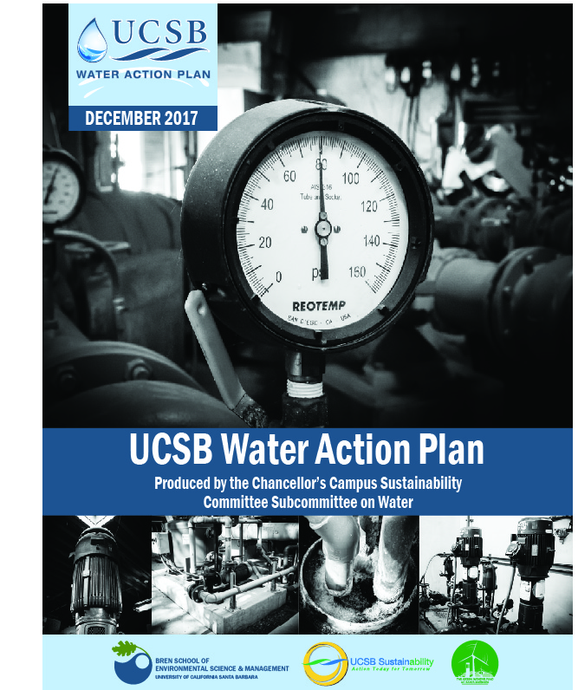

Table of Contents
Figure List iv
Table List v
Acknowledgements vi
Executive Summary viii
University Departments & Coordination of Water Conservation Efforts xiv
Potable Water Conservation Efforts 1
Regional Geographic and Regulatory Context 1
Scope of the UCSB Water Action Plan 4
ESTABLISHING A CAMPUS WATER USE BASELINE 7
BENCHMARKING WATER USE ON THE UCSB CAMPUS 7
Purpose and Delineation of UCSB’s Benchmark 7
Total Reductions to Date 8
HISTORICAL WATER USE REDUCTIONS 10
Academic, Research, and Other Non-Residential Buildings 10
Housing & Residential Services 14
Landscape & Irrigation 15
Industrial Water Uses 19
STRATEGIES & GOALS FOR ACHIEVING 20
POTABLE WATER REDUCTIONS 20
Academic, Research, & Other Non-Residential Buildings 21
Housing & Residential Services 25
Landscape & Irrigation 28
Industrial Water Uses 33
Administrative Action 36
SUMMARY & FUTURE STEPS 43
Summary & Goals 43
Meeting the 2020 & 2025 Per Capita Goals 46
Stormwater Management and Environmental Compliance 48
Regional Physiogeography and Hydrology 48
Surface Water and Hydrology 49
Environmental Protection and Regulatory Context 50
HISTORICAL STORMWATER MANAGEMENT EFFORTS 54
Restoration Efforts 54
Municipal Stormwater 55
Oil Pollution Prevention 59
Wastewater 60
STRATEGIES AND GOALS FOR FUTURE STORMWATER MANAGEMENT 61
Design of New Development Projects 61
Construction of New Development Projects 62
Operational and Maintenance Efforts 63
Educational Opportunities and Community Engagement 65
Stormwater Management Goals 66
Financing Opportunities 69
Reporting Criteria & Schedule 71
References 72

Figure List

Figure 1: Land use on-campus (LRDP 2010) 3
Figure 2 | UCSB existing built environment 4
Figure 3 | UCSB building types and designations 5
Figure 4 | UCSB metering infrastructure 6
Figure 5 | UCSB total potable water trends from FY 1996/97 to 2016/17 in gallons per year. 8
Figure 6 | UCSB potable water use trends normalized by weighted campus user (WCU), a UC standardized population metric, from FY 1996/97 to 2011/12 in gallons per year. 9
Figure 7 | Estimated total potable water use by sector. 10
Figure 8 | Academic, research, and other non-residential building bathroom audit breakdown 12
Figure 9 | Toilet flush breakdown in gpf based on in-situ testing of a sample of 31 toilets across campus; pie chart breaks represent the current public restroom efficiency standard (1.6 GPF) and the previous efficiency standard (3.5 GPF). 12
Figure 10| Annual recycled and potable water consumption for irrigation. 17
Figure 11 | Indoor per capita water percentages. 26
Figure 12 | Landscape areas evaluated for potable water savings 30
Figure 13 | Total potable water use projections, both 'BAU' and with implementing water conservation recommendations. 46
Figure 14 | From the UCOP FY 05-08 baseline, UCSB has the ability to significantly reduce per capita potable water consumption, and can achieve a 51% per-capita reduction if all recommendations are implemented. 47
Figure 15 | Projected daily per capita water consumption with WAP recommendations. 47

Table List

Table 1 | Summary of Infrastructure Goals x
Table 2 | Summary of Management Goals xi
Table 3 | Summary of Implemented & On-going Stormwater Management Goals (1) xii
Table 4 | Summary of Implemented & On-going Stormwater Management Goals (2) xiii
Table 5 | UCSB’s average annual potable water use during the baseline period 7
Table 6 | UCSB’s average annual potable water use during the benchmark period 7
Table 7 | Percent reductions in potable water use 8
Table 8 | H&RS current fixture standards 15
Table 9 | Estimated potable water reductions for H&RS bathroom retrofits 15
Table 10 | Recycled water extension timeline 16
Table 11 | Alternative cooling system options and suitability 21
Table 12 | Single-pass cooling water consumption matrix 22
Table 13 | Estimated water loss from Old Gym pool leak 22
Table 14 | Aerator retrofits costs including installation costs 23
Table 15 | Toilet retrofits costs including installation costs 24
Table 16 | Urinal retrofit costs, including installation costs 25
Table 17 | Shower retrofit costs, including installation 26
Table 18 | Toilet retrofit costs including installation costs 27
Table 19 | Aerator retrofit costs including installation costs 28
Table 20 | Estimated water savings from replacing underutilized turf irrigated with potable water to alternate landscape 29
Table 21 | Water consumption and expenditures due to overwatering with potable water 31
Table 22 | Commencement green treatment options 32
Table 23| Potable to recycled irrigation conversion landscapes 32
Table 24: Utilizing recycled water as make-up in BioII cooling tower 34
Table 25 | The annual water usage and water savings in gallons as well as the water cost and payback period for implementing increased cycles of concentration 35
Table 26 | Summary of Infrastructure Goals 44
Table 27 | Summary of Management Goals 45
Table 28 | Goleta, California, Temperature and Precipitation Data 2007 to 2017 49
Table 29 | Relevant Regulatory Requirements 51
Table 30 | Summary of Implemented and On-going Stormwater Management Goals (1) 67
Table 31 | Summary of Implemented & On-going Stormwater Management Goals (2) 68

Acknowledgements
We would like to thank the following individuals for their involvement and contributions not only to the current 2017 Water Action Plan, but also to the original 2013 document:

The UCSB Water Action Plan Team
The five graduate students from the Bren School of Environmental Science & Management who produced the original version of the award-winning UCSB Water Action Plan: Katie Cole, Rebecca Dorsey, Dane Johnson, Matthew O’Carroll, Briana Seapy, and Jewel Snavely, as well as their Project Advisor, Derek Booth, Adjunct Professor, UCSB Bren School.

Administrative Services
Marc Fisher, Senior Associate Vice Chancellor; Ron Cortez, Associate Vice Chancellor, Co-Chair of Campus Chancellor’s Sustainability Committee

Budget and Planning
Terry Macy, Senior Facilities Planner; Steven Velasco, Director of Institutional Research

Bren School of Environmental Science & Management
Arturo Keller, Professor, UCSB Bren School; Bob Wilkinson – Adjunct Professor, UCSB Bren School

Campus Planning & Design
Ray Aronson, P.E. – Associate Director; Mark Peppers, Project Manager, Design and Construction Services; Alissa Hummer, Acting Director Campus Planning and Design

College of Creative Studies
Bruce Tiffney, Dean, Co-Chair of Campus Chancellor’s Sustainability Committee

Department of Geography
Mo Lovegreen, Director, Campus Sustainability; Katie Maynard, Sustainability Coordinator

Environmental Health & Safety
Stacey Calloway, Environmental Compliance Specialist
Jodi Woods, Environmental Compliance Technician

Facilities Management, UCSB
Jon Cook, Associate Directory, Landscape & Custodial Services; Dan Marquez, Area Manager, Zone 1 & 2; David McHale, Associate Director of Energy and Utilities; Jordan Sager, LEED Program Manager; Ron Yamane, Assistant Manager, Financial Services; Valerie Knight, District Account Manager, NALCO; Kazimir Gasljevic, Senior Engineer.

Goleta Water District
Chris Rich, Water Supply & Conservation Manager; Misty Williams, Senior Water Resources Analyst

Goleta Sanitary District
Kathleen Werner, Technical Services and Laboratory Supervisor

Housing and Residential Services, UCSB
Mark Rousseau, Environmental & Energy Manager; Barry Colwell, Resource Planning Coordinator; Bonnie Crouse, Assistant Director, Residential Dining Services; Jeff Hillary, General Manager, Portola Dining Commons; Robbie Wright, General Manager of De La Guerra Dining Commons

Irvine Ranch Water Conservancy District
Nathan Adams, Water Efficiency Analyst; Amy K. McNulty, Water Efficiency Supervisor; Fiona Sanchez, Assistant Director of Water Policy; Mark Tettemer, Water Resources Manager

The Green Initiative Fund (TGIF)
The TGIF grant, awarded to the Water Action Plan through UCSB, provided funding for two student summer internships to advance the Water Action Plan.

The James S. Bower Foundation
The James S. Bower Foundation gave the Bren School a grant to assist the Bren School in supporting the Water Action Plan Group Project.

UCSB Sustainability
Lauren Barnum, Environmental Affairs Board Leadership; Amorette Getty, UCSB Laboratory Resources, Advocates, and Teamwork for Sustainability (LabRATS) Co-Director and Materials Research Facilities Network Administrator, Materials Research Laboratory; Ian Castillo, Water Action Plan Researcher

University of California, Office of the President
Matt St. Clair, Director of Sustainability, Sustainability; Alicia Jensen, Associate Planner, Budget and Capital Resources; Hilary Bekmann, Associate Director of Sustainability; Janika McFeely, Sustainability Specialist

Executive Summary
California is vulnerable to water shortages; as water demand increases, water planning will be an essential part of California’s future. The University of California, Santa Barbara (UCSB; the University) recognizes the importance of water planning and conservation, and has made many historical efforts to reduce water usage. The University of California, Office of the President (UCOP) mandated all universities system-wide to reduce growth-adjusted potable water consumption 20% by 2020, and 36% by 2025 when compared to a three-year average baseline of 2005-2008. UCSB has currently achieved a 17% reduction from the baseline. Given the University’s historical water conservation and efficiency achievements, in addition to the new recommendations outlined in the 2017 Water Action Plan (WAP), UCSB has the ability to not only meet the UCOP mandated goal, but also achieve further potable water reductions while meeting future water demand.
In 2013, UCSB published the original Water Action Plan as a cooperative effort with the Bren School of Environmental Science & Management at UCSB. The 2013 Water Action Plan highlighted the University’s historical conversation efforts that helped UCSB meet the original UC water conservation goal of a 20% overall reduction in potable water use by 2020; UCSB achieved a 25% reduction, nine years in advance of original 2020 goal. Importantly, the 2013 Water Action Plan highlighted various water conservation and efficiency recommendations in various settings throughout the campus to help achieve future reduction goals. Now tasked with a new set of goals, the 2017 Water Action Plan (approved by UCSB’s Chancellor’s Sustainability Committee on January 10, 2018) builds upon the foundation laid by the previous plan, and includes more recent data and information for many of the original recommendations, as well as covers new strategies and recommendations.
The baseline for UCSB, set by UCOP of all University of California (UC) campuses, uses a three-year fiscal year (FY) average (2005 to 2008), in which to measure future reductions. In addition to this measure, the University chose to keep their benchmark period, FY 2008 to 2011, identified in the original plan, as an even more recent time period to measure future reductions against. The metric utilized to determine per capita numbers on the campuses is ‘weighted campus user’ (WCU), which weights various groups on-campus based upon how intensely they utilize the campus’ resources. The baseline average per capita annual potable water use for the Campus was 10,743 gallons per year per weighted campus user (gpy/ WCU) for FY 2005 to 2008, representing a 17% reduction in potable water use from the baseline to date.
The UCSB Campus (the Campus) faces distinct water challenges due to its arid coastal climate, state regulations, local water sources that have been impacted in recent drought years, the growing campus population, and significant increase in recent water rates. This setting helps define which water-reduction strategies are most suitable for the University to not only meet the growth-adjusted potable water consumption 20% by 2020, and 36% by 2025 reduction goals, but to exceed them.
Our goals in the 2017 Water Action Plan for further potable water reductions at UCSB focus on implementing multiple conservation and efficiency strategies, including the substitution of recycled water for potable water in a variety of applications. Goals include increasing the installation of low-flow aerators, showerheads, and toilets in academic and housing buildings; improving the quality of recycled water used in irrigation and other non-potable applications; and expanding overall administrative actions to encourage water conservation. The goals of the WAP that target infrastructure changes have both financial costs and benefits; they are evaluated based primarily on their potable water savings potential and their financial benefits, which are summarized in the ‘Infrastructure Goals’ table (Table 1). Most of the goals have an economic payback period of one to four years. The goals of the WAP that discuss the administrative and management changes are summarized in the ‘Management Goals’ table (Table 2). These goals are evaluated on the expected effect of the action, savings seen in similar actions or programs, and the time frame needed to implement the action.
While the University has already achieved the previous UC goal, it still has some work to do to achieve the new growth-adjusted potable water consumption 20% by 2020, and 36% by 2025 reduction goals. If all recommendations were fully achieved, the Infrastructure Goals would save UCSB approximately 76.4 million gallons of potable water and yield roughly $800,000 in annual cost savings, given the current cost of water remains flat. These savings mask the savings determined in the 2013 Water Action Plan due to the increase in campus population and significant increase in potable water costs. While water reductions from the Management Goals are not easily quantifiable before the management actions are implemented, they are estimated to contribute significantly to annual potable water use reductions.
UCSB has also complied with federal, state, and local regulations related to stormwater management and environmental compliance, such as the federal Clean Water Act and the statewide MS4 General Permit. Human activities have the potential to degrade the biophysical environment by directly and indirectly discharging pollutants into the environment or by changing the landscape through construction practices. To avoid these impacts, UCSB has implemented a series of stormwater and environmental compliance best management practices that protect riparian areas, minimize pollutant loading, and maximize infiltration of clean stormwater, while also reducing the rate and volume and runoff.
The UCSB Water Action Plan defines management goals for stormwater and environmental compliance (Table 3). Notable goals include the development and creation of standard operating procedures for stormwater, oil pollution prevention, and wastewater inspection and enforcement. The resource requirements for these goals are expressed in employee full-time equivalent hours and their implementation horizon is defined as either short or medium term.
The UCSB Water Action Plan also sets financial and reporting recommendations. Financial opportunities and funding strategies to achieve the water conservation goals are identified and outlined for future use. These funding agencies include the US Environmental Protection Agency (EPA), the California Department of Water Resources, the Bureau of Reclamation, and The Green Initiative Fund (TGIF) of UCSB. In addition to the required annual reporting of water use to UCOP, this WAP should be assessed every five years to prioritize mitigation efforts and explore new technologies and conservation techniques as they emerge.

Table 1 | Summary of Infrastructure Goals
Sector | Infrastructure Goal | Initial Cost  ($2017) | Payback Period | Annual Potable Water Savings (Gal) | Annual Water Cost Savings ($2017) | Implementation Horizon¹
Academic, Research and other Non-Residential Buldings | Replace soft-plumbed single-pass cooling systems in labs | NA | NA | 14.4 Million | $159,020 | Short-Term
 | Repair leak in Old Gym Pool | NA | NA | 706,950 | $7,810 | Medium-Term
 | Retrofit Aerators in Bathrooms | $9,000 | <1 year | 2.8 million | $31,040 | Short-Term
 | Retrofit Toilets in Bathrooms | $80,400 | <1 year | 18.7 million | $206,580 | Medium-Term
 | Retrofit Urinals to 0.125 gpf in Bathrooms | $217,000 | 3 years | 6.7 million | $74,270 | Long-term
Housing & Residential | Retrofit Showers in Bathrooms | $2,800 | <1 year | 6.5 million | $32,200 | Medium-Term
 | Retrofit Toilets in Bathrooms | $80,100 | < 6 years | 3.0 million | $14,900 | Medium-Term
 | Retrofit Aerators in Bathrooms | $1,200 | <1 year | 364,400 | $1,800 | Short-term
Landscape & Irrigation | Continue to Evaluate Landscape Areas for Potable Water Savings | NA | NA | 1.3 million | $14,650 | Medium-Term
 | Expand Weather-based Irrigation Control Systems | NA | NA | 3 million | $33,240 | Long-Term
 | Install On-Site Filtration System for Commencement Green | $16,500 | <5 years | 831,000 | $4,100 | Medium-Term
 | Expand Recycled Water Infrastructure for Irrigation | $234,810 | <4 years | 7.1 million | $78,900 | Medium-Term
Industrial Water Use | Increase Concentration Cycles for Cooling Towers | NA | NA | 7.5 million | $104,800 | Short-Term
 | Pilot Recycled Water in BioII Cooling Tower | $115,400 | 7 years | 4.8 millon | $53,000 | Short-Term
¹ “Short-Term” = 2018-2019; “Medium-Term” = 2019-2025; “Long-Term” = 2025-2032

Table 2 | Summary of Management Goals
Sector | Management Goal | Description | Cost $2017  (Initial/ Annual)¹ | Implementation Horizon²
Landscape & Irrigation | Conduct Annual Constituent Soil Samples | Will help to identify constituent build-ups on-campus, which will allow Facilities Management to proactively remediate soils and eliminate the idea of returning to potable water irrigation. | NA/$ | Short-Term,  Ongoing
Industrial Water Uses | Calibrate Existing Industrial Water Meters and Install New Where Needed | Will ensure maximum cooling tower operating efficiency, accurate determination of water use trends, and increased leak and malfunction detection capabilities. | $/NA | Short-Term
 | Quarterly Reviews for Industrial Infrastructure | Will facilitate proper adjustment and optimization of industrial water infrastructure to maximize water and energy savings. | NA/$ | Short-Term
Administrative Actions | Install Real-Time Meters in All Buldings and New Construction | Will facilitate quick and efficient data collection, identify leaks within the system, and help incentivize campus water users to conserve. | $$$/$ | Short-Term
 | Create a Living Central Database for Water Use and Infrastructure. | Will provide realistic monitoring trends allowing the University to better predict future water needs and adjust campus population growth accordingly. Will assist with the efficient pinpointing of the most inefficient areas on campus. | $/$  (Included in WM Salary) | Short-Term
 | Implement a Campus Wide Water Conservation Education Program | Increase students’ perception of water conservation activities by providing them with the knowledge and motivation to reduce water usage. | NA/$$$  (Partially Included in WM Salary) | Short-Term,  Ongoing
 | Incorporate Water Conservation into Academics | Projects incorporated into the academic curriculum create opportunities to engage students and expand their understanding of the issues surrounding water conservation. | $$/$ | Short-Term,  Ongoing
 | Participate in Campus and National Water Conservation Competitions | Competitions engage and motivate students and encourage the use of water conservation knowledge, particularly longer duration competitions that create long-term behavioral change. | NA/$  (Included in WM Salary) | Medium-Term,  Ongoing
 | Begin Dialogue with State to Encourage Implementation of Incentives for Water Conservation | Will help explore state funding opportunities and collaboration with the State and other UC’s regarding water conservation strategies and funding sources. | NA/$  (Included in WM Salary) | Long-Term,  Ongoing
¹ Cost: “$” = <$10,000; “$$” = $10,001-$100,000; “$$$” >$100,000

² “Short-Term” = 2018-2019; “Medium-Term” = 2019-2025; “Long-Term” = 2025-2032; “Ongoing” = May require action at short, medium, and long horizons

Table 3 | Summary of Implemented & On-going Stormwater Management Goals (1)
Sector | Description | Tasks | Resource Requirements (FTE)¹ | Implementation Horizon²
Stormwater | Create a stormwater program effectiveness assessment and improvement plan | Development of plan  Implementation of plan | 43 FTE* hours  8 FTE hours/month, 96 hours annually | Short-term
 | Implement new post-construction design requirements | Development of requirements  Implementation of requirements | 27 FTE hours  8 FTE hours/month, 96 hours annually | Short-term
 | Develop a stormwater public outreach and education plan | Development of plan  Implementation of plan | 80 FTE hours  27 FTE hours/month, 324 hours annually | Short-term
 | Audit existing contract documents, design standards, policies, and procedures, update to include stormwater compliance requirements | Initial development  Ongoing implementation | 60 FTE hours  32 FTE hours annually | Short-term
 | Generate standard operating procedures for construction and stormwater inspections | Initial development  Ongoing implementation | 40 FTE hours  32 FTE hours annually | Short-term
 | Generate standard operating procedures for outfall stormwater inspections and sampling | Initial development  Ongoing implementation | 40 FTE hours  32 FTE hours annually | Short-term
 | Generate standard operating procedures for priority facilities stormwater inspections | Initial development  On-going implementation | 40 FTE hours  32 FTE hours annually | Short-term
 | Continue campus stormdrain labeling | On-going implementation costing for labels | 16 FTE hours/month  $2.00/ea x 500/yr initial | Short-term
 | Create Stormwater pollution prevention plans for priority hotspot facilities | Development of plan  Implementation of plan | 80 FTE* hours  8 FTE hours/month, 96 hours annually | Mid-term

²“Short-Term” = 2018-2019; “Medium-Term” = 2019-2025

¹ FTE = Full-time Equivalent Employee

Table 4 | Summary of Implemented & On-going Stormwater Management Goals (2)
Sector | Description | Tasks | Resource Requirements (FTE)¹ | Implementation Horizon²
Stormwater | Produce a long-term strategy for maintenance of post-consumer features | Development of plan  Implementation of plan | 80 FTE* hours  8 FTE hours/month, 96 hours annually | Mid-term
 | Create a best management practices guideance manual for staff that have the ability to pollute stormwater systems | Development of plan  Implementation of plan | 80 FTE* hours  8 FTE hours/month, 96 hours | Mid-term
 | Develop enforcement protocols for the construction stormwater program | Initial development  Ongoing implementation | 20 FTE hours  30 FTE hours annually | Mid-term
 | Develop enforcement protocols for the municipal stormwater program | Initial development  Ongoing implementation | 20 FTE hours  30 FTE hours annually | Mid-term
 | Generate a post-construction stormwater best management practices manual | Initial development  Ongoing implementation | 40 FTE hours  30 FTE hours annually | Mid-term
Oil Pollution Prevention | Generate standard operating procedures for spill prevention, control, and countermeasures inspections | Initial development  Ongoing implementation | 40 FTE hours  32 FTE hours annually | Short-term
 | Development enforcement protocols for spill prevention, control, and countermeasures program | Initial development  Ongoing implementation | 20 FTE hours  30 FTE hours annually | Mid-term
Wastewater | Generate standard operating procedures for waste water inspections | Initial development  Ongoing implementation | 40 FTE hours  32 FTE hours annually | short-term
 | Develop enforcement protocols for the wastewater program | Initial development  Ongoing implementation | 20 FTE hours  30 FTE hours annually | Mid-term
¹ FTE = Full-time Equivalent Employee

²“Short-Term” = 2018-2019; “Medium-Term” = 2019-2025

University Departments & Coordination of Water Conservation Efforts
Fresh water is a limited resource, with several competing uses that pose an ever-increasing burden on water supplies. In California, the state’s growing population and regions of semi-arid climate magnify water shortage problems. To meet future water demands, California will need to take drastic measures to reduce overall water consumption, and specifically, potable water consumption. The Chancellor’s Sustainability Committee at UCSB approved the 2017 Water Action Plan in January 10, 2018. On-campus, introducing and managing water conservation and efficiency measures, are a collective effort. The UCSB Chancellor’s Sustainability Committee Subcommittee on Water will help to lead the implementation efforts of the UCSB Water Action Plan (WAP) in collaboration with the following key departments.

Associated Students and the Environmental Affairs Board
The Associated Students (AS) of the UCSB is a non-profit organization funded by undergraduate student fees. Direction of the organization is controlled by the AS Senate, composed of elected student positions and appointments, whose mission it is to voice student concerns and expresses student opinion to the UCSB administration and the UC system.
The branch of UCSB’s AS Government that is most involved with water issues on campus is the Environmental Affairs Board (EAB). The main goal of the EAB is to protect, preserve, and enhance the environment. The group coordinates with University departments and other groups to promote environmental perspectives and sustainability throughout the University and the surrounding communities. In 2004, AS’s EAB, aided by University staff, recommended that the Chancellor develop a Sustainability Plan as part of the effort to update the 1990 Long Range Development Plan (LRDP).

Campus Sustainability
Campus Sustainability is a conglomeration of efforts from key faculty, administrators, students, and staff across the campus that work in a decentralized manner with the overarching goal of improving the University’s effect on the environment and reducing the dependence on non-renewable resources. UCSB Sustainability is the driving force behind the WAP and has helped foster a culture of environmental awareness at UCSB by supporting campus-wide sustainability efforts, coordinating sustainability program development, and publicizing the sustainability work of staff, faculty, and students on campus.

Cheadle Center for Biological and Ecological Restoration
The Cheadle Center for Biodiversity and Ecological Restoration (CCBER) is a UCSB campus department dedicated to education, research, and outreach, and is the driving force in the University’s efforts to provide stewardship of campus natural resources and maintain an environment rich in biodiversity. Through the ecological restoration program, CCBER encourages and facilitates land restoration on and near campus.

design, facilities & safety services (DFSS)
The mission of all Campus Design and Facilities units is to design, build, operate, maintain, and renew the physical environment required to support the University’s instructional, research, and public service mission. Units under the Facilities Management umbrella that affect water reduction and water quality include:
Campus Planning & Design (Planning)
The responsibilities of Campus Planning include providing guidance for capital project design, maintaining and implementation of the Long Range Development Plan, ensuring California Coastal Commission and California Environmental Quality Act (CEQA) compliance, and implementation of the UC Sustainability Practices policy. During the CEQA process, mitigation measures directly affecting water usage and water quality are identified and included in new development projects.
Design & Construction Services (D&CS)
D&CS staff is responsible for implementation and oversight of UCSB’s major and minor capital improvement projects including managing the design of the project, development of bidding documents, bidding, and construction. D&CS staff directly affects water quality by incorporating stormwater treatment features and water efficiency devices such as waterless urinals and aerators into the design of new development projects.
Environmental Health and Safety (EH&S)
The Department of Environmental Health and Safety (EH&S) is responsible for promoting a safe and healthful environment for research, instruction, and campus community life and assists the campus in meeting its obligations for compliance with federal, state, and local regulations. Examples of services provided by EH&S staff that directly affect water quality on campus include the development and implementation of the UCSB Stormwater Management Program, oversight of compliance with the Municipal Separate Storm Sewer System (MS4) General Permit and the Construction General Permit, and advising on incorporation of Low Impact Development elements into new development projects.
Facilities Management (FM)
Facilities Management is comprised of skilled trades people organized in multiple groups such as Custodial, Energy & Utility Services, Grounds, Maintenance, and Recycling. Facilities Management staff affects water usage and water quality by conducting routine maintenance and repairs of campus buildings, water mains, sewer and storm drains, and sidewalks and roadways. Facilities Management also houses the UCSB LEED program which greens the campus’ building portfolio and develops and implements sustainable operations. In addition, Facilities Management staff has been instrumental in retrofitting existing campus facilities with waterless urinals, aerators, and stormwater treatment devices.

Housing, dining & auxilary enterprises (HDAE)
Residential Operations (Res Ops)
Residential Operations provides housing and associated residential life services for UCSB's undergraduate student, graduate student and faculty population. Similar to Campus Facilities Management, Residential Operations is responsible for day-to-day operations and maintenance of University owned housing facilities and the associated landscaping features.

Potable Water Conservation Efforts

Regional Geographic and Regulatory Context
The State of California has a varied climate and physiography, ranging from the temperate rainforests of the Northwest to the arid deserts of the Southwest and from the large mountain ranges to the coastal plains and the Central Valley. As a result, the State experiences a wide range of precipitation and water availability. With a history of periodic droughts, California works continuously to meet the growing water demand of the State with local water resources. Climate change forecasting for the State of California continues to project exacerbating competition for existing water resources in the in the coming years. According to the California Department of Water Resources (DWR), climate change will continue to have a profound impact on California water resources, evident in dynamic snowpack levels, sea level, and river flows. These changes are expected to shift more precipitation from snow to rain, reducing mountain snowpack. Snowpack in the Sierra Nevada Mountains provides the State with critical water supplies in the spring and summer, supplying water through the drier seasons. Less snowpack will result in less late summer water availability, and increased rainfall will intensify flood risks and add additional challenges for water supply reliability. Given the risks and challenges that climate change poses to the State of California’s water supply, proper planning and preparation is necessary.
In an effort to plan for the future of water resources in California, the State has passed several regulations that address water conservation. In 2009 Senate Bill (SB) X7-7 was passed, which specifically targeted water conservation and required that all urban water districts reduce consumption by 20% by 2020., The University of California, Office of the President (UCOP) modeled their original water reduction goal in the ‘Sustainable Water Systems Policy’ after SB X7-7 by urging a 20% reduction in overall potable water use at all the campuses within the University of California (UC) system by 2020. In response to recent intense drought events in the State of California, the UC system revised their goals to be in line with the Federal Government’s Executive Order – Planning for Federal Sustainability in the Next Decade, and implemented goals to reduce growth-adjusted potable water consumption 20% by 2020, and 36% by 2025 when compared to a three-year average baseline of 2005-2008. The State has put in place the CalGreen Building Code regulations, Title 24, which detail green building standards, including potable water efficiency requirements for residential and non-residential buildings in the state of California. The California Code of Regulations, Title 22, also plays a large role in water conservation by delineating quality expectations for recycled water. The law outlines appropriate uses for recycled water, requirements for plumbing, and the necessary treatment for various approved uses. This is particularly relevant at the University of California, Santa Barbara (UCSB; the University) where recycled water is already widely used for irrigation, with the potential to expand recycled water use to other applications allowed by Title 22.

University of California, Office of the President Mandate
The UC system has formally recognized the value of water as a scarce resource and the importance of addressing water conservation in the UC system. In October 2010, the UC Sustainability Steering Committee formed the UC Sustainable Water Systems Working Group. The Group is composed of students, staff, and faculty from each of the UC campuses and medical schools. The working group plays an instrumental role in helping develop water-related policy language for the UC Sustainable Practices Policy. The latest and most current UC Sustainable Water Systems Policy went into effect June 2, 2017. Each of the UC campuses are planning to complete an updated Water Action Plan by December 15, 2017 (deadline extended from December 2016), in accordance with the defined policy language.

Potable Water and the UCSB Campus
This statewide context for water use exerts an overarching influence on the sources and the uses of water on the UCSB campus. Although it has driven many of the past and future policies regarding water use, local conditions are no less important in explaining past conditions and determining future trajectories. UCSB has long recognized the importance of addressing water issues and proactively implementing solutions. Current campus overall potable water consumption (based on 2014-2017 averages) is approximately 29% less than it was in 1996-1998. The 2010 Long Range Development Plan projected that UCSB faculty, staff, and student population would increase by 13% in the following eight years, which is on track with current growth rates. This population increase, combined with the anticipated growth of on-campus housing to accommodate a larger quantity of faculty and staff, will raise UCSB’s demand on current water supplies. Acknowledging the need for water conservation, UCSB has taken proactive steps to reduce water consumption. Looking forward, the University seeks to continue to decrease overall water use while meeting the demands of its current and future users.

UCSB Physical Context
The 1,055 acre UCSB Campus is located in Santa Barbara County on the Pacific coastline. The local watershed that contains the campus is bounded to the Northwest by the east-west trending Santa Ynez Mountains and to the Southeast by coastal bluffs and the Pacific Ocean. The University enjoys a Mediterranean climate with typical temperatures ranging from lows in the 40’s °F to highs in the 80’s °F. Average annual rainfall is less than 20 inches a year, but precipitation data is highly variable from year-to-year and between seasons.
UCSB is made up of four principal campuses: the 422 acre Main Campus acquired in 1948, the 184 acre Storke Campus purchased in 1962, the 273 acre West Campus purchased partly in 1967 and partly in 2007, and the 174 acre North Campus purchased in 1994. The University also owns two apartment buildings in Isla Vista (El Dorado and Westgate).

Figure 1: Land use on-campus (LRDP 2010)

UCSB Water Sources
The Campus is nestled next to the City of Goleta and receives its water from the Goleta Water District (GWD). GWD uses a mix of local surface water supplies from Lake Cachuma in the Santa Ynez Valley, groundwater from the Goleta Groundwater Basin, recycled water from the Goleta Sanitary District, and imported State Water Project (SWP) water to meet the district water demand. The area relies heavily on Lake Cachuma, during non-drought years, but with the Southern Santa Barbara County remaining one of the few areas of the State still in drought, and entering its sixth year of historic drought, potable water supplies are altered. GWD forecasts water deficiencies of 26-35% over the next year, as they expect to remain in a Stage III Water Shortage Emergency for FY 2017-18. Available potable water sources are anticipated to include: Lake Cachuma (7,886 AFY); Goleta Basin Groundwater (1,500 AFY); California State Water Project (4,500 AFY).⁹

Motivation for UCSB’s Water Action Plan
The overarching purpose of the 2017 Water Action Plan (WAP) is to identify future water reduction strategies at the Campus in accordance with objectives set forth by UCOP. Anticipating future pressures and continued constraints on water usage at UCSB, this document outlines the most effective avenues to achieve a more sustainable campus water system in light of anticipated water stressors.
In addition to being located in a naturally water scarce area, UCSB is experiencing other drivers relevant to future water consumption. These are (1) campus population growth, (2) increased on-campus residences, and (3) water-cost increases. One stated goal of the Long Range Development Plan (LRDP) is to house a larger number of faculty and staff in on-campus housing. Not only will student population increase in the coming years, but so will the number of faculty and staff living on Campus. Finally, current potable water rates are $5.63/HCF with a $2.63 drought surcharge per HCF (current rate UCSB pays for potable water is $8.26/ HCF), and with an uncertain water future, the cost of water could increase. In fact, since the 2013 Water Action Plan water rates have increased $4.55/ HCF.
These three factors create a perfect opportunity for UCSB both to evaluate its water use and to compile a plan to identify water conservation strategies. Our WAP has been designed to achieve these two objectives.

Scope of the UCSB Water Action Plan

Geographic Scope
The WAP accounts for all on- and off-campus water use of UCSB-operated buildings. The Plan’s geographic scope includes all Main Campus buildings and residential halls, plus the campus housing units not on the Campus utilities grid, which includes San Clemente Graduate Student Housing, Storke Apartments, Santa Catalina Residence Halls, San Joaquin Apartments, Santa Ynez Apartments, West Campus Housing, and Sierra Madre Apartments. The only off-campus buildings included in the scope of the WAP are IV Theatre, Embarcadero Hall, El Dorado apartments, and Westgate apartments. These off-campus properties are included in the geographic scope because UCSB is responsible for their utilities. The WAP does not include off-campus faculty housing (e.g., West Campus Point and Ocean Walk at North Campus Point) when reporting campus water use, because faculty residential units’ utilities do not fall under the operational control of UCSB. Nor does the Plan account for distant, off-campus water consumption, such as UCSB natural reserve infrastructures and satellite campuses. The reference map below labels the UCSB built environment; academic, research, and other non-residential buildings are colored purple, and Housing & Residential Services (H&RS) buildings are colored orange (Figure 2, 3).
Figure 2 | UCSB existing built environment
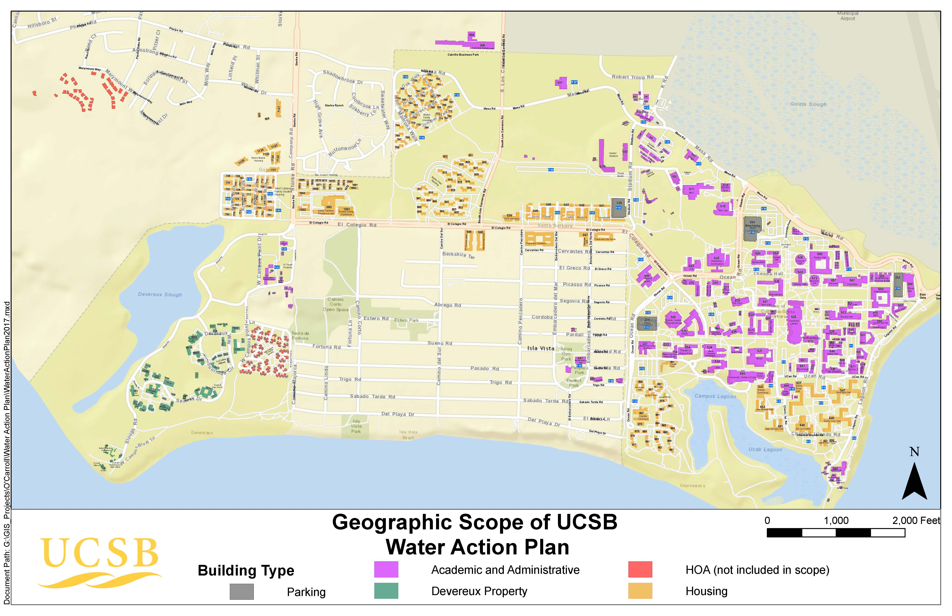

Figure 3 | UCSB building types and designations

Temporal Scope
The UCSB WAP considers a 21 year historical scope, representing FYs (i.e., July to June; hereafter abbreviated FY) 1996/97 to 2016/17. The University has data on both potable and recycled water for this period; based on historical water conservation progress and campus growth over these 21 years, the WAP recommends water conservation and efficiency strategies for consideration over the next eight years, until 2025. This planning horizon encompasses UCSB’s Long Range Development Plan (LRDP) timeline and aligns its projections with growth predictions from the LRDP.,

Water-Type Scope
“Water” for the WAP is broadly categorized into potable water; water suitable for human consumption; and non-potable water, water unsuitable for human consumption. The WAP examines UCSB’s historical and current use of potable and non-potable water types. The category of “non-potable water” includes graywater, blackwater, industrial water, stormwater, and recycled water:
- Graywater (wastewater with little-to-no fecal content) is excluded in this document’s analysis because its practical applications at the University level are limited by legal statutes (e.g., Title 22).
- Blackwater (wastewater with significant fecal content) is acknowledged by the WAP in the context of sewage effluent.
- Stormwater (runoff from precipitation events that flows over land and impervious surfaces) is acknowledged by the WAP from a watershed perspective in a campus-wide, comprehensive way that recognizes stormwater as a resource. Also addressed are aims to protect and restore the integrity of the water bodies surrounding the campus.
- Recycled water (wastewater treated with the intention of reuse) and industrial water, which include water provided for specific industrial applications, are examined by the WAP because of their potential role in reducing potable water consumption.

Campus Water Metering Infrastructure
UCSB’s metering infrastructure is more centralized than building-specific. On the older, main portion of the campus, many buildings share a centralized meter. Centralized meters make it difficult to determine building specific water usage and therefore difficult to target conservation and efficiency programs to areas that need it the most. Another constraint with centralized metering, is that building-specific water meters are a prerequisite to the LEED Existing Building Operation & Maintenance certification process. Newer buildings on the campus have building specific meters, as they were a part of the building’s portfolio when being designed. Many of these buildings include residence halls, which provide not only building-specific, but also real time data to operations staff and building occupants. There are nine billable meters from Goleta Water District that serve the non-residential portions of campus, and 12 that serve the residential side of campus. Figure 4 identifies both potable and recycled water meters on the campus.
Figure 4 | UCSB metering infrastructure

ESTABLISHING A CAMPUS WATER USE BASELINE
Under the direction of University of California, Office of the President (UCOP), UCSB is required to reduce growth-adjusted potable water consumption 20% by 2020, and 36% by 2025 when compared to a system-wide three-year average baseline of FY 2005/06, FY 2006/07, FY 2007/08. To determine growth-adjusted potable water consumption, each UC campus is required to report potable water use in gallons per year and gallons per weighted campus user (WCU). Weighted Campus User is the standardized per capita metric used for all the UC campuses that normalizes varying water users by weighting students, staff, and faculty by their different degrees of time spent at UCSB (i.e., full-time students, part-time staff, etc.). UCSB’s baseline water use has been calculated in accordance with UCOP requirements.
During the UCOP-defined baseline period, average per capita (WCU) potable water use for the Campus was 10,743 gal/year/WCU, with an overall average consumption of 220,869,667 gallons
Table 5 | UCSB’s average annual potable water use during the baseline period
Baseline FY | Total/ Gal | Gal/WCU
2005/06-2007/08 | 220.8 million | 10,743

BENCHMARKING WATER USE ON THE UCSB CAMPUS

Purpose and Delineation of UCSB’s Benchmark
In addition to the University of California, Office of the President’s (UCOP) mandated baseline, the objective of selecting a three-year water use benchmark is to mark reductions already achieved by UCSB and to encourage further reductions. This was initially noted in the 2013 Water Action Plan and will still be relevant going forward. The benchmark will serve as an internal check point from which the University can reevaluate historical water use and water conservation strategies, and launch new conservation efforts that move beyond the major conservation steps taken since UCSB’s baseline era. These efforts are detailed below in ‘Campus Historical Water Use & Water Reduction Progress.’
FY 2008/09, 2009/10, and 2010/11 constitute the three-year period selected for benchmarking UCSB’s water use. This timeframe was selected to consider the impact of concurrent climate factors, campus growth, and infrastructure changes in water use. These three years constitute a benchmark intended to push UCSB to move forward with further water reductions that are reflections of new conservation efforts, not simply lasting effects of historical conservation strategies. During the UCSB benchmark period, average water use for the campus was 218.8 Mgal/yr, roughly 9,983 gallons per weighted campus user (WCU) (Table 6).
Table 6 | UCSB’s average annual potable water use during the benchmark period
Benchmark FY | Total (Gal) | Gal/WCU
2008/09-2010/11 | 218.8 million | 9,983

Total Reductions to Date
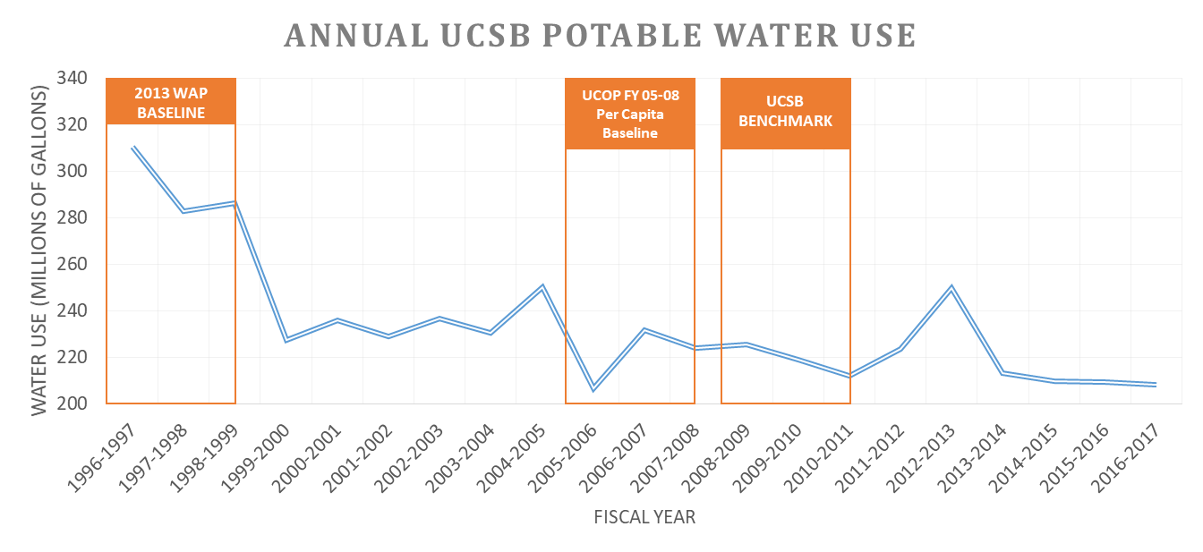
Increases in water use efficiency, major industrial water infrastructure improvements, and significant replacement of potable water with recycled water earned UCSB substantial reductions in overall potable water use from the 2013 Water Action Plan baseline average of 292.7 million gallons (1996/97 to 1998/99) to the benchmark average annual use of 218.8 million gallons (2008/09 to 2010/11), and to the current FY 2016/17 annual water use of 208.3 million gallons. As evidenced in Figure 5, total potable water use dropped significantly in the late 1990s, followed by little change for more than a decade. This stagnation since the late 90s can be attributed to an almost doubling in the student population living in campus housing and an eight to twelve percent growth in student enrollment, coupled with ongoing conservation efforts. In light of this historical population growth, the stability of total potable water use required a simultaneous decrease in per capita potable water use (Figure 5).

Figure 5 | UCSB total potable water trends from FY 1996/97 to 2016/17 in gallons per year.
As described in the 2013 Water Action Plan, the University reduced overall potable water use 25% from the 1996/97 to 1998/99 baseline to the UCSB benchmark. When normalized by Weighted Campus User over the same time period, reductions reached 38%. Based on the current policy’s growth-adjusted potable water reduction goals, 20% by 2020, and 36% by 2025, UCSB has achieved a 17% reduction from the system-wide 2005/06 to 2007/08 baseline (Table 7, Figure 5, 6).
Table 7 | Percent reductions in potable water use
2013 Water Action Plan Potable Water Reductions  (Goal: 20% overall reduction by 2020) | Reduction
Total Potable Water | 25%
Potable Water/ Weighted Campus User | 38%

2017 Water Action Plan Potable Water Reductions  (Goal: growth-adjusted reduction, 20% by 2020; 36% by 2025) | Reduction
Total Potable Water | 6%
Potable Water/ Weighted Campus User | 17%

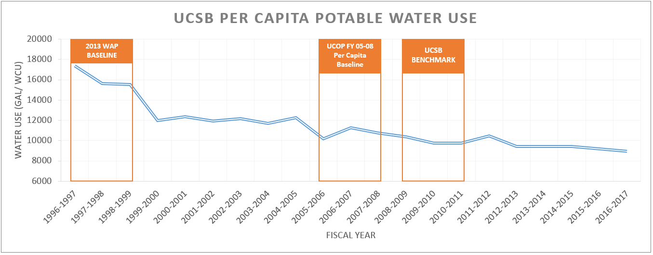
Figure 6 | UCSB potable water use trends normalized by weighted campus user (WCU), a UC standardized population metric, from FY 1996/97 to 2011/12 in gallons per year.

HISTORICAL WATER USE REDUCTIONS
The following summary of historical water use reductions and conservation actions reconstructs UCSB’s water-use history and identifies the water-related actions that have led to a 29% overall reduction in total potable water use between FY 1996/97-1998/99 and FY 2016/17. Water on-campus is used within two broad categories: academic, research, and other non-residential buildings; and Housing & Residential Services. However, water used for irrigation and industrial applications is embedded in each of these categories. Therefore, the WAP analyzes potable water use and water-use reductions as they fall into each of the following four “sectors”: academic, research, and other non-residential buildings (41%); Housing & Residential Services (45%); irrigation and landscaping (3%); and industrial applications (11%) (Figure 7).
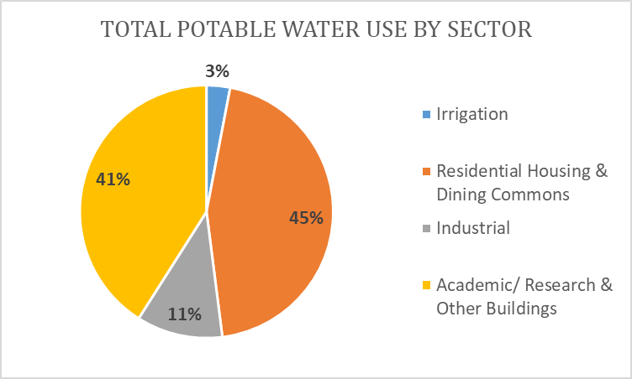
Figure 7 | Estimated total potable water use by sector.

Academic, Research, and Other Non-Residential Buildings
Academic, research, and other non-residential buildings (e.g., the University House, the Faculty Club, the University Center, etc.) include all non-Housing, Dining & Auxiliary Enterprises (HDAE) buildings on the UCSB main campus.
In the late 1980s, UCSB instituted a water-efficiency program in reaction to a severe local drought. Thousands of low-flow toilet valves and sink aerators were installed, and concurrent conservation efforts were instituted, including plumbing maintenance, leak-repair, and water audits. Chronicling further water reduction efforts in non-residential restrooms after the 1980s drought, however, has proven a more complicated process. Retrofit records have not been well-kept and misleading fixture labels and untraceable records of maintenance work and retrofits have blurred past water use patterns and conservation opportunities.
Through grants from The Green Initiative Fund (TGIF), a student-generated environmental fund at UCSB, restroom retrofits have continued on a smaller scale in the past decade, replacing aerators, and high-flow toilets, and urinals. However, a thorough restroom audit was necessary to better assess the true state of retrofits on campus. As part of the 2013 Water Action Plan, on-campus restrooms were visited in the summer of 2012, and the number and flow rate of all faucet, aerator, toilet, and urinal fixtures were recorded. Each faucet flow rate was manually measured, and a sample of toilet flush flows across campus was gathered.
According to the audit results, approximately 61% of faucets have aerators in place, and the average faucet flow rate across campus is 2.01 gallons per minute (gpm). Newer or retrofitted buildings generally have faucets with lower flow rates; some restroom flow rates average as low as 0.5 gpm, whereas less efficient restrooms have average flow rates up to 3.8 gpm. The aerator brands in use have market-specified flows of 0.5-2.2 gpm. About 20% of toilets in on-campus academic buildings have dual-flush valves, which theoretically save roughly 0.6 gpf every time a lighter flush is used (given ratings of 1.6 gpf/solids and 1.0 gpf/liquids). Additionally, 35% of urinals are waterless, whereas older models in place flush up to 2 gpf (Figure 8).
The in-situ testing of fixtures such as aerators and toilet valves performed during the audits revealed the performance of old fixtures. Older or poorly installed fixtures frequently failed to meet the efficiency standards for which they are designed, and even new fixtures may exceed their advertised flow rates. For example, a number of aerated faucets found across the UCSB campus flowed at rates over 4 gpm, indicating that the 2.0 gpm aerator was no longer properly in place or that wear over time had decreased function. Toilet flow audits indicated that real flows far exceeded expected toilet flows. A sample of 31 toilets across campus yielded an average flush of 3.5 gallons, with a standard deviation of 1.2 gallons. A conservative estimate based on the extrapolation of in-situ testing suggests that over 87% of campus toilets flush at a level higher than the current public restroom efficiency standard of 1.6 gpf (Figure 9). Challenges to the success of historic conservation efforts include the removal or theft of aerators and the wearing out of fixture components, such as diaphragms in toilet valves.

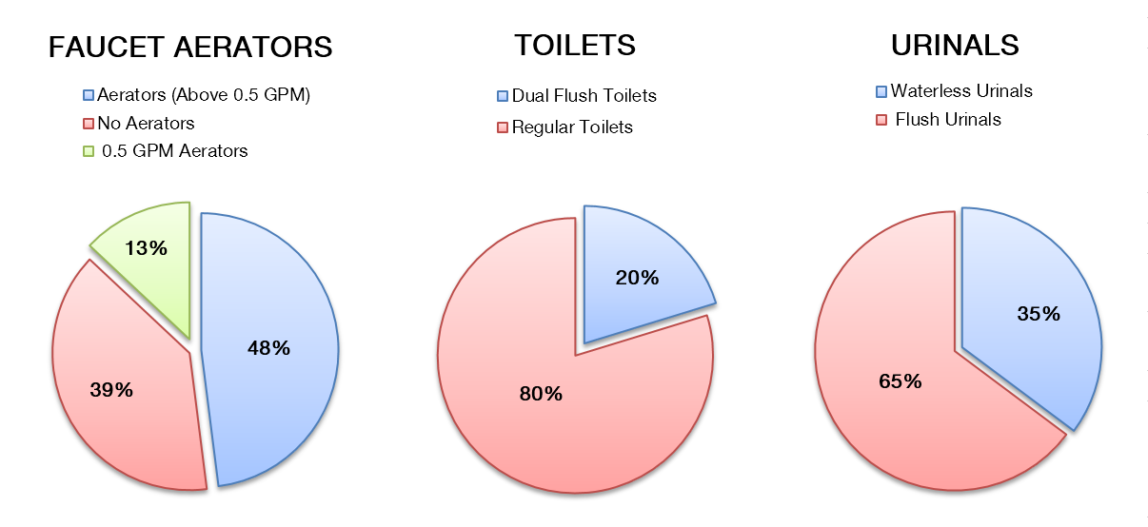
Figure 8 | Academic, research, and other non-residential building bathroom audit breakdown

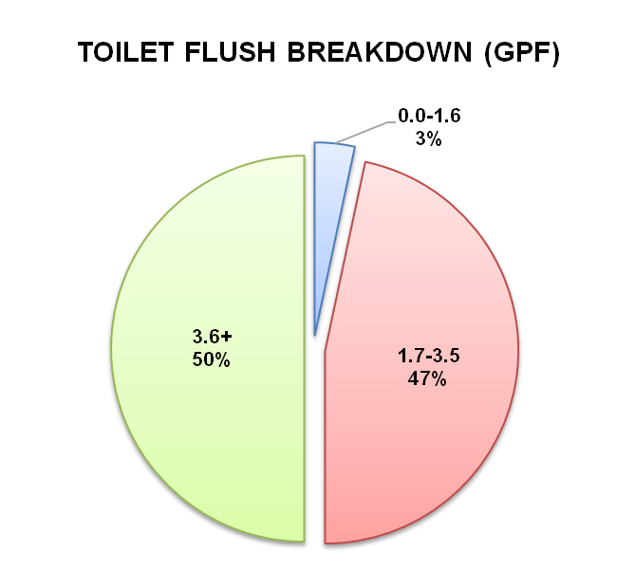

Figure 9 | Toilet flush breakdown in gpf based on in-situ testing of a sample of 31 toilets across campus; pie chart breaks represent the current public restroom efficiency standard (1.6 GPF) and the previous efficiency standard (3.5 GPF).

Apart from numeric audit results, discussions with regular restroom users, as well as Facilities Management staff, paint a more complete picture of UCSB water use efficiency challenges. For example, waterless urinals have been installed in some older buildings. The plumbing in these older buildings is susceptible to line blockage, and facilities staff ran into problems with urea buildup in piping junctions because there was insufficient water to usher the liquid waste through the system in place. From user perspectives, feedback also indicated that toilets governed by automatic sensors were hypersensitive and flushed more than required.
Since the original restroom audit in 2012, there have not been significant changes to restroom fixtures, due to the aforementioned challenges with old plumbing infrastructures. An audit is planned for winter and spring quarter of 2018 to evaluate where the campus currently stands with restroom fixture conversation efforts, and to develop a methodology that improves efficiency efforts in this area but does not compromise the usability of our plumbing infrastructure.
UCSB has close to 750 laboratory spaces in over 40 buildings on campus however, lab water use is often overlooked when it comes to conservation efforts. Sensitive research experiments at UCSB demand precise levels of sanitation, cooling, and heating, these specific requirements make water conservation in labs difficult. For instance, many departments require water filtered by reverse osmosis (RO) to reduce potential interference with ion-sensitive experimentation. Since the reverse osmosis process inherently produces both a product and reject stream of water, a building’s RO process can potentially dump thousands of gallons of reject water per month.
LabRATS, an on-campus group that promotes sustainable lab practices, has sought to balance conservation efforts and the needs of researchers to maximize water savings, communication, good lab management practices, and high quality experimental results. LabRATS has achieved marked success in reducing lab water use, primarily through equipment replacement, low-cost adaptations to existing equipment, equipment maintenance checks, and education and outreach. In the past several years, LabRATS has been immensely successful in helping eliminate once through or single-pass cooling system for soft-plumbed systems using flexible tubing and quick connect fittings for short term research settings. While this has always been a goal of LabRATS, a flood in 2014 where a water supply tube to a single-pass, soft-plumbed system came undone and water ran approximately 1-2 gpm for between 6-10 hours, causing $2.2M in damage to custom built research equipment, a loss in over 200 hours of staff time, and a pause in research for over four months, helped to bring this conservation strategy to the forefront in the laboratory setting. With the help of LabRATS, the campus responded to this incident with a ban of such systems in the California NanoSystems Institute (CNSI) building, and received grant funding to replace closed-loop or waterless cooling systems from TGIF, the Be Smart About Safety Program at UCSB, and Goleta Water District. Past successes also include replacing water tube aerator vacuums with small electronic vacuums, ensuring that autoclaves and washers are functioning properly; and posting signage on efficient and effective rinsing techniques. For example, LabRATS demonstrated that beakers rinsed three times for 30 seconds used significantly less water than beakers left under a running faucet for 10 minutes and were significantly cleaner. Another example of ongoing water saving efforts in lab settings, is the cooling loop in the Ocean Science Education Building (OSEB), which is cooled using pass-through water from the ocean rather than using potable water.
The culmination of all such efforts to reduce water consumption in academic, research, and other non-residential buildings has yielded substantial water savings. Reductions can be attributed to restroom water efficiency retrofits, infrastructure changes (see “Industrial Water Uses”), use of recycled water instead of potable water for irrigation, and irrigation efficiency improvements (see “Landscape & Irrigation”). Although significant reductions have been achieved, restroom audits and in-situ testing reveal gaps in conservation efforts and draw attention to potential future efficiency improvements in these buildings.

Housing & Residential Services
H&RS buildings include four dining commons, 16 residential halls and two? campus-owned student apartment complexes, accounting for roughly 45% of potable water use on campus. Similar to efficiency measures taken in the academic, research, and other non-residential buildings, H&RS implemented serious efficiency and conservation measures in the late 1980s in response to a severe drought. Some of the actions taken to save potable water are as follows.
In 1998, the Ortega Dining Commons installed a Salvajor washing system that filters water and reuses it for the entire shift. The system reduced the building’s potable water use by almost 40%. Water efficient dishwashing machines were also installed in the Carrillo Dining Commons in 2001 and in De La Guerra in 2004, and in 2003, H&RS adopted a policy to only purchase Energy Star and water efficient appliances. Apart from the dining commons, Corona Dual Flush Toilets were installed in part of Santa Ynez Apartments in 2002.
The use of recycled water for irrigation of residential lawns has also resulted in potable water savings. Since 2004/05, H&RS has saved roughly 148.6 million gallon of potable water by using recycled water for irrigation. In 2004, recycled water lines were extended for irrigation at the resident halls of Santa Cruz, Anacapa, part of Santa Rosa, and De la Guerra. In addition to extending the lines, the whole piping system was fixed, which reduced water loss due to leaks in the system. Recycled water for irrigation was also brought to San Nicolas and San Miguel resident halls in 2007. Along with potable water savings from efficiency measures and recycled water use in 2009, all of the Dining Commons went tray-less, which resulted in additional savings estimated to be 1 Mgal/yr per year.
Recycled water has recently been utilized as make-up water for toilets in the six-story Tenaya Towers at UCSB’s San Joaquin Villages. UCSB worked with Goleta Water District on an extensive planning and permitting process that involved several external agencies. The project is estimated to save over 600,000 gallons of potable water use each year.
H&RS began retrofitting bathrooms in the late 1980s. As technology has improved, H&RS has increased their standards for aerators, low flow toilets, and showerheads. Table 8 lists the current fixture standards for all building retrofits within H&RS. Until more efficient restroom fixtures are introduced to the market and proven effective for institutional use, H&RS purchasing standards will align with the following fixture efficiency standards.
Table 8 | H&RS current fixture standards
Fixture | Brand | Water Use
Faucets | Chicago | 0.5 gpm
Showerheads | Niagara Pismire | 1.5 gpm
Toilets | Corona Caravelle | Dual Flush Tank (1.6/0.8 gal)
Urinals | Falcon, Sloan | Waterless
To get an estimate of the actual water use of the current suite of replacement fixtures, a random sample inventory was taken in 2012 of bathrooms in each residential hall and a portion of the student apartment buildings. Faucet flow rates were manually measured in each bathroom, and showerhead flow rates and toilet brands were recorded. Based on the sample, an estimated 90% of all faucets had 0.5 gpm aerators, 53% of the bathrooms had dual flush toilets, and 57% of the showerheads were rated at 1.5 gpm. Decreasing water use by faucets, showerheads, and toilets below the US required standards has saved an estimated 32.25 million gallons of potable water annually within H&RS buildings (Table 9).
Table 9 | Estimated potable water reductions for H&RS bathroom retrofits
Fixture Replacement | Annual potable water savings | Annual $ 2012 saved from potable water reductions
90% 0.5 gpm faucet aerators | 3.3 million gallons | $16,300
43% Duel flush toilets | 2.95 million gallons | $14,650
57% 1.5 flow showerheads | 8.2 million gallons | $42,800
Total Savings | 32.25 million gallons | $159,900
H&RS has also taken several steps to educate its residents on the importance of water conservation. Some examples include the installation of shower timers in all the residential halls, along with informational signs encouraging short showers. Other, larger programs include the Green Campus Interns, who have hosted energy and water efficiency competitions since the 2011-12 academic year between the eight on-campus residential halls. This competition educated residents about the importance of conserving energy and water, leading to a decrease in consumption of both during the competition. Over the three-week competition, it is estimated that approximately 90,000 gallons of potable water are saved from the competition baseline each year. While the competition was highly successful in getting students to reduce energy and water consumption, their usage later increased to above pre-competition levels. Sustaining these low consumption rates is a goal of H&RS staff.

Landscape & Irrigation
Currently, irrigation accounts for about 3% of total Campus potable water use. UCSB has been proactive in implementing potable water conservation practices in this sector and has made great strides in switching from irrigating with potable to reclaimed water. In addition to utilizing smart irrigation and xeriscaping practices, UCSB has made switching to recycled water for irrigation a campus-wide priority. Both Facilities Management (FM) and H&RS have incorporated water conservation practices and techniques into their daily operations.

Recycled Water Use
In 1994, the University first utilized recycled water for irrigation purposes. It is estimated that 60% of the Campus was irrigated with recycled water when the system was installed in 1994. Various recycled water line extension projects over the years have increased the use of recycled water for irrigation at UCSB (Table 10).
Table 10 | Recycled water extension timeline
Date | Recycled Water Extension Projects | Percentage of Campus Irrigated with Recycled Water
1994 | Santa Ynez Recycled Water Line | 60%
1994 | Rob Field Recycled Water Pump | 60%
1995 | Goleta Water District Recycled Mainline | 60%
1995 | UCSB Recycled Water Line | 60%
2001 | San Rafael Recycled Water Line | 66%
2002 | West Campus Recycled Extension | 72%
2006 | Academic Green Recycled | 78%
2007 | Recycled Housing Phase I | 84%
2007 | Recycled Housing Phase II | 84%
2008 | San Miguel Recycled Water Continuation | 90%
2015 | Psychology | 90%
2016 | HSSB/ Events | 90%

90% of the total water used for irrigation on-campus is recycled water. The remaining 10% of all water used for irrigation on Campus is potable, accounting for 3% of total Campus potable water use. From FY 1994 to 2011-12 the recycled water infrastructure has saved approximately 1.16 million gallons of potable water (Figure 10).
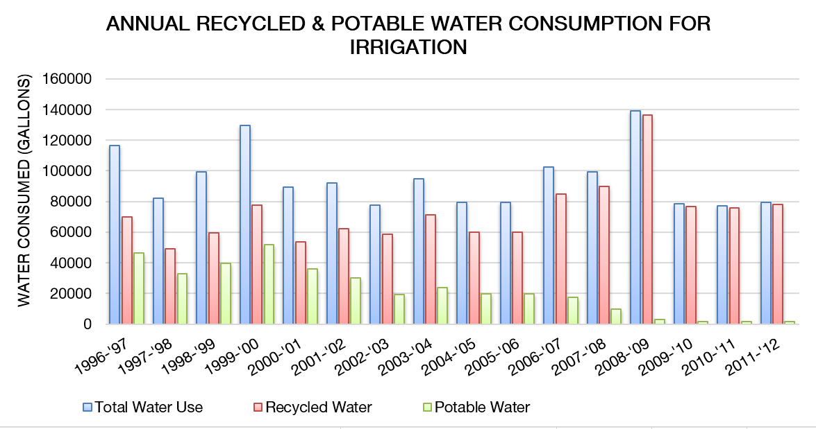
Figure 10| Annual recycled and potable water consumption for irrigation.

Smart Irrigation Practices
In conjunction with the use of recycled water on-campus, UCSB practices smart irrigation techniques, specifically, the use of weather-based irrigation controllers, using matched precipitation (MP) Rotators® and drip tubing irrigation where appropriate. Weather-based irrigation controllers are used throughout the Campus to establish water schedules that reflect on-site weather conditions and soil moisture. These particular irrigation controllers ensure that the landscapes at UCSB receive optimal levels of irrigation. UCSB has a central Rain Master Oasis weather-based irrigation system that controls 60% of Campus irrigation.
MP Rotators® were installed on UCSB’s West Campus in the spring of 2012. MP Rotators® deliver a multi-trajectory rotating stream of water rather than a uniform spray of water like traditional sprinkler heads. The MP Rotators’® ability to deliver water at a slower speed allows time for more water to percolate into the soil. MP Rotators® can conserve 30% more water than traditional sprinkler heads and significantly reduce the amount of runoff during irrigation. TGIF issued a grant in support of retrofitting outdated sprinkler heads with MP Rotator® replacements. A total of 577 sprinkler heads were replaced, which represents two-thirds of the total number of heads in operation at West Campus. H&RS staff estimates that the retrofit will conserve approximately one-third of the water that the traditional pop-up nozzles used at West Campus.
In addition to MP rotator® heads, drip tubing irrigation is used on five-acres of the UCSB campus. Drip tubing irrigation can be one of the most efficient irrigation methods if properly maintained because it delivers water to the plant root zone, eliminating runoff and unnecessary evaporation. However, the higher level of required maintenance and the inability to irrigate broad swaths of grasses limit the practical applications of drip irrigation on the UCSB campus.
UCSB also converted Rob Field, a multi-sport outdoor athletic field, from sod to artificial turf in 2002. This transformation to artificial turf eliminated all irrigation at Rob Field, roughly 80,000 ft². With irrigation practices for sod normally specifying an average of 1 inch of water per week, the water savings from this artificial turf installation are estimated at 2.6 million gal/yr.

Xeriscaping
UCSB has prioritized the use of native and drought-tolerant plant species on-campus to limit vegetative water consumption. The Chancellor’s Sustainability Subcommittee on Landscape & Biotic Environment, composed of university staff and faculty and local landscape specialists, chooses plant species that are appropriate for the UCSB environment. Plant species are primarily chosen based upon maintainability, survivability, and longevity.

Researching the Impacts of Recycled Water Use on Campus Vegetation
Since 2014 Facilities Management has partnered with the King Lab, a soil science research lab on-campus to better understand constituent buildup in soils due to recycled water quality and the soil characteristics on-campus. This practice was recommended as part of the 2013 Water Action Plan in an effort to better understand the potential negative impacts on soil and plant health irrigated with recycled water due to salinity and other constituent accumulation. Soil samples have been collected at strategic locations across the campus that range from areas with clay to loam soil conditions, and landscapes that have recently been converted to recycled water, to those that have been irrigated with this water source since it was introduced to the campus. Initial research focused on conducting soil sampling from depths of 6 inches to 32 inches at different times throughout the year to determine if there were seasonal changes in the rate of constituent build-up (i.e. after a rainfall event vs. during a time of little to no precipitation), focusing on electrical conductivity (EC) and sodium absorbtion rate (SAR). The data from this research suggested that 1) increased EC and SAR are long-term effects from the usage of recycled water; 2) salinity can have a deleterious effect on the ability of soil to support plant life; 3) salinity can build up during the dry season, however, the trend in salinity concentrations at particular sites can be due to the build-up of salinity over time from irrigation practices. Subsequent research involved the purchase of a handheld electrical conductivity meter to help monitor EC levels in the soil. In combination with this tool, mapping projects were undertaken using geographic information systems to help display trends. Although these efforts have no direct potable water savings, they have helped our campus better understand the long-term implications of irrigating with recycled water, and have helped provide valuable information to the staff and departments that oversee the campus landscape and biotic environment in regards to plant species selection. With this information, the Campus can avoid having to re-plunt landscapes with plant species that cannot tolerate recycled water. This research is planned to continue.

Industrial Water Uses
Water use in industrial applications at UCSB, falls into several categories: cooling tower make-up water, boiler feed water, reverse osmosis system feed water, and lubrication water for equipment such as vacuum pumps, which supply vacuums to laboratory buildings on campus. RO and lubrication uses constitute a small amount of the consumptive water use on Campus, with the majority of industrial water being used in cooling towers and boilers. Collectively, industrial applications account for approximately 11% of potable water use on Campus. The following sections will, therefore, specifically address the University’s history of water use and efficiency in these areas.
Cooling tower water use and associated evaporative losses constitute one of the highest industrial consumptive water uses on the UCSB campus. Before 1999/00, the Campus chilled water infrastructure was building-specific, meaning that buildings had their own cooling towers, chillers, pumps, and electric control equipment. This decentralized configuration is inefficient for three primary reasons: 1) multiple buildings incur the water losses associated with individual cooling towers; 2) all cooling towers must remain in operation simultaneously, whereas if the systems were connected, only a few running cooling towers would be needed on average to supply the cooling needs of the whole campus; and 3) each individual building has to replenish evaporated water (“makeup water”) to their cooling towers. Decentralized cooling systems exacerbate the fundamental water issues that all cooling towers face: water losses due to evaporation and drift (fine droplets entrained in the air stream from the draught fans), concentration of impurities in water, and the concomitant need of makeup water to maintain performance. The result of the decentralized approach is, thus, not only more water consumption but also more energy use.
Given the numerous drawbacks of having decentralized cooling towers on multiple buildings, the Campus decided to address them by installing a chilled water loop starting in 1999-2000 on the east side of campus, connecting Davidson Library, Biology II, Engineering I, Brioda Hall, Physical Science Building (PSB) North, and Chemistry. At that stage, there were five main cooling towers on campus supplying chilled water to the loop. However, the chilled water loop enabled the advantage of only having to turn on as many cooling towers as needed to meet the thermal load of all the buildings connected to the loop. Other buildings added later to the chilled water loop include: Bren Hall (2001), Psychology (2002), Engineering Science (2003), Music (2003), Elings Hall (2003), Marine Science Resource Building (MSRB) (2004), Kohn Hall (2005), PSB South (2005), Psychology Addition (2007), Nobel Hall (2007), MRL (2016), and BioEngineering (2017). The chilled water loop also expands to the west side of the campus and connects Student Affairs & Administrative Services Building (SAASB) (2008), Education & Social Science Building (ESSB) (2010), and North Hall (2011). A separate west campus chilled water loop was also connected to Humanities & Social Science Building (HSSB) and Sindecor/Theater-Dance in 2004. The western chilled water loop was later connected to the Student Resource Building (SRB) in 2005 and/Theater-Dance expansions in 2006. In 2010, the east and west chilled water loops were joined with an additional connection to the Event Center (Thunderdome). After the buildout of the chilled water loop, there are now 12 cooling towers operating on campus. In addition to the five original cooling towers on the loop mentioned above, cooling towers were added to Bren Hall, Engineering Science, Elings Hall, and BioEngineering.
The current chilled water loop serves to meet the cooling requirements for a large portion of campus and leverages a network of cooling towers and chillers. Infrastructure in this network can be turned on one by one to meet increasing campus demands for chilled water during times of peak demand, building expansion, and campus growth. Expansion of the chilled water loop has resulted in a 10% savings of industrial water use. Using the 2010/11 cooling tower water usage (31.8 million gallons) as a baseline and factoring in this savings percentage, the chilled water loop has saved the campus about 3.5 million gallons per year, which constitutes a little over 1% of the baseline water use.
Main Campus Chilled Water Loop Connections by Date
Year Connected to Loop | Building Number | Building Name | Cooling Tower
2001 | 503 | Engineering II | No
2001 | 521 | Bren School of Environmental Science | Yes
2001 | 525 | Davidson Library | Yes
2001 | 551 | Psychology | No
2001 | 556 | Harold Frank Hall (Engineering I) | Yes
2001 | 557 | Chemistry | Yes
2001 | 657 | Physical Science Building North | No
2002 | 531 | Music and Lotte Lehman Concert Hall | No
2002 | 572 | Broida Hall | Yes
2003 | 225 | Engineering Science Building | Yes
2005 | 520 | Marine Science Research Building | No
2005 | 571 | Biological Sciences II | Yes
2006 | 266 | Elings Hall | Yes
2006 | 568 | Student Affairs and Administration Services Building | No
2007 | 515 | Humanities and Social Science Building | No
2009 | 276 | Social Sciences and Media Studies | No
2010 | 505 | Event Center | Yes
2011 | 554 | Theater and Dance East | Yes
2012 | 535 | North Hall | No
2016 | 615 | Material Research Laboratory (MRL) | No
2017 | 512 | BioEngineering | Yes

STRATEGIES & GOALS FOR ACHIEVING

POTABLE WATER REDUCTIONS
Our campus has financial, contractual, and policy incentives to achieve the following set of efficiency and conservation goals. Firstly, many capital investments required for increased water efficiency (e.g., restroom retrofits) would pay for themselves within a two to four year period, with continued savings thereafter. Secondly, the decrease in effluent leaving campus as a result of decreased water use will reduce energy costs required to pump the sewage effluent from Campus to the Goleta Sanitary District (GSD). Additionally, UCSB is contractually restricted in its water use and sewage discharge. Goleta Water District (GWD) caps the water available to the University at almost 308 Mgal/yr (411,600 HCF/yr), and the University can account for no more than 7.09% of the effluent that GSD receives. Therefore, decreasing consumption will help the University to stay within its maximum allotted water supply and maximum allotted sewer effluent, despite planned, continued campus growth. Finally, we have historically been a leader in achieving real water use reductions; to maintain its institutional standing in the field of water conservation, UCSB has expressed its intention to meet or exceed current efficiency expectations and keep pace with other institutional leaders in the field of water conservation.
The goals below include payback periods, based on financial calculations that assume 1) a 5% annual discount rate; and 2) a 15% project contingency value.

Academic, Research, & Other Non-Residential Buildings
The following goals target restroom fixture water efficiency and are based on available water use data, as well as 2012 restroom audit of all Campus academic, research, and other non-residential buildings. This sector will continue to be a major focus of our water-conservation efforts.

Goals:
  - Replace existing single pass cooling systems and constant flow sterilizers and autoclaves in laboratories
Once through or single pass cooling systems shall not be allowed for soft-plumbed systems using flexible tubing and quick connect fittings for short-term research settings in accordance with the UC Sustainable Practices Policy. Simple recirculating baths, recirculating baths with plumbed heat exchangers, or the Radley’s Findenser condenser are suitable alternatives (Table 11).
Table 11 | Alternative cooling system options and suitability
Alternative Cooling systems | Cost ($2017) | Flow Rate | Installation Details | Suitability
Simple Recirculating Bath | $50 - $160 | up to 1 GPM | No installation required | Gas condensing
Recirculating Bath w/ Plumbed Heat Exchanger | $2,370 (not including plumbing labor) | 0.5 GPM | Connected to building chilled water loop | Most applications
Radley’s Findenser | $350 | Uses no water | No installation required | 95% of chemistry applications
Estimated savings from replacing single-pass cooling condensers with closed-loop systems or systems that do not utilize water is extremely variable and dependent upon the duration of the experiment it is being utilized for, and the incoming flow rate. The following water savings matrix estimates the potential potable water savings assuming that there are 200 users on the campus, and the single-pass condensers are utilized 50 weeks per year (Table 12). It is difficult to determine the exact payback on for this strategy because each lab may request a different type of alternate cooling system.
Table 12 | Single-pass cooling water consumption matrix
Usage Rate: | 0.25 GPM | 0.5 GPM | 1 GPM | 2 GPM
16 hrs/ week | 2,400,000 Gal | 4,800,000 Gal | 9,600,000 Gal | 19,200,000 GPM
48 hrs/ week | 7,200,000 Gal | 14,400,000 Gal | 28,800,000 Gal | 57,600,000 GPM
60 hrs/ week | 9,000,000 Gal | 18,000,000 Gal | 36,000,000 Gal | 72,000,000 Gal
72 hrs/ week | 10,800,000 Gal | 21,600,000 Gal | 43,200,000 Gal | 86,400,000 Gal

  - Repair pool at the old gym on-campus
- Determine source of water leak from the pool
- Evaluate options to repair pool and determine cost effectiveness
It is believed that the pool at the Old Gym at UCSB experiences water loss due to a leak in the pool. The exact source of water loss has yet to be determined, but in 2015, a one week audit, when the pool was not in use, was conducted to determine water loss. The pool covers were placed on the pool for the week, and water level was measured at the start and end of the audit period. The pool dropped 1.25 inches in that time period (Table 13).
Table 13 | Estimated water loss from Old Gym pool leak
Amount lost during audit (gal) | Esimated Daily Loss (gal) | Estimated annual water loss (gal) | Annual water loss cost from
13,560 | 1,940 | 706,950 | $7,806

  - Implement and prioritize aerator retrofits:
- Replace aerators (where applicable) with flow rates above 0.5 gpm with tamperproof 0.5 gpm aerators. Recycle old stocks of aerators.
- Reference the 2013 Water Action Plan (WAP) restroom audit to target highest flowing faucets for first retrofits.
The current average faucet flow rate across campus, based on in-situ testing of all bathroom faucets, is 2.0 gpm. If we could fully implement aerator retrofits to the 0.5 gpm standard, our water savings would be on the order of 2.6 Mgal/yr with cost savings of approximately $31,044 annually. As a caveat, some specific faucet types, like push-type faucets, may not be compatible with 0.5 gpm aerators because the design requires higher flows, but these faucet types are few in number at UCSB. Ultra-low-flow aerators with flow rates less than 0.5 gpm exist but are discouraged by custodial staff, whose cleaning efforts are undermined by the extra low-flow that does not provide water fast enough to streamline their cleaning practices; therefore, it is advised that retrofits adhere to the current public restroom efficiency standard of 0.5 gpm when applicable. The cost of a retrofit to replace all aerators with flows greater than 0.5 gpm and install aerators on un-aerated sinks (840 aerators altogether) is approximately $9,000, including tamperproof aerators and labor costs. Although tamperproof aerators are more expensive than regular aerators and place the retrofit at the higher end of the cost spectrum, they would also extend the lifespan and, therefore, the cost-effectiveness of the initial aerator investment. Almost 40% of faucets in academic, research, and other non-residential buildings do not presently have aerators, but at one time, all of the faucets on the UCSB Campus had aerators. Aerator removals via theft or maintenance operations are the only viable explanations for the absence of aerators. Therefore, investing in tamperproof aerators would guard against unexpected losses in faucet efficiency. The retrofit investment would pay itself off within one year (Table 14).
Table 14 | Aerator retrofits costs including installation costs
Aerator Retrofits | Annual potable water savings (gal) | Annual water cost savings ($ 2012) | Payback Period  (approx. cost $2017)
0.5 gpm | 2.8 million | $31,044 | <1 year ($9,000)
  - Implement and prioritize toilet retrofits:
- Replace toilet valves that exceed 1.6 gpf with a High Efficiency Toilet (HET) valve (1.28 gpf) (note: most toilet valves indicated as 1.6 gpf exceeded 1.6 gpf)
- Consult with the Facilities Management (FM) Lead Plumber and Utilities Manager to select an ergonomic dual-flush retrofit toilet valve kit. Brand options include Kohler, Sloan, Zurn, etc.
- Implement new purchasing standards for facilities, making 1.28 gpf a ‘ceiling’ for toilet valve flush rates
- Recycle old stocks of toilet valves and diaphragms
- Reference the WAP restroom audit to target highest flowing toilets for first retrofits
- Perform in-situ testing on dual-flush valves after installation to ensure proper function
- Employ preventative maintenance when retrofitting old, inefficient restrooms with high-efficiency toilets (HET’s)
- Study building plumbing to avoid installation of HET’s along low-sloping horizontal lines where there is exceptionally high waste discharge (e.g., highly trafficked buildings)
- Consider installing higher volume flow toilets farther from the sewer on the drainline to provide additional flow for the transport of solids
- Consider installing automatic flush valves on HET’s or urinals at the end of a horizontal drainline to add extra periodic flows to flush the lines
- Change the toilet paper to a low-flow friendly variety
- Design new buildings to accommodate the high efficiency toilet effluent flow without frequent maintenance, considering building traffic, pipe width, pipe slope, etc.
- Do not use sensor-flush toilets in new buildings, as they save no water
- Pilot lower flush toilets as they enter the market to test for potential maintenance issues; if pilot toilet projects do not pose significant plumbing challenges, adjust purchasing standards appropriately
The average flush rate for on-campus academic, research, and other non-residential buildings, based on the in-situ testing and subsequent extrapolation of a sample of 31 toilets, is 3.7 gallons per flush (gpf). Flush rates for the primarily Sloan brand toilets ranged from 1.6 to 5.25 gpf, with one outlier toilet flushing at about 9 gpf. Flushes were consistently higher than manufacturer’s specifications. These high flows can be attributed to corrosion or wear-down of fixtures over time (e.g., old, leaky toilet diaphragms allow more water to flow than new diaphragms), poor initial installation (e.g., if dual flush valves are not installed correctly, there will be no variability between flush options), and/or malfunctioning fixtures that do not perform at the advertised efficiency standards. Estimated water savings for a full toilet retrofit to a conservative 1.6 gpf standard are approximated to be 18.7 Mgal/yr, with water cost savings of approximately $206,580/yr. Replacing all the toilet valves on campus with a HET retrofit toilet valve kit (1.28 gpf) would cost approximately $90,000, including installation costs; the payback for toilet retrofits is, therefore, less than a year (Table 15). A full toilet retrofit alone is estimated to reduce annual potable water use for the whole university by approximately 8%. Thus, if thoughtfully implemented, considering plumbing implications and verifying flow rates post-installation, toilet retrofits can provide significant and cost-effective water savings opportunities.
Table 15 | Toilet retrofits costs including installation costs
Scenario | Annual Potable Use (gal) | Annual potable water savings (gal) | Annual water cost savings  ($ 2017) | Payback Period  (approx. cost $2017)
Status Quo | 33.2 million | -- | -- | --
Full Campus Retrofit | 14.5 million | 18.7 million | $206,580 | <1 year ($90,000)
  - Implement and prioritize urinal retrofits:
- Replace urinal valves that exceed 0.5 gpf with low-flow (0.125 gpf); Implement new purchasing standards for facilities, making 0.125 gpf a ‘ceiling’ for toilet valve flush rates. Recycle old stocks of urinal valves and diaphragms
- Reference the WAP restroom audit to target the highest flowing urinals for first retrofits
- Monitor plumbing where waterless urinals are in place to test for potential maintenance issues; if existing waterless urinals do not pose significant plumbing challenges, such as detrimental salt build ups in plumbing lines, reevaluate facilities’ purchasing standards to consider using water-free urinals where plumbing lines have sufficient drainage capacity
Urinals are a peripheral focus of the WAP and are not easily tested on-site for flow rates; therefore, the above goals come with a note of warning. The University should switch to low flow, 0.125 gpf, urinals, which are a suitable alternative to water-free urinals, as maintenance difficulties of water-free urinals outweigh water savings. A best estimate suggests that a retrofit of all urinals that exceed 0.125 gpf (251 urinals) would yield annual water savings on the order of 6.7 million gallons and associated water cost savings of $74,270. Consultation with the Facilities Management Lead Plumber for advice on urinal retrofit choice and feasibility is strongly encouraged to appropriately place and best understand the maintenance implications of high-efficiency urinals.
Table 16 | Urinal retrofit costs, including installation costs
Retrofit Scenario | Annual Potable Use (gal) | Annual potable water savings (gal) | Annual water cost savings  ($ 2012) | Payback Period  (approx. cost $2012)
Status Quo | 7 million | -- | -- | --
0.125 gpf | 866,500 | 6.7 million | $74,270 | 3 years ($216,500)

Housing, Dining & Auxiliary Enterprises (HDAE)
The following goals target restroom fixture water-efficiency for Housing, Dining & Auxiliary Enterprises (HDAE). With student population growth projected at 1% per year and a campus goal of housing all new students on campus, H&RS will need to further reduce average potable water use per resident in order to keep total potable water use down.
The majority of water used within HDAE can be broken down into three sections: irrigation, dining commons, and restrooms. The following goals target dining commons and restrooms. Irrigation goals can be found in the “Landscape & Irrigation” section.

Goals:
- Restroom Retrofits
Restrooms represent a significant portion of water use in a residential setting, and, as with academic buildings (see previous section), are a natural target for water reductions within H&RS. Toilets, showers, and faucets represent three out of four of the greatest indoor water users (Figure 11). The main way to reduce water use within bathrooms is to improve the efficiency of these fixtures (see “Administrative Action” section below for behavioral goals). To get an estimate of the actual water use of the current suite of replacement fixtures, a random sample was taken of bathrooms in each residential hall and a portion of the student apartment buildings. Findings suggest that over 10 million gallons of water can be saved annually by continuing to retrofit bathrooms with high-efficiency fixtures.
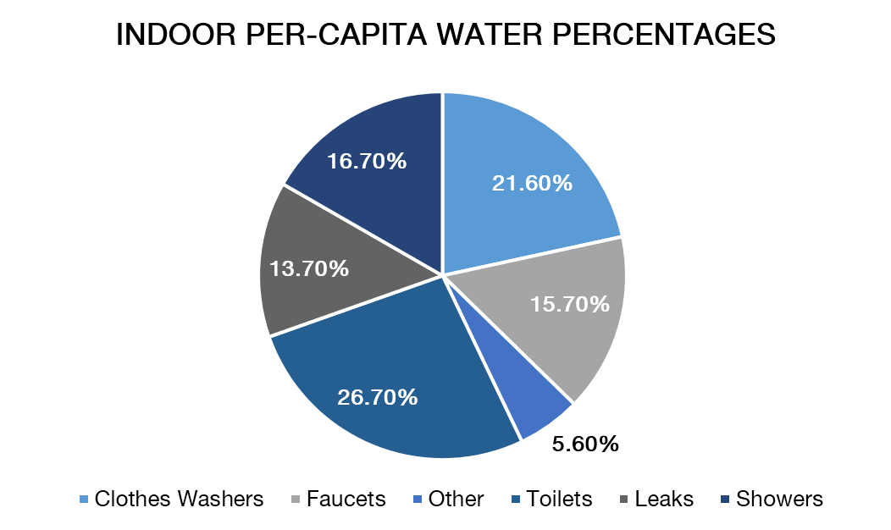
Figure 11 | Indoor per capita water percentages.
  - Implement and prioritize shower retrofits:
- Replace all showerheads that exceed 1.5 gpm with high-efficiency showerheads
- Perform in-situ testing on showerheads to ensure proper functionality
- Develop a pilot project to see if adjustable shower heads would be used appropriately
Showers are the second-largest water user within bathrooms, however, water use can be greatly reduced by switching from 2.5 gallons per minute (gpm) showerheads to 1.5 gpm showerheads, which saves a gallon of potable water per minute and around 8 gallons for a typical-length shower. While the majority of showers within HDAE have already been switched to 1.5 gpm, the residential hall inventory suggests that there are still 43% of showers with a manufacturer’s flow rate of 2.5 gpm. Switching the remaining 43% of showerheads from 2.5 gpm to 1.5 gpm would save an estimated 8.1 million gal/yr (Table 17).
Table 17 | Shower retrofit costs, including installation
Scenario | Annual potable water savings (gal) | Annual water cost savings ($ 2012) | Payback Period  (approx. cost $2012)
Switching the remaining 43% standard 2.5 gpm to 1.5 gpm | 8.1 million | $89,980 | <1 year ($28,00)
Switching remaining 2.5 gpm showerhead to adjustable flow | 12.2 million | $134,970 | <1 year ($50,600)
HDAE already has plans to make the aforementioned retrofits, but shower water use could be reduced even further. Significantly more efficient technology is currently available. For example, Niagara Pismire, a company from which HDAE currently purchases 1.5 gpm showerheads, also makes a showerhead called the Tri-Max with adjustable flow rates. The Tri-Max allows the user to change the flow rate while showering. Students could use an ultra-low-flow 0.5 gpm setting while soaping, shaving, or shampooing, and then switch to 1.0 or 1.5 gpm for rinsing.
A pilot project should be implemented to test the effectiveness of using adjustable showerheads. The project should be combined with education and outreach so that students not only know that they can adjust the flow of their showerhead but that they are also aware of the importance of conserving water. If the pilot study determines that students do in fact switch to 1.0 gpm and 0.5 gpm while soaping, shaving, or shampooing, retrofitting showerheads across campus with adjustable flow rates, would be cost-effective.
  - Implement and prioritize toilet retrofits:
- Replace toilet valves that exceed 1.6 gpf with high efficiency 1.28 gpf toilets
- Consult with Plumbing Supervisor and Utilities Manager to select an ergonomic dual-flush retrofit toilet valve kit. Brand options include Kohler, Sloan, Zurn, etc.
- Perform in-situ testing on dual-flush valves after installation to ensure proper functionality
- Employ preventative maintenance when retrofitting old, inefficient restrooms with HETs
H&RS should continue to install high-efficiency toilets with a focus on 1.28 HETs rather than dual-flush in an effort to eliminate the human error probability associated with dual-flush toilets. Considering HETs at 1.28 gpf, at minimum, are 20% more efficient than the required 1.6 gpf U.S. standard. Currently, only about 57% of toilets within H&RS have dual flush valves. Reaching 100% HET toilets within HDAE could save 2.9 Mgal/yr.
This estimate is conservative because it assumes that all toilets within student housing are either dual flush or the standard 1.6 gpf. If there are still 3.5 gpf toilets in student residences that have not been retrofitted since 1996 when the 1.6 gpf standard was adopted, then the savings potential could be much higher. (Table 18).
Table 18 | Toilet retrofit costs including installation costs
Scenario | Annual Potable Use (gal) | Annual potable water savings (gal) | Annual water cost savings  ($ 2017) | Payback Period  (approx. cost $2017)
Status Quo  (57% Flowing AT 1.6 GPM) | 23.5 million | -- | -- | --
Full Campus Retrofit | 20.6 million | 2.9 million | $32,440 | < 3 years ($80,126)
Status Quo  (57% flowing at 3.5 gpm) | 41 million | -- | -- | --
Full Campus Retrofit | 20.6 million | 20.4 million | $ 225,000 | < 1 years ($80,126)
  - Implement and prioritize aerator retrofits:
- Replace all aerators with flow rates above 0.5 gpm with tamperproof 0.5 gpm aerators. Recycle old stocks of aerators.
- Reference the WAP restroom audit to target highest flowing H&RS buildings for first retrofits.
An estimated 10% of bathrooms in HDAE have aerators whose efficiency standards are higher than the current efficiency standard of 0.5 gpm. Although this is a low number, aerators are inexpensive to replace, and they can be one of the most cost-effective water conservation measures; for details, see “Academic, Research, & Other Non-Residential Buildings” above. If the remaining 10% of aerators were replaced with 0.5 gpm aerators, approximately 456,380 gallons of water would be saved each year (Table 19).
Table 19 | Aerator retrofit costs including installation costs
Aerator Retrofits | Annual potable water savings (gal) | Annual water cost savings ($ 2017) | Payback Period  (approx. cost $2017)
0.5 gpm | 456,380 | $5,039 | < 1 Year (1,200)

  - Connectionless/Boiler-less Food Steamers
Connectionless and boiler-less food steamer technology yields significant water use reductions in food service due to the elimination of condensate-cooling water. In a connectionless steamer, steam is generated using a reservoir at the bottom of the compartment, and water is added and drained manually at the beginning and end of the day, unlike conventional steamers, which connect to a water line and continually consume water.
  - Air-cooled Ice Machines
Air-cooled machines are the recommended option because they are more water efficient and energy efficient than water-cooled machines.

Landscape & Irrigation
Further potable water reductions in this sector are possible if we continue expanding our practices of smart irrigation techniques, increasing the quality and usage of recycled water, and emphasizing xeriscaping techniques. The following goals were made after analyzing water usage data, identifying potential water- and money-saving irrigation techniques and practices, and collaborating with landscaping specialists from the University.

Goals:
- Continue to evaluate landscape areas for potable water savings
Continuing to evaluate landscape areas for potable water savings, specifically under-used turf areas irrigated with potable water has the ability to further decrease potable water use in the landscape and irrigation sector. To determine these areas the following criteria was used: 1) turf/ lawnscape; 2) irrigated with potable water 3) low perimeter to area ratio 4) serves no functional value to the campus community (i.e. not used for recreation, tabling, congregating, etc.) In total, 71,101 ft² of under-used turf was identified based on the following parameters. Replacing these turf areas irrigated with potable water to landscapes with alternate vegetation, such as drought-tolerant plants shrubs has the potential to save the 1.3 Mgal based on both irrigation information from the California Irrigation Management Information System’s (CIMIS) recommended application rates of 1 in./week for turf and 0.25 in./ week for shrub areas, and areas where we know the defined quantity of water applied based on metering at the master valve level. UCSB has a very robust recycled water infrastructure and the primary strategy should be to convert the irrigation source from potable water to recycled water in these areas. If irrigation was converted from potable to recycled, it would then result in zero gallons of potable water utilized for these landscapes (see Goal 4 of this section).
Table 20 | Estimated water savings from replacing underutilized turf irrigated with potable water to alternate landscape
Underutilized Turf Irrigated with Potable Water (ft²) | Annual Potable Water Savings with Conversion to Alternate Vegetation (Gal) | Annual Cost due to Overwatering ($2017)
71,101 | 1,326,750 | $14,650
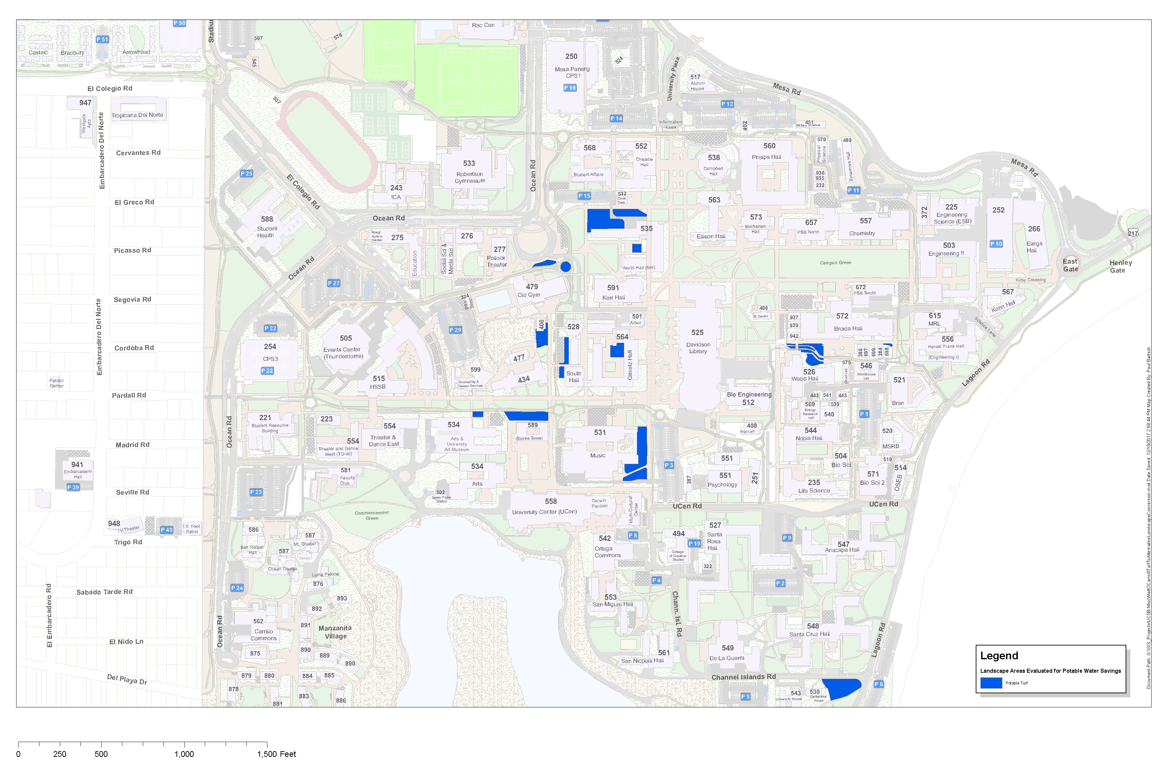
Figure 12 | Landscape areas evaluated for potable water savings

- Expand weather-based irrigation control system
To further reduce potable water use and ensure that optimal amounts of water are being applied to the University’s landscapes, UCSB should expand the weather-based irrigation system to include all of the University’s landscapes. Of the 45% (3,018,708 ft²) of landscape that is unincorporated under the weather-based irrigation system, 334,980 ft² are irrigated with potable water. The irrigation schedule for this landscape is manually controlled, and if irrigation schedules are left unmonitored, overwatering can occur. Through consultation with UCSB’s Facilities Management landscape and irrigation staff, it was determined that overwatering can amount to 0.5 inches/week. If the University were to expand the Rain Master Oasis system to include all landscapes, it could reduce unnecessary irrigation and reduce expenditures of potable water for irrigation (Table 21).

Table 21 | Water consumption and expenditures due to overwatering with potable water
Percentage of Landscape NOT Covered by Rain Master Oasis | Overwatering by 0.5 inches/ week (gal) | Annual Total due to Overwatering (Mgal) | Annual Cost due to Overwatering ($2017)
45% | 103,000 | 5.37 | $59,300
35% | 80,300 | 4.18 | $46,160
25% | 58,000 | 3.01 | $33,240
10% | 22,900 | 1.19 | $13,141
Weather-based irrigation control is not feasible everywhere because landscapes being included under the weather-based irrigation control system must have Internet access. Jon Cook, Facilities Management’s Associate Director of Landscape & Custodial Services, judges that economic feasibility limits the further expansion of weather-based irrigation control system by 25%. Much of the landscaping not presently covered by the weather-based irrigation system are in remote locations where Internet access via Ethernet connection is unavailable and for which expansion could be quite costly, depending on site-specific requirements. However, with potable water prices increasing yearly, expanding Internet access and Ethernet connections in order to include more landscapes irrigated with potable water may become economically viable.
  - Increase the Current Water Quality of Recycled Water for Commencement Green
High concentrations of sodium, chloride, and boron in recycled water can render soil sterile and damage landscapes. The recycled water UCSB currently receives suffers from this condition, which is a serious issue at Commencement Green. The landscape at Commencement Green is a low-lying, downward sloping lawn located at the southern-end of the UCSB Main Campus, adjacent to Campus Lagoon. The dynamics of the landscape and high water table level allow for the sodium, chloride, and boron in the recycled water to accumulate in the soil in high concentrations, particularly for the 51,829 ft² southern half of the lawn. Sodium and chloride are present in extremely high concentrations to depths of 36 inches. High concentrations of sodium can cause clay particles to plug soil pores, resulting in reduced soil permeability from what is termed soil dispersion. The combination of soil dispersion and a high water table essentially ensures that the concentrations of sodium, chloride, boron, and other nutrients continue to increase. Currently, the concentrations of these chemicals are high enough to be slowly sterilizing the soil, killing vegetation.
The University should install a reverse osmosis system on-site at Commencement Green to raise the water quality of the recycled water. This is the best treatment option for this landscape, as it would reduce constituent concentrations and is considered a permanent solution. AXEON Water Technologies provided a quote that would meet the needs of Commencement Green. The major components of the system include a 2,000 GPD reverse osmosis system, 5,000 gallon storage tank, and a 350 gpm repress pump. The financial breakdown of this goal is compared with temporary solutions that are also being considered in Table 22.
Table 22 | Commencement green treatment options
Treatment Option | Permanent or Temporary | Upfront Cost ($2017) at 5% | Recurring Cost ($2017) at 5%
Soil Replacement | Temporary | $470,980 | $1,550 (every 8 years)
Soil Medium | Temporary | $333,730 | $1,550 (every 4 years)
On-site Treatment System | Permanent | $16,490 | $400 (Every 2 Years)

The on-site R/O system for Commencement Green is a permanent solution that will solve the soil quality issues caused by the current quality of the recycled water. The achievement of this goal is significantly less expensive over the long term than the temporary solutions that are also being considered, and it also has smaller recurring costs. Installing a reverse osmosis system would also eliminate the prospect of switching back to irrigation with potable water in the area, an unsustainable and costly alternative with increasing potable water prices.
  - Expand the recycled water infrastructure
Expansion of the recycled water infrastructure allows UCSB to continue using recycled water as a means to augment potable water use. The use of recycled water for irrigation in FY 2016/17, alone has helped to save approximately 60 Mgal of potable water. 3% of the Campus’ total potable water is used for irrigation, and the practice of expanding the recycled water infrastructure remains a feasible and attractive water conservation strategy with utility infrastructure renewal projects and new construction on the campus already planned. Irrigation practices on the campus reflect both the California Irrigation Management Information System’s (CIMIS) recommended application rates of 1 in./week for turf and 0.25 in./ week for shrub areas, and areas where we know the defined quantity of water applied based on metering at the master valve level. Irrigating with recycled water for the remaining 10% of the Campus landscape that is irrigated with potable water would save approximately 7.2 Mgal of potable water annually. Table 23 displays landscapes that have the potential to and feasibility to be converted from potable to recycled water. The Chase Palm Park potable to recycled water conversion is anticipated to be complete in 2018.
Table 23| Potable to recycled irrigation conversion landscapes
Project Name | Turf (ft²) | Vegetation (ft²) | Upfront Project Cost ($ 2017) | Average Annual Potable Water Savings (Gal) | Pay Back Period (cost $ 2017)
Physical Science | 2,776 | 28,716 | $8,950 | 226,266 | 3.97
Ellison | - | 37,513 | $10,500 | 207,822 | 5.07
Music | 6,934 | 27,715 | $40,000 | 321,344 | 12.48
Girvetz | 17,540 | 41,762 | $1,550 | 655,829 | 0.24
Counseling & Career | - | 21,280 | $8,955 | 117,891 | 7.62
Arts | - | 23,056 | $12,850 | 127,730 | 10.09
UCen Lawn | 25,268 | - | - | 611,486 | -
Chase Palm Park | 61,624 | 51,794 | - | 1,778,240 | -
North/ South Hall | 105,573 | 99,415 | $150,000 | 3,105,626 | 4.84

  - Continue to conduct annual constituent soil samples
Annual and even quarterly soil samples should be collected from the campus to continue gaining a better understanding of the implications of irrigating with recycled water. The Campus should not only continue this practice, but also look to further compare the results of in-situ soil sampling vs. results yielded from the electrical conductivity (EC) meter to continue building the EC and SAR databases. Facilities Management should continue to partner with academic departments to help collect, analyze, and display the data. Further use of the EC meter will allow for a quicker collection and analyses of data compared to in-situ soil sampling. Facilities Management should also consider partnering with academic departments that focus on communication strategies to help effectively and efficient display this information. Facilities Management should also seek Master’s and PhD candidates to take on this research, as it would guarantee a long-term partnership.
In regards to water conservation, proactively identifying problem areas would also reveal areas for additional on-site water filtration systems. As previously mentioned, these systems would increase the quality of recycled water and eliminate the potential need for us to switch from recycled to potable water at a particular location.

Industrial Water Uses
The following actions target reductions in industrial water consumption on-campus, based on available water use data, the potential for significant water savings, and the future expansion of the Campus. Goals include increasing cooling tower cycles of concentration (increasing water reuse in the towers), calibrating and installing industrial use water meters, and conducting regular quarterly reviews to assess cooling tower and other industrial infrastructure performance. This sector accounts for approximately 11% of UCSB’s potable water use, based on cooling tower consumptive data provided for FY 2016/17. Other industrial infrastructure such as vacuum pumps, reverse osmosis systems, and boilers, may account for even more savings, but the magnitude of potential water conservation efforts in these operations are negligible compared to the gains that can be made by optimizing cooling tower operations. With this in mind, we should work to achieve the following goals:

Goals:
- Introduce recycled water as make-up water for cooling towers
Recycled water can be used as a means to augment potable water used as make-up water incooling tower infrastructure at UCSB. In 2015, UCSB worked with Goleta Water District to amend their recycled water use permit with the Water Resources Control Board to include the use of recycled water as an approved source for make-up water in cooling towers. Although each cooling tower presents an opportunity for such a project, the proximity to the recycled water infrastructure, cooling tower location, and frequency of cooling tower use, determine feasibility. It is possible that the total amount of potable water used as make-up water in the cooling tower infrastructure could be sourced from recycled water. However, the aforementioned factors in determining feasibility, in addition to the need to significantly improve the quality of recycled water before it can be used as make-up water makes some locations more cost effective than others. It is recommended that UCSB pilot the use of recycled water as make-up water in the BioII cooling tower as it is the most cost effective location, given its water demand.
The recycled water line will need to be introduced into BioII from Mesa Road through the basement. The campus will then need to utilize a water softening system to reduce the hardness of the recycled water. For the purpose of this project, it is suggested that the Campus utilize contracted water softening tanks from a vendor. Once softened, the recycled water lines should then be extended through the building’s pipe chases and up to the roof where the cooling tower is located. It is recommended that the University utilize a blend of 60% recycled water and 40% potable water, as it will ensure the project remains cost-effective, and utilizes the maximum amount of recycled water allowable without compromising the cooling tower infrastructure. Table 24 shows the project’s estimated costs and savings. The amount of potable water that could be saved annually from this project is 4.8 Mgal.
Table 24: Utilizing recycled water as make-up in BioII cooling tower
Location | Upfront Project Cost ($ 2017) | Average Annual Potable Water Savings (Gal) | Pay Back Period (cost $ 2017)
BioII | $115,400 | 4.8 Million | 7 Years

- Increase concentration cycles for cooling towers to reduce water consumption and increase operational efficiency:
  - Adjust the Johnson Controls computer automation system:
- Adjust make-up water and blowdown settings to achieve up to 7 cycles of concentration.
- Gradually step up cycles of concentration to the maximum goal to evaluate the potential for scaling and operational instability.
  - Utilize the current chemical supplier, Nalco, as a consultant for implementing necessary chemical treatment changes:
- Determine the appropriate amount of make-up water chemical dosing to accommodate increased cycles of concentration.
- Determine if additional side stream filtration is needed to reduce specific conductivity of the cooling water, which will allow for more cycles of concentration.
The current estimated average cycles of concentration for all campus cooling towers is three. However, based on the quality of potable water supplied by GWD, the maximum cycles of concentration were calculated to be approximately seven. It is possible to operate the cooling towers at an even higher number of cycles, but the risk of scaling and equipment malfunction increases since constituents such as alkalinity, total dissolved solids, and sulfates are more prone to precipitate out of the cooling water and cause damage to wetted surfaces. If we raised the cycles of concentration to seven, several benefits would be gained over the status quo. First, a switch to seven cycles of concentration would drop the yearly water consumption of cooling towers from approximately 23 Mgal to 13 Mgal, based on metered cooling tower water use data from 2016-2017. This results in an annual cost savings of approximately $104,800. Second, chemical treatment costs for cooling tower water should decrease as cycles of concentration are increased. The Campus currently spends approximately $70,000 annually in chemical treatment for cooling towers. Increasing cycles of concentration to seven would result in an annual treatment cost of $28,000, marking an annual savings of $42,000 (Table 25). Thus, significant water savings can be achieved with negligible cost, assuming that scaling conditions are monitored to ensure continued system performance. An adjustment to the cycles of concentration will require only a small adjustment to the Campus HVAC control system and chemical treatment systems. As it is likely that actual cooling tower performance may vary compared to calculated estimates, a pilot feasibility assessment should be conducted, using one or two of the campus cooling towers.
Table 25 | The annual water usage and water savings in gallons as well as the water cost and payback period for implementing increased cycles of concentration
Scenario | Annual Potable Use (gal) | Annual Potable Water Savings (gal) | Annual Water Cost Savings ($ 2012) | Payback Period (approx. cost)
Status Quo | 23.3 million | -- | -- | --
4 Cycles | 15.8 million | 7.5 million | $83,000 | --
5 Cycles | 14.8 million | 8.5 million | $94,000 | --
6 Cycles | 14.2 million | 9.0 million | $100,400 | --
7 Cycles | 13.8 million | 9.4 million | $104,800 | --
  - Calibrate existing industrial water use flow meters and install new meters where required.
Properly installed and adjusted flow meters on the make-up and blowdown lines of cooling towers will allow HVAC system operators to closely monitor the volume of water being used and verify that the system is operating at optimum cycles of concentration. Ideally, the meters would be set up to transmit meter data into the Campus Java Application Control Engine (JACE) system so that operators in FM can remotely check the performance of the system, as well as log meter readings in the EEM central database. Currently, the meters installed on campus cooling towers require manual reading, which is a time-consuming endeavor since most of the cooling towers are in hard to access areas. In addition, the cooling towers on Engineering I, Cheadle Hall, and the Student Health Building lack meters altogether on the blowdown lines. The cost for meters, depending on pipe size and advanced features, range from $150 to more than $1,000. An ideal first step would be to calibrate the existing 17 meters on cooling towers and install three new meters on the cooling towers missing a blowdown line meter. With costs of about $200 for a basic meter, $50 for removal and installation of a meter (based on a $50/hr labor rate), and $30 per meter for calibration, the overall cost of this suggested action would be approximately $2,500. A calibration schedule for industrial meters should then be established to certify meters on a five year recurring basis. A later switch to ‘smart’ water meters that integrate with campus control systems could be implemented to fine-tune cooling tower operation.
  - Regular quarterly reviews to assess cooling tower and other industrial infrastructure performance.
Engineers, facility managers, and other personnel in FM should meet quarterly to discuss the performance of cooling towers and other industrial infrastructure. For cooling towers, variables such as cycles of concentration, specific conductivity, and chemical treatment concentrations need to be assessed to determine whether they fall within specific limits. In addition, the review should be a forum to discuss indications of leakage, overflows, and other types of water loss (or other deleterious conditions), as well as corrective actions to remedy these conditions. The review should additionally apply to other industrial equipment, such as vacuum pumps and reverse osmosis systems that may be present in laboratory and research buildings. Although water use from this equipment is not addressed by the goals in this plan, it has the potential to save significant amounts of potable water.

Administrative Action
This section recommends actions that address procedural processes, behavioral incentives, and University policy. Effectively addressing these areas can enable further water reductions by embedding sustainable water practices into daily routines.

Goals:
- Install real-time meters in all existing buildings, and require that all new construction include meters
Knowledge of current water use is the foundation of future conservation efforts. The current metering system on our campus is inconsistent and sparse in coverage. While all residential buildings have meters, only a small handful of non-residential buildings are metered, similar to what was documented in the 2013 Water Action Plan. In addition, many existing meters malfunction and are in need of replacement. A standardized, real-time metering system will facilitate the efficient collection of water-use data, thereby establishing accurate, current use data and enabling quick identification of inefficient or excessive water use. Standardizing the Campus system with remote monitoring will allow ease of data collection and consistency in reporting. For example, departments of state-funded buildings do not see their water use. If these departments were provided reports of monthly use, they might be more conscious of water consumption.
In addition, this information can be easily published in the main lobby of residential and academic buildings by installing real-time monitors, incentivizing conservation by increasing public accountability. This long-term goal would provide students, faculty, and staff with real-time feedback about building utility usage and efficiency. A real-time metering system can quickly identify water waste such as system leaks and inefficient water application. The current system is unable to identify and quantify system leaks. A well-designed metering system can streamline water billing by allowing bills to reflect the actual quantity of water used rather than estimated quantities.
Accuracy in water billing will avoid bureaucratic discrepancies and will prevent water users from either over or under paying for their water consumption. For example, the water metering system at Stanford University reports the volumetric water use every 15 minutes and records the average usage at different times of day at that meter point. Because of this, the system was able to detect a water leak at Oval Park, the main entrance lawn on campus. When the meter point at Oval Park began reading volumes of water significantly higher than the average, an alert was sent out to Stanford’s Facilities Planning and Management. This enabled staff to turn off the water to Oval Park and prevent further water loss while the line was fixed. Overall, between July 2011 and June 2012, Stanford detected over 200,000 gallons of water leaking using a real-time metering system. Savings in the following years would be significantly less, assuming that they repairs leaks as they come to their attention.
  - Utilize a living, central database for water use and water infrastructure data that builds on the existing set of documents archived by the Water Action Plan
  - Continue to utilize EnergyCAP to record water consumption and billing information
EnergyCAP is utilized in the UC System to record utility consumption data, most notably energy usage data. UCSB has been utilizing EnergyCAP’s cloud-based service to also document water usage both potable and recycled. Both Housing, Dining & Auxiliary Enterprises and Facilities Management should continue to use EnergyCap as a broad database, as it has the ability for bills to be scanned to ensure accuracy in recording information, and also because stakeholders throughout the campus can log into the system to see both the raw data and the data displayed in a user-friendly manner (i.e. graphs, tables, and figures).
  - Continue to maintain local water consumption database
Data is currently taken from EnergyCAP and further aggregated locally by use (total recycled water, total potable water, and total water use) and disaggregated water use (water use by sector, water use by metered building, water use normalized by weighted campus user (WCU), California-Adjusted Gross Square Footage (CAGSF; OSGSF50), and season). It is also aggregated by the various water permits and subsequent allocations the University has acquired throughout the years.
  - Develop and maintain an archive of bathroom fixtures organized by building
Include estimated installation date, manufacture efficiency standards, retrofit dates, repairs (date, reason), and in-situ testing records (when available).
  - Develop and maintain an archive for irrigation fixtures
This archive would be organized by the Campus Zone System and contain various irrigation practices and specific details on irrigation infrastructure. Specifically, it would include irrigation types and respective locations on-campus, areas included and not included under the weather-based irrigation control system, and equipment specifications such as product type, model, installation date, and any repair details or infrastructure upgrades.
Database development and maintenance would enable us to monitor trends in our water consumption. Consequently, we would be better equipped to realistically predict future water needs as the campus continues to grow. Additionally, monitoring trends can help pinpoint excessive water use and/or attribute water savings to concurrent conservation efforts. Apart from water use data, comprehensive and centralized water fixture archives can direct effective and efficient facilities maintenance efforts by funneling retrofit efforts to the least-efficient buildings.
  - Implement a campus-wide outreach and awareness education program
In order to better students’ perception of water conservation activities, outreach programs should be implemented. The goal of education programs implemented should be knowledge, motivation, and control for students to feel empowered to make changes. Educating students on the importance of water conservation is the first step in encouraging thoughtful use of water on-campus and overall reductions per capita.
  - Integrate water awareness into orientation and transfer programs for incoming students
Ideally, this early introduction to water use on-campus will encourage students to participate in future water savings activities, whether that be under their own initiation or under the University’s. This should be included during the mandatory Freshman Orientation that students attend, and the equivalent orientation for transfer students. Alternatively, this session could be incorporated into the residence halls mandatory orientation shortly after students move into the buildings. Such an education program would alert incoming students that the University is committed to conserving water on-campus. As part of this program, students should be given the HDAE and Physical Facilities call-in number to report leaks.
These call-in numbers should also be programmed to receive text messages. Texting allows immediate action without requiring a significant time investment from students, increasing the likelihood that they will report water waste. Widely advertising this number among the University population would contribute to overall water use awareness and foster ownership over water conservation. In the future, this number could be expanded to include energy-wasting activities as well, such as malfunctioning lights or HVAC issues.
  - Post informational signs on water usage in academic bathrooms
Residential bathrooms already have some signs with information and encouragement to conserve water. Increasing the presence and appeal of signs would serve as an active reminder to students to use dual flush values and not leave faucets or showers running when not in use. Signs should include information on the average use of faucets and showers when running, as well as facts about water scarcity in Santa Barbara and in California. This provides students with more information about the actual use of fixtures to help them understand the true magnitude of their water use through daily activities. These signs would also serve to keep water conservation on the campus community’s mind. In addition, signs should be easy to read, with a small amount of very specific information presented on any given sign. This helps to ensure students easily digest the message.
  - Choose a water conservation book for the entire campus to read one year
The book chosen every few years as a part of the UCSB Reads program, could center on water conservation issues. UCSB Reads works to encourage dialogue and understanding about a particular topic on-campus and in the Santa Barbara Community. This makes water conservation an excellent candidate for the program and would provide a fun way to reach new and old students over the years, as well as faculty and staff, about the complexities of water conservation.
  - Train Residential Assistants on water conservation
As a part of a required freshman seminar, Residential Assistants should be provided with material during their training to post in residential halls and common areas (see Goal 4a of this section) regarding water conservation. The presence of information discussed and taught at the Orientation Session throughout the residential halls would serve as a reminder of the seminar and its water conservation suggestions throughout the year. This material would be put together by the Water Manager and based on the content presented at the start of each year. This is an immediate step that can be taken to bring water conservation forward in the minds of students.
  - Install real-time dashboards in all UCSB residential halls and apartment complexes
An important factor in residential hall reductions during the year and during competitions is the availability of information to students. The real-time meters mentioned in Goal 1 of this section can be used to provide students with information about their water conservation progress. Combining the use of real-time meters and dashboards will give students the ability to see the impact of certain actions. A study done at Oberlin College on a residential hall competition supports this approach, because it found that students with real-time data were more successful in conserving water than other dorms.
An important component of encouraging student action is creating motivation, which was achieved in a competition in residential halls at Dartmouth College by using real-time dashboards in 2008. The dashboards at Dartmouth displayed information about energy use, as well as a polar bear that responded positively when students were conserving and negatively when students were not. The Dartmouth competition focused on energy reduction, and the residential halls saw an average decrease in 10% energy usage just by making the information available in a visually motivating way. The visual representation of data engaged students, and not only decreased utility usage during the competition, but also caused lasting changes in behavior—67% of students in the competition said the real-time information system encouraged them to adopt energy savings habits. This shows that real-time data has been successful in not only reducing use during competitions but also in creating year-round motivation to conserve.
It is anticipated that awareness of water conservation would motivate students to reduce their water use; however, that may not be the case on a college campus where students do not pay a water bill or receive an award for conservation. The listed outreach programs that encourage water use awareness and conservation should be implemented on-campus; water usage before, during, and after the programs should be monitored to document progress. If these education programs do not have a substantial impact on water use reduction, new methods of motivation will need to be researched and implemented.
  - Incorporate water conservation into the University’s academics
  - Encourage professors to choose water conservation examples and topics
The University should encourage professors to utilize the Campus’s unique location and water challenges as topics for class discussion. UCSB has established the New Leaf Grant program that helps faculty infuse sustainability into their curriculum. They should be encouraged to use this funding to integrate water conservation/sustainability into their courses. One example of a method of incorporating water conservation education into the classroom is by asking art professors and their classes to create water conservation-focused installations on campus. These installations would allow art students to explore the many facets of 3D art, its installation, and conveying a message. This would also provide information to the general campus community, who will engage with the projects on a daily basis. Another such example would be using the film Chinatown in a film class or a history class to highlight the water issues in Southern California. Professors that are unsure of how to incorporate water conservation, or do not feel they can speak to the topic adequately, could take advantage of the University’s course modules of short lectures given by other professors on key topics. Projects incorporated into the academic curriculum create opportunities to engage students in water conservation issues through avenues that interest them and expand their understanding of the issues surrounding water conservation.
  - Encourage water-conserving behavioral change in laboratories
To improve water conservation in laboratories, the administration should require that each laboratory establish written protocols for washing glassware (if applicable). These protocols should be designed to maximize water efficiency without jeopardizing the cleanliness of the glassware. In addition, each laboratory should establish protocols that dictate what kind of water (DI, RO, purified, or tap) should be used for each laboratory process. This strategy will prevent an unnecessarily high laboratory water footprint. Finally, shut-down timers should be installed on water intensive laboratory equipment, if appropriate to the experiment at hand, in order to prevent water waste after experiments are finished. These types of changes will encourage more conscientious water use in labs, while allowing labs to maintain the high standards at which they perform.
  - Explore a Living Laboratory for a treatment system at Commencement Green
If a treatment system were to be installed at Commencement Green, it could be used as an on-site, educational opportunity to engage students and help them better understand water treatment processes. This could include chemistry students studying the treatment of the water and biology students studying the effects of recycled water on plants; engineering students and material science students could also benefit from the study of the reverse osmosis (RO) system through the theory of design, maintenance, and the materials used to treat water. The treatment system’s education component could even target social science students in regards to urban studies, global studies, politics, and policy, and it could apply to economics students who would be interested in the implementation, legal requirements, theories, and cost effectiveness of similar systems for cities across the globe.
  - Encourage competition in on-campus competitions and Campus Conservation Nationals or other nation-wide competitions focused on water conservation
Competitions can engage and motivate students. We should try to implement residential hall competitions that last for longer durations to encourage conservation. In addition, we should conduct competitions every one to two years in order to engage new classes of students in the importance of water conservation. In particular, longer duration or higher frequency of competitions may encourage longer-term behavioral changes, rather than just short-term adjustments made to win the competition. However, it should be noted that habit conversion is specifically difficult in a residential hall setting because residents do not pay their utilities and have no direct incentive to conserve resources. One study showed that only 44% of students said they would continue to use these conservation strategies after the competition. We saw a 7% on average weekly conservation during the 2012 Energy and Water Savings competition.
Metering would make evaluating the results of the competition more accurate. For example, the most recent on-campus utilities conservation competition had several weeks of data thrown out for several residential halls due to unlikely high values. This reduced the reliability of the competition data and made it difficult to assess the conservation results. Real-time monitors would make this effortless for the Campus for any buildings with meters installed.
The University should consider competing in the Campus Conservation Nationals, which is the largest nationwide energy and water reduction competition (http://www.competetoreduce.org/). Participation in competitions such as this would provide students with motivation to conserve, as well as attracting national awareness about our campus and its water savings efforts.
We should also have an annual “water conservation month” where the Campus community pledges its efforts to reduce water use. This would create a focus on water conservation campus-wide, similar to a competition. In return for their pledge, they would receive rewards and acknowledgments.
  - Begin dialogue with the State of California to encourage the implementation of incentives for water conservation in state funded buildings
The State of California pays the water bills for those buildings it funds. Because of this, departments do not see their water bills and, therefore, have little incentive to alter water-using habits. As a means to reduce water use in state funded buildings, the Water Manager should engage the State of California in a dialogue about how the State could implement incentives for water reduction. UCSB should formulate a strong case as to why the State should consider offering water reduction incentives. Such a case might include the cost savings that UCSB has realized in their water saving efforts, as well as potential cost savings that the State could achieve through incentivizing water reduction strategies. For the State, most of the cost savings will most likely be in energy. Any reduction in the use of State water would lead to a substantial reduction in the amount of energy used by the State of California. Depending on the size of this reduction, there may be an important tie-in to the overall reduction mandated by AB32. We should consider partnering with other UC’s to show the State of California that water conservation initiatives on UC Campuses undertaken by the State will significantly help them to reach State conservation goals, such as those outlined in SB X7-7 and AB32.

SUMMARY & FUTURE STEPS

Summary & Goals
UCSB surpassed the “20% by 2020” overall potable water reduction mandate, which was the focus goal of the 2013 Water Action Plan, due to its many proactive conservation practices. With the 2017 Water Action Plan focusing on the target goals of reducing growth-adjusted potable water consumption 20% by 2020, and 36% by 2025 when compared to a three-year average baseline of 2005-2008, UCSB currently sits at 17% growth-adjusted reduction. With regional water demand increasing, supply uncertain, and the University’s building infrastructure and population growing, we must focus our efforts on reduction strategies to not only meet the policy goals, but to also reduce the stress on our local water resources. Current and anticipated economic conditions for the University of California (UC) system may affect funding for major conservation projects, but there are many low-cost potable water conservation measures that can be pursued with substantial benefits. To further reduce potable water consumption, the University should make the following actions its highest priority for conservation and water-use efficiency (Table 26, 27).
If fully achieved, the Infrastructure Goals would save UCSB approximately 76.4 million gallons of potable water and roughly $800,000 in annual cost savings, if water prices remain at current rates (Table 26). These savings are greater than the quantities determined in the 2013 Water Action Plan due to the increase in campus population and significant increase in potable water costs. While water reductions from the Management Goals are not easily quantifiable before the management actions are implemented, they will contribute to annual potable water use reductions.

Table 26 | Summary of Infrastructure Goals
Sector | Infrastructure Goal | Initial Cost  ($2017) | Payback Period | Annual Potable Water Savings (Gal) | Annual Water Cost Savings ($2017) | Implementation Horizon¹
Academic, Research and other Non-Residential Buldings | Replace soft-plumbed single-pass cooling systems in labs | NA | NA | 14.4 Million | $159,020 | Short-Term
 | Repair leak in Old Gym Pool | NA | NA | 706,950 | $7,810 | Medium-Term
 | Retrofit Aerators in Bathrooms | $9,000 | <1 year | 2.8 million | $31,040 | Short-Term
 | Retrofit Toilets in Bathrooms | $80,400 | <1 year | 18.7 million | $206,580 | Medium-Term
 | Retrofit Urinals to 0.125 gpf in Bathrooms | $217,000 | 3 years | 6.7 million | $74,270 | Long-term
Housing & Residential | Retrofit Showers in Bathrooms | $2,800 | <1 year | 6.5 million | $32,200 | Medium-Term
 | Retrofit Toilets in Bathrooms | $80,100 | < 6 years | 3.0 million | $14,900 | Medium-Term
 | Retrofit Aerators in Bathrooms | $1,200 | <1 year | 364,400 | $1,800 | Short-term
Landscape & Irrigation | Continue to Evaluate Landscape Areas for Potable Water Savings | NA | NA | 1.3 million | $14,650 | Medium-Term
 | Expand Weather-based Irrigation Control Systems | NA | NA | 3 million | $33,240 | Long-Term
 | Install On-Site Filtration System for Commencement Green | $16,500 | <5 years | 831,000 | $4,100 | Medium-Term
 | Expand Recycled Water Infrastructure for Irrigation | $234,810 | <4 years | 7.1 million | $78,900 | Medium-Term
Industrial Water Use | Increase Concentration Cycles for Cooling Towers | NA | NA | 7.5 million | $104,800 | Short-Term
 | Pilot Recycled Water in BioII Cooling Tower | $115,400 | 7 years | 4.8 millon | $53,000 | Short-Term
¹ “Short-Term” = 2018-2019; “Medium-Term” = 2019-2025; “Long-Term” = 2025-2032

Table 27 | Summary of Management Goals
Sector | Management Goal | Description | Cost $2017  (Initial/Annual)¹ | Implementation Horizon²
Landscape & Irrigation | Conduct Annual Constituent Soil Samples | Will help to identify constituent build-ups on-campus, which will allow Facilities Management to proactively remediate soils and eliminate the idea of returning to potable water irrigation. | NA/$ | Short-Term,  Ongoing
Industrial Water Uses | Calibrate Existing Industrial Water Meters and Install New Where Needed | Will ensure maximum cooling tower operating efficiency, accurate determiniation of water use trends, and increased leak and malfunction detection capabilities. | $/NA | Short-Term
 | Quarterly Reviews for Industrial Infrastructure | Will facilitate proper adjustment and optimization of industrial water infrastructure to maximize water and energy savings. | NA/$ | Short-Term
Administrative Actions | Install Real-Time Meters in All Buldings and New Construction | Will facilitate quick and efficient data collection, identify leaks within the system, and help incentivize campus water users to conserve. | $$$/$ | Short-Term
 | Create a Living Central Database for Water Use and Infrastructure. | Will provide realistic monitoring trends allowing the University to better predict future water needs and adjust campus population growth accordingly. Will assist with the efficient pinpointing of the most inefficient areas on campus. | $/$  (Included in WM Salary) | Short-Term
 | Create a “Water Manager” | Will help with the effective and efficient implementation of water conservation programs and strategies across campus. | $/$$ | Short-Term
 | Implement a Campus Wide Water Conservation Education Program | Increase students’ perception of water conservation activities by providing them with the knowledge and motivation to reduce water useage. | NA/$$$  (Partially Included in WM Salary) | Short-Term,  Ongoing
 | Incorporate Water Conservation into Academics | Projects incorporated into the academic curriculum create opportunities to engage students and expand their understanding of the issues surrounding water conservation. | $$/$ | Short-Term,  Ongoing
 | Participate Campus and National Water Conservation Competitions | Competitions engage and motivate students and encourage the use of water conservation knowledge, particularly longer duration competitions that create long-term behavioral change. | NA/$  (Included in WM Salary) | Medium-Term,  Ongoing
 | Begin Dialogue with State to Encourage Implementation of Incentives for Water Conservation | Will help explore state funding opportunities and colloboration with the State and other UC’s regarding water conservation strategies and funding sources.  ¹ Cost: “$” = <$10,000; “$$” = $10,001-$100,000; “$$$” >$100,000 | NA/$  (Included in WM Salary) | Long-Term,  Ongoing

Meeting the 2020 & 2025 Per Capita Goals
Based on the ability of UCSB to conserve water over the past 15 years and the efficiency and conservation opportunities identified in the ‘Summary & Goals’ section above, it appears feasible for UCSB to achieve the growth-adjusted goal of reducing potable water consumption 20% by 2020, and 36% by 2025; the campus has currently achieved a 17% reduction from the UCOP defined baseline 2005-08. Forecasting campus population growth at 1%, and considering a ‘business as usual’ (BAU) scenario that assumes UCSB partakes in no additional water conservation or efficiency strategies, overall potable water consumption is understandably projected to increase. The short-term recommendations alone could help to yield a 29% reduction in per capita water use from the 2005-08 baseline, and if implemented by 2020, could achieve both the 20% by 2020, and 36% by 2025 growth-adjusted goals. If all water conservation and efficiency recommendations outlined in the 2017 Water Action Plan are implemented, the University has the potential to achieve a 51% reduction in per capita water use from the 2005-08 baseline and bring per capita water use down to 14 gal/WCU/year.
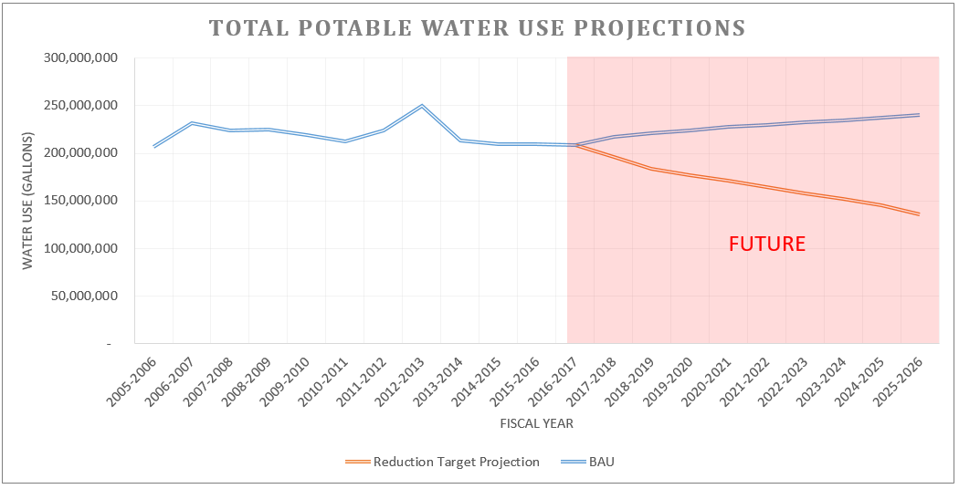
Figure 13 | Total potable water use projections, both 'BAU' and with implementing water conservation recommendations.

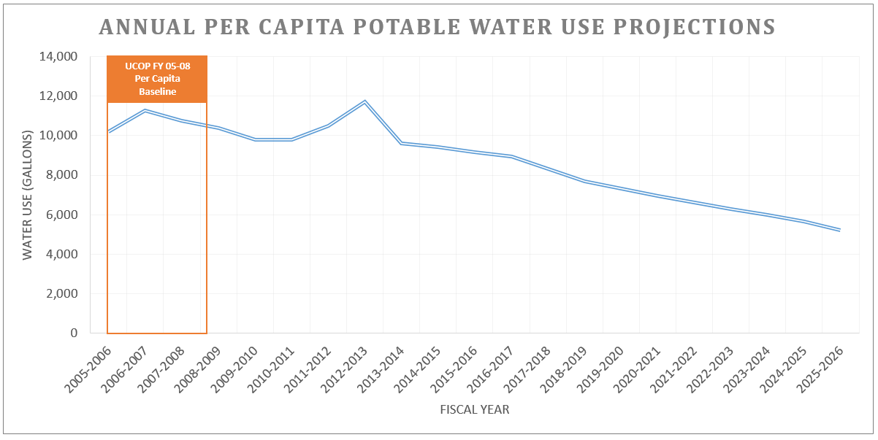
Figure 14 | From the UCOP FY 05-08 baseline, UCSB has the ability to significantly reduce per capita potable water consumption, and can achieve a 51% per-capita reduction if all recommendations are implemented.

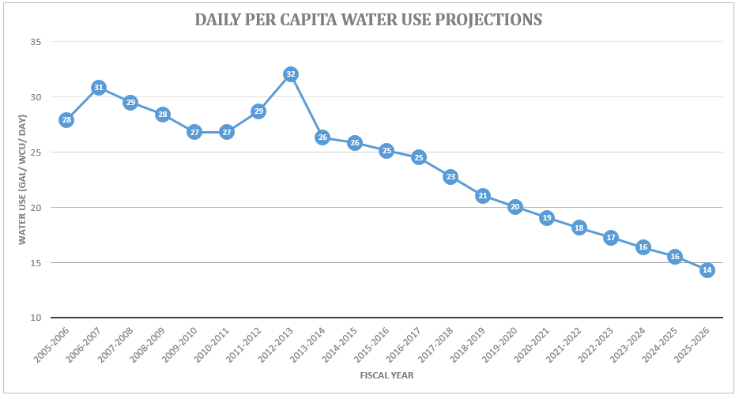
Figure 15 | Projected daily per capita water consumption with WAP recommendations.

Stormwater Management and Environmental Compliance
This section aims to give a brief overview of our stormwater program, providing a look at historical actions and recommending future actions. Stormwater was incorporated into its own specific section as it does not directly contribute to potable water reduction; however, UCOP policy emphasizes that stormwater management must be addressed from a watershed perspective in a campus-wide, comprehensive way that recognizes stormwater as a resource and aims to protect and restore the integrity of the water bodies surrounding the campus. In accordance with this, the following section lists our stormwater best management practices and initiatives, as well as future goals, based on the current policy and regulatory framework as mandated by the State Water Resources Control Board.

Regional Physiogeography and Hydrology

Main Campus Geology
The UCSB campus can be divided into four campuses (Main Campus, Storke Campus, West Campus, and North Campus), all of which are located on the Goleta Point and are bordered by five surface water bodies: Devereux Slough, Goleta Slough, Campus Lagoon, the Pacific Ocean, and Storke Wetlands. The topography of the Main Campus tends to generally slope towards the Campus Lagoon and the Pacific Ocean, but a small northern portion discharges into the Goleta slough. In addition into discharging to the Campus Lagoon, the Goleta Slough, and the Pacific Ocean, UCSB also discharges into the Devereux Slough and the Storke Wetlands.
The UCSB Main Campus lies south of the Santa Barbara Municipal Airport on a portion of land elevated roughly 40-50 feet above the Pacific Ocean. The bulk of the Main Campus is underlain by marine terrace deposits and Sisquoc bedrock formation. The marine terrace deposits rest on elevated marine wave cut platforms and form single terraces or flights of terraces and are identified as Quaternary. The Sisquoc formation is distinguished by thick beds of conglomerate, containing angular clasts derived from the Monterey Formation, and is identified as Tertiary. This subterranean formation, which is visible in layers when viewed along the marine bluffs, is overlain by a layer of permeable soil. Because this Sisquoc layer is highly impermeable, any infiltrated water will pass through the soil layer and flow along the Sisquoc formation before discharging at the face of the marine bluff.

Relevant Regional Conditions
Santa Barbara has a Mediterranean climate with mild winters and generally dry summers. Temperatures typically range from 40 degrees Fahrenheit to 74 degrees Fahrenheit. The average annual rainfall is 17.87, inches and precipitation typically occurs between November and April.

Table 28 | Goleta, California, Temperature and Precipitation Data 2007 to 2017
Month | Temperature (°F) |  |  | Average Precipitation (Inches)
 | Average High | Mean Average | Low Average
January | 67 | 53 | 42 | 0.12
February | 65 | 55 | 44 | 0.10
March | 68 | 57 | 46 | 0.05
April | 69 | 59 | 48 | 0.02
May | 70 | 61 | 51 | 0.00
June | 71 | 63 | 55 | 0.01
July | 74 | 66 | 58 | 0.00
August | 75 | 67 | 58 | 0.00
September | 76 | 66 | 56 | 0.00
October | 75 | 64 | 52 | 0.03
November | 70 | 58 | 45 | 0.03
December | 64 | 53 | 41 | 0.10
Source: Weather Underground, 2017

Surface Water and Hydrology
UCSB is located within the 240,720-acre South Coast Hydrologic Area (Hydrologic Unit 315), which is made up of small, coastal watersheds (Central Coast Ambient Monitoring Program [CCAMP] 2007). The UCSB campus comprises approximately 0.4% of the hydrologic area. UCSB is situated on a promontory, Goleta Point, which is bordered by five surface water bodies: Devereux Slough, Goleta Slough, Campus Lagoon, the Pacific Ocean, and Storke Wetlands.

Devereux Slough
The Devereux Slough is located on the West Campus and is managed by UCSB’s Coal Oil Point Reserve. The 45-acre slough receives discharges primarily from Devereux Creek and its tributaries which encompass a 2,240-acre watershed. Land uses in the watershed include agriculture/open space in the upper reaches and residential/commercial usage in the lower areas. The Slough discharges to the Pacific Ocean via a tidal channel breach.

Storke Wetlands
The Storke Wetlands comprise approximately 20 acres along the northern perimeter of the Storke Campus. The Storke Wetlands watershed covers 347 acres and includes the northern portion of Isla Vista, the Storke Campus, and a narrow portion of the City of Goleta adjacent to Tecolotito Creek. The wetlands discharge into Goleta Slough.

Goleta Slough
The 430-acre Goleta Slough comprises freshwater wetlands and tidal marsh. It is located north of and adjacent to the Main Campus. The slough receives discharges from UCSB’s Storke Campus, north-facing bluffs, and More Mesa, as well as from seven creeks within the 45-square mile watershed: Atascadero, Las Vegas, Los Carneros, Maria Ygnacio, San Jose, San Pedro, and Tecolotito. Land use in the watershed is primarily open space, but the portions nearest the slough are developed, and a large portion of the slough itself has been filled and subsequently developed. The slough generally discharges to the Pacific Ocean; however, sedimentation from upland sources and littoral drift frequently prohibits discharges, which limits tidal flushing and lowers oxygen levels in the slough waters.

Campus Lagoon
The Campus Lagoon is a 31-acre brackish pond, thought to have once been a historic stream channel, located in the southern portion of the Main Campus adjacent to the Pacific Ocean. The water level in the lagoon is maintained between 4 and 7 feet above sea level by an overflow weir at the western end, outfall at the eastern end, and a series of berms. However, the lagoon is potentially subject to tidal and wave action which could result in unexpected draining. The lagoon’s watershed comprises approximately half of UCSB’s Main Campus, which includes open space and bluffs at the lagoon perimeter. The primary source of water supporting the lagoon is the seawater discharged from the UCSB Marine Science Laboratories. The lagoon also receives stormwater runoff from the University, which contributes substantial amounts of water to the system during rain events.

Environmental Protection and Regulatory Context
Human activities have the potential to degrade the biophysical environment by directly discharging pollutants into the environment or by changing the land physically through construction practices. Urban runoff is a leading cause of pollution throughout the state, and it contributes pollutants of concern such as sediments, non-sediment solids, nutrients, pathogens, oxygen-demanding substances, petroleum hydrocarbons, heavy metals, polycyclic aromatic hydrocarbons (PAHs), trash, and pesticides to waterways.
The UCSB community greatly values the environment and, more specifically, the watershed, and will continue to implement best management practices to prevent pollution and to restore the integrity of the local water bodies.

Relevant Regulatory Requirements
UCSB is required to comply with federal, state, and local regulations related to environmental protection, such as the federal Clean Water Act. The purpose of the Clean Water Act is to protect and restore the physical, chemical, and biological integrity of our nation’s waterways by controlling and limiting discharges of pollutants. The California State Water Resources Control Board (SWRCB) and the nine Regional Water Quality Control Boards have regulatory authority over water bodies within the state and are responsible for enforcing laws and regulations to protect water quality and beneficial use of the waterways. The California Coastal Commission works with coastal agencies to plan and regulate the use of land and water within the coastal zone. The California Natural Resources Agency is charged with the adoption of the California Environmental Quality Act (CEQA) guidelines and assisting state and local public agencies with the interpretation of those guidelines. See Table 29 for a listing of relevant environmental regulatory requirements as they relate to water at UCSB.

Table 29 | Relevant Regulatory Requirements
Program Name | Permit | Regulating Agency | General Requirements
Construction Stormwater | National Pollutant Discharge Elimination System (NPDES) General Permit for Storm Water Discharges Associated with Construction and Land Disturbance Activities Order No. 2009-0009-DWQ | State – California State Water Resources Control Board  Regional-Central Coast Regional Water Quality Control Board | Projects that disturb one acre or more of land are required to obtain coverage under this General Permit. Permittees are required to implement best management practices to prevent erosion and reduce sediment and other pollutants in discharges from construction projects.
Municipal Stormwater | National Pollutant Discharge Elimination System (NPDES) General Permit for Storm Water Discharges from Small Municipal Separate Storm Sewer Systems (MS4s), Water Quality Order No. 2013-0001-DWQ | State – California State Water Resources Control Board  Regional-Central Coast Regional Water Quality Control Board | Small municipalities and non-traditional municipalities (such as UCSB) are required to obtain permit coverage. Permittees are required to prevent pollution from municipal activities by implementing best management practices, training staff, and preventing illicit discharges.
Oil Pollution Prevention | Code of Federal Regulations, Title 40-Protection of Environment, Chapter 1-Environmental Protection Agency, Subchapter D-Water Programs, Part 112 – Oil Pollution Prevention | Federal – Environmental Protection Agency | Requires facilities that have an aboveground oil storage capacity of greater than 1,320 gallons to prepare and implement a Spill Prevention, Control, and Countermeasure Plan, to prevent oil spills, and to clean them up if they occur.
 | California Health and Safety Code, Division 20, Chapter 6.67, Section 25270 - Aboveground Petroleum Storage Act  Assembly Bill 1130 (Laird) | State – Certified Unified Program Agencies  Formerly the State Water Board
Planning | California Code of Regulations (CCR), Title 14, Division 5.5 – California Coastal Commission | State – Natural Resource Agency | The Act outlines, among other things, standards and policies for development within the Coastal Zone. Chapter 3, Article 4 of the Act addresses protection of the marine environment, including water quality issues, wetlands protections, and coastal armoring. Chapter 3, Article 5 contains requirements for the protection of environmentally sensitive habitat areas.
 | California Code of Regulations (CCR), Title 14, Division 6, Chapter 3 – Guidelines for Implementation of the California Environmental Quality Act | State – Natural Resource Agency | Requires state and public agencies to identify the environmental impacts of proposed discretionary activities or developments, to determine if the identified impacts will be significant, and to identify alternatives and mitigation measures that will substantially reduce or eliminate significant impacts to the environment.
Post-Construction Stormwater Requirement | Post-Construction Stormwater Management Requirements for Development Projects in the Central Coast Region, Resolution No. R-3-2013-0032 | State – California State Water Resources Control Board  Regional-Central Coast Regional Water Quality Control Board | Projects that create and/or replace 2,500 square feet or more of impervious surface over the entire project area are required to implement tiered performance requirements. Dependent on the quality of impervious surface and the associated performance requirements, a project will be required to implement general Low Impact Development site design measures, treat the volume of stormwater generated by an 85th percentile rain event, infiltrate the volume of stormwater generated by an 95th percentile rain event, and manage peak stormwater flows from the 2-10 year storm events. These site design performance requirements are intended to mimic the natural watershed processes of the un-developed landscape.
Wastewater | Statewide General Waste Discharge Requirements for Sanitary Sewer Systems Order No.-2006-0003-DWQ, amended by Order No. WQ 2013-0058 EXEC | State – California State Water Resources Control Board | Public entities that own sanitary sewer systems greater than one mile in length that collect and/or convey untreated wastewater are required to comply, to prevent sanitary sewer overflows and report them if they happen, and to write and implement a Sewer System Management Plan.

HISTORICAL STORMWATER MANAGEMENT EFFORTS

Environmentally Sensitive Habitat Areas
UCSB has been restoring the area’s natural habitat since the campus was first built in 1945 and has a history of being very progressive when it comes to the protection of environmentally sensitive habitat areas (ESHA). Since the mid-1970s, the focus has been on the ecological restoration of habitats on undeveloped areas of the campus, such as the Campus Lagoon Island, Coal Oil Point Reserve, and the margins of the campus where natural areas lie next to buildings and roads. Additional efforts have included enhancing and protecting environmentally sensitive habitats, such as wetlands.
The 2010 Draft LRDP classified 237 acres of campus land as ESHA (including Coal Oil Point Reserve), either because of the area’s rarity or special role in the ecosystem or because the area served as a visual or natural buffer to more sensitive areas. These buffers include the top of the ocean bluffs on the Main and West campuses, the banks of the Campus Lagoon, areas bordering the Storke Campus Wetland, and the eastern banks of the Devereux Slough. In other areas where open space was not available as a buffer, LRDP policies and development standards control building setbacks, planting, run-off, fences, and signs in order to protect natural resources from degradation. Often, non-native trees that provide critical habitat for Monarch butterflies, exotic trees that contain raptor nests, and very small, occasionally wet vernal pools are also classified as ESHA.

Restoration Efforts

Natural Areas
UCSB’s management policy additionally focuses on the restoration of areas to their natural state. Restoration projects at UCSB cover all four campuses and range from modest native oak tree planting along roadways to larger scale wetland creation and enhancement.
On the Main Campus, restoration projects have focused on areas around the Campus Lagoon and the north bluff facing the Goleta Slough. To the west of the lagoon, restoration projects associated with Manzanita Village housing include six acres of coastal bluff restoration and a suite of vernal pools and marshes with bioswales and filters to improve the quality of storm water runoff. Restoration efforts on the Lagoon Island include experimental prescribed burns to reduce invasive plants and significant oak tree plantings. North bluff restoration efforts have emphasized native oak woodland planting on the bluff, with a belvedere and pedestrian trail winding along the bluff overlooking the Goleta Valley and Santa Ynez Mountains.
On the Storke Campus, restoration has focused on removing invasive exotic plants around the West Storke Campus wetlands and improving the system of informal trails and signs. More than two acres of wetlands east of Los Carneros Road have been restored with native plants, and naturalized basins have been built for water containment and purification. Oak trees have been planted along Mesa Road and north of Harder Stadium, and a bioswale has been constructed between the parking lot and gardens.
On West Campus, projects have established vernal pools on the bluffs and replanted native species along the edges of the Devereux Slough. Dune restoration projects have included the removal of non-native plants and re-vegetation with coastal dune scrub. The Devereux Foundation restored the eastern finger of the Devereux Slough by replacing many exotic plants with native riparian and upland species.
A large portion of the North Campus is currently being restored from a former golf course to historically natural conditions, including a nature park on the south parcel, with new wetlands, grasslands, and riparian areas, as well as trails, signs, and a small outdoor amphitheater for tours and orientation. Restoration efforts to the north of the former golf course have focused on the vernal pool wetlands and improvements to the riparian habitat of Phelps Creek.

Local Watersheds
Along with efforts to reduce potable water consumption and prevent pollution, UCSB community members aim to improve the local watershed by restoring natural areas around campus. In 2005, the Cheadle Center for Biological and Ecological Restoration (CCBER) was founded and now works to support education, research, collections management, ecosystem management, restoration, and conservation in relation to this area.
CCBER has been instrumental in the management of natural areas throughout UCSB and is responsible for the championing, design, and maintenance of the many bioswales and restored wetlands. The management areas are located between Ellwood Mesa and Goleta Slough and consist of more than 350 acres of open space characterized by oak woodland, coastal sage scrub, grassland, and wetland ecosystems. CCBER’s ecosystem management areas include the Campus Lagoon, Manzanita Village, East Bluff, North Bluff, San Clemente, Storke Wetland, West Campus Bluffs, South, and the North Campus Open Space (NCOS). NCOS itself is 136.4 acres, which includes properties previously called ‘South Parcel’, ‘Whittier Parcel’, and ‘Ocean Meadows Golf Course’, and is a restoration effort of the estuary and flood plain, which will include over 2.5 miles of trails that will provide scenic views and connectivity to the California Coastal Trail. It is projected to be completed in May 2018.
Another unique feature of UCSB is the Coal Oil Point Reserve located on the West Campus. The Coal Oil Point Reserve consists of 170 acres of shoreline and estuarine habitats, including more than 20 acres of restored wetland margins, vernal pools, coastal sage scrub, dunes, and beach habitat. The Reserve offers opportunities for research, teaching, restoration projects, and native plant propagation.

Municipal Stormwater

Regulations and Permitting
UCSB complies with both federal and state environmental protection regulations, such as the Clean Water Act and the California MS4 General Permitting process.
In March 2003, UCSB was identified by the State Water Board as a “non-traditional” municipality and was required to comply with the statewide MS4 General Permit. The University submitted its original Stormwater Management Plan to the Central Coast Regional Water Quality Control Board (Central Coast Water Board) and implemented pollution prevention practices ahead of their required enrollment in 2008. On February 15, 2008, UCSB enrolled in the State Water Board’s MS4 General Permit and revised the existing UCSB Stormwater Management Plan, which was later adopted by the Central Coast Water Board in June of 2008.
In April of 2011, the Federal EPA and the Central Coast Water Board audited the UCSB MS4 Stormwater Management program. They reviewed documents, conducted interviews, and performed inspections of the entire campus, focusing on all areas of compliance, especially construction sites and good housekeeping practices. In December of 2011, UCSB received an audit report from the EPA that listed a few deficiencies, including not having consistent practices at construction projects and not having a central location to store all compliance documents, such as a database. However, the EPA also noted that UCSB had achieved a great deal of progress with the MS4 Program in the two years the University was enrolled under the program, and the audit team observed a high level of awareness of stormwater issues among our staff.
The Central Coast Water Board adopted the Post-Construction Stormwater Management Requirements for Development Projects on September 6, 2012, after working with the municipalities in the Central Coast for almost three years; the process was called the “Joint Effort.” The purpose of this requirement is to reduce pollutant discharges to the maximum extent practicable from development projects.
The State Water Board revised and adopted the new MS4 General Permit on February 5, 2013, with the intention of bringing more consistency to the program and to the regulated municipalities throughout California. The main purpose of the permit remains the prevention of stormwater pollution, but an additional emphasis has been placed on the prevention of long-term watershed degradation resulting from poor design of development projects. The revised permit also allows municipalities to better allocate their resources towards implementing effective practices, rather than compiling redundant paperwork and developing lengthy stormwater management plans. Additionally, all UCs and Cal State Universities will be regulated under this MS4 General Permit.

Best Management Practices

Construction Stormwater
During construction of new development projects, contractors are required to implement BMPs to prevent construction-related pollutants from leaving the site and possibly entering the campus storm drain system. Examples of these BMPs include a perimeter control, separately containing all waste and chemicals in covered storage with secondary containment, regularly sweeping all hardscape, and protecting all storm drains within and around the construction site. These stormwater pollution prevention requirements are included in the contract signed by contractors that work on campus. Additionally, the UCSB Construction BMP Handbook was developed to aid contractors in selecting the most effective BMP to prevent sediment and construction-related pollutants from leaving the site.
All UCSB staff involved in the construction process, such as project managers and inspectors of record, receive training on proper installation and maintenance of pollution prevention BMPs and notification and mitigation procedures in the event of a hazardous material spill. The construction sites are also regularly inspected by UCSB staff to observe BMP effectiveness and to communicate to contractors any necessary improvements.

Post-Construction Stormwater Design
The construction of new buildings and impervious surfaces, such as roadways, parking lots, sidewalks, and bike paths, can negatively affect aquatic systems long after construction is complete. The runoff from these surfaces can contain pollutants, such as sediment, nutrients, bacteria, petroleum hydrocarbons, and heavy metals. Increasing the amount of impervious surfaces leads to stormwater discharges that have greater volumes, velocity, and pollutant loads than pre-development runoff.
To prevent the harmful effects from the construction of new buildings, post-construction stormwater design standards were developed with the following goals:
- Maximize infiltration of clean stormwater and minimize both runoff volume and rate
- Protect riparian areas, wetlands, and their buffer zones
- Minimize pollutant loading
- Provide long-term watershed protection
When new development projects are being designed, stormwater treatment features are also incorporated in the design to manage stormwater at that site long after construction is completed. Examples of development projects that incorporated stormwater treatment features include:
Manzanita Village
The Manzanita Village is a student residence hall located on the southwest corner of Main Campus and surrounded by roughly one acre of restored wetlands. The restoration project included the creation of 1,300 linear feet of bioswales, it created wetlands designed to convey and filter stormwater runoff, and it involved installing more than 80,000 native plants. Examples of stormwater treatment features are shown below and include rocky landscape swales, bioswales with rock check dams, bioswales with native plants and varied topography, rocks around outfalls to dissipate stormwater flow, vernal pools, disconnected roof drains, and rocks used as energy dissipaters.
San Clemente
San Clemente is a double certified LEED Gold student residence hall located on the Storke Campus and is adjacent to approximately 5.4 acres of restored wetland. All of the stormwater runoff from San Clemente residence hall discharges to the wetland where it is treated by a series of detention ponds, bioswales, and natural wetlands. This protected area is home to over 100 native plant species, including the rare and endangered Southern Tarplant. Stormwater runoff is also treated throughout San Clemente by features such as rain gardens, disconnected roof drains, permeable paving, and curb cuts.
Library Corridor and San Nicolas Bioswale
The library corridor runs north to south on the east side of the Davidson Library and was redeveloped in 2011 when a new stormwater pipe was installed along the interior of Main Campus. During a rain event, stormwater filters through the permeable pavement and the underlying gravel basin, and then it flows to the rain gardens adjacent to the walkway where it is able to percolate into the soil or eventually discharge to a continuous deflective separation (CDS) unit and then to the San Nicolas bioswale. Stormwater treatment features along the library corridor include permeable pavement, rain gardens with stone check dams and detention ponds, and a CDS unit. The San Nicolas bioswale is a native freshwater wetland and includes a filtration marsh, rock energy dissipaters at outfalls, berms for water cleansing, micro-topography for species diversity, and stone check dams for water aeration and pooling.
Sierra Madre Villages
Finished in 2015, the Sierra Madre Villages are located on the west side of the campus, adjacent to the North Campus Open Space. It was awarded LEED Platinum under LEED for Homes and boasts impressive onsite stormwater retention and wetland restoration efforts. Its proximity to NCOS allows Sierra Madre to share many of the same wetland restoration strategies and serves as a great showcase piece for the students living in the Sierra Madre Villages.
Pauley Track
UCSB’s Pauley Track, located in the northwestern portion of Main Campus, underwent substantial renovation in the summer of 2017. Included in the scope of the renovation project was the removal and replacement of all track surfaces, re-design of track to conform to current competition standards, and addition of outdoor sports lighting. The newly designed track and field layout resulted in an impervious surface increase from 56,485 sq. ft. to 106,431 sq. ft. This new and replaced impervious surface triggered the requirement for the project to infiltrate the 95th percentile, 24-hour rain event and manage peak runoff from the site. To comply with these requirements, an underground stormwater infiltration system was installed in parallel rows along the interior of the track infield. All stormwater runoff from the site are directed into these underground chambers, retained, and allowed to slowly infiltrate through a base layer of gravel and native soil.

Operational and Maintenance Efforts
Daily operations and maintenance of campus have the greatest ability to reduce and eliminate stormwater pollution. Staff that work in areas such as dining services, facilities maintenance, fleet services, grounds, housing and residential services, and vehicle maintenance receive training about relevant BMPs and ways to conduct their daily activities without causing, but also by preventing, pollution. Operational and maintenance BMPs include clean-up efforts, such as sweeping all roads and parking lot surfaces on a monthly basis, maintaining landscaped areas, preventing erosion, and continuing an impressive refuse and recycling program.

Education and Outreach
The UCSB campus community and visitors have the potential to impact the water quality within the UCSB watershed, especially the storm drain system.
Pollution prevention efforts are focused on staff involved in daily operations; however, communicating the significance of a healthy watershed to all the campus community members is also important to the success of the municipal stormwater program. Examples of bringing stormwater awareness to the campus community include:

- Organizing educational events, which include coastal cleanup days, tours of restoration projects, campus touch tanks, and LEED certified buildings
- Provide guidance and educational materials about Low Impact Development (LID) best management practices (BMPs) to the UCSB community involved in design of new development and redevelopment projects at UCSB. Document all outreach and training events.
- Provide employee self-scheduling via the UCSB Learning Center and advertise training opportunities that will increase stormwater awareness. Track and periodically evaluate all relevant training.
- Launching a comprehensive stormwater website that includes current planning documents and information on stormwater best practices
- Label stormdrains located in roadways, parking areas, loading docks, and service areas throughout the UCSB MS4.
- Launching a comprehensive stormwater website that includes current planning documents and information on stormwater best practices
- Creating a campus stormwater conveyance map
- Provide guidance and examples of best management practices regarding hazardous materials storage, handling, and disposal, as well as appropriate waste management and recycling practices
- Instilling an understanding of stormwater management from a watershed perspective
- Facilitate or promote stormwater lectures or presentations to the UCSB community. Retain records of the stormwater lectures and/or presentations.

Oil Pollution Prevention

Regulations and Permitting
UCSB developed and implemented a Spill Prevention, Control, and Countermeasure (SPCC) Plan in January 1996 that was later rewritten in August of 2003, December 2008, October 2012, and October 2017. The SPCC Plan is also updated as the facility or its operational practices change. The EPA required development of this plan because UCSB is located near a navigable waterway and has storage of oil in quantities greater than 1,320 gallons. By developing and implementing the SPCC Plan, the University commits the necessary personnel, equipment, and materials needed to expeditiously control and remove any harmful quantity of oil discharged from UCSB storage vessels and equipment. In November of 2012, the EPA audited the UCSB Oil Pollution Prevention program and acknowledged that the University had developed and implemented the SPCC plan, but it advised the University to implement a central file storage location, such as a database, to store all compliance documentation. More recently, UCSB’s SPCC program was audited by the Santa Barbara County Certified Unified Program Agency (CUPA) in August of 2017. Findings and required corrective actions noted during the inspections have been incorporated into the October 2017 version of the Plan.

Best Management Practices
The EPA’s definition of oil includes petroleum oils (diesel, gasoline, and motor oil) and non-petroleum oils (synthetic oils, animal fats and oils, and edible and inedible seed oils from plants). At UCSB, oils are stored in various containers and equipment having a capacity equal to or greater than 55 gallons, such as aboveground storage tanks (AST), emergency generators, drums, and transformers. There is no underground or buried fuel oil storage at UCSB.
UCSB has practices in place, such as design standards and contract language, to ensure that oil storage tanks are designed and constructed properly to prevent an oil spill. Examples of these practices include the fact that:
- Oil storage tanks and associated piping are constructed of materials that are compatible with the commodity being stored
- Only double-walled, secondary containment ASTs are used for bulk storage of oil at UCSB
- The inner tank of all double-walled ASTs is an Underwriters’ Laboratory (UL)-listed steel tank
- The outer wall of all double-walled ASTs is constructed in accordance with nationally accepted industry standards
- All ASTs have overfill prevention measures that include an overfill alarm and an automatic flow restrictor or flow shut-off
- A safe fill level is established for all oil storage tanks
UCSB maintenance staff in the departments of Facilities Management, Housing and Residential Services, and the University Center maintain oil storage containers and oil-containing equipment, with additional support from Environmental Health and Safety. Examples of BMPs for the maintenance of oil storage containers include the fact that:
- Preventive maintenance is conducted regularly to ensure proper operation and to prevent oil discharges.
- All product transfers are monitored and documented
- Adequate spill prevention and cleanup materials are stored near oil containers
- Inspections are regularly conducted
- The SPCC Plan is updated as the UCSB facility changes

Wastewater

Regulations and Permitting
The UCSB Wastewater Collection System Management Plan was developed and implemented in 2006 in response to the Waste Discharge Requirements (WDR) Order No. R3-2004-0130, issued to the Goleta Sanitary District (GSD) by the Central Coast Water Board. In 2006, the State Water Board adopted a statewide general permit to promote uniformity in the management of California’s wastewater collection systems and to reduce sanitary sewer overflows. As a result, UCSB revised the document in May of 2009 and renamed it the UCSB Sewer System Management Plan. The document is revised every two years to account for changes in the facility.

Best Management Practices
The UCSB sanitary sewer system serves the majority of the campus and is comprised of over 78,000 linear feet of collection pipe, ranging from 4 to 18 inches in diameter. Original pipe is replaced as upgrades or repairs are necessary or new facilities are constructed. Sanitary sewage is collected from campus buildings that house administration, classroom, research, residential, and dining common facilities. The system ultimately feeds to the Goleta Sanitary District wastewater treatment plant, of which UCSB is a 7% stakeholder. There are ten building locations on the Main Campus that have lift stations, and three have odor control filtration systems. The campus has five grease interceptors and three grease traps to collect fats, oil, and grease and to reduce the amount that is discharged to the Goleta Sanitary District.

Staff members that work in food facilities are trained in proper disposal of fats, oil, and grease so that none of it is washed down the sanitary sewer. Grease interceptors and grease traps are cleaned and pumped regularly to prevent buildup and to maintain effectiveness. Staff members that are likely to observe a sanitary sewer overflow are trained in proper procedures, such as reporting the overflow, stopping it, stopping public access to the area, and proper clean-up techniques. Design standards are in place so that grease interceptors in new buildings are designed in accordance with state requirements.

STRATEGIES AND GOALS FOR FUTURE STORMWATER MANAGEMENT
The UCSB staff and community members have, and will continue to develop and implement, practices to reduce environmental impacts and to restore the local watershed. Opportunities to make the greatest impact occur during three stages of operation at UCSB: design of new development projects, construction of new development projects, and campus operation and maintenance.

Design of New Development Projects
During the design of new development and redevelopment projects, efforts can be made to reduce the potential environmental impacts from a future project. The following are examples of BMPs and strategies that are incorporated into the design of new projects in order to reduce impacts to the environment:
- A design standard has been developed for generator fuel tanks, which account for about 95% of oil storage tanks at UCSB. Continue to work on a Design Standard for the remaining oil storage tanks. Oil storage tanks and associated piping should be constructed of materials that are compatible with the commodity being stored. Oil storage tanks should be equipped with high-level alarms and/or automatic high-level shut-off valves. Only use double-walled, secondary containment ASTs for bulk storage of oil. The inner tank of all double-walled ASTs should be an Underwriters’ Laboratory-listed steel tank and the outer wall should be constructed in accordance with nationally accepted industry standards.
- Continue to implement UCSB’s design standard for new and redevelopment projects, titled Post-Construction Stormwater Management Requirements, to manage stormwater at that site long after construction is completed. Examples of stormwater treatment features outlined in the design standard include rain gardens, permeable pavement, infiltration basins, treatment devices, and disconnected roof drains.
- Develop a Design Standard for equipment and infrastructure related to the sanitary sewer, such as connections to the sanitary sewer and grease interceptors. Sewers and connections must be designed properly. All grease-bearing discharge lines should have grease interceptors or traps and comply with Goleta Sanitary District standards.
- All new development and re-development projects must be in compliance with the California Coastal Act
- All major development projects must receive a thorough CEQA review, including, if necessary, the development of an Environmental Impact Report (EIR) and mitigation plan.
- All projects will adhere to the LRDP policies and development standards that control building setbacks, planting, runoff, fences, and signs with the intent to protect natural resources from degradation.
- All new projects on campus will strive for Gold LEED Certification, requiring selection of a building site that will be minimally invasive, planning for water-efficient landscaping, design of a sustainable wastewater management system, design of a quantity- and quality- focused stormwater management system, and preservation of the natural and native environment.

Construction of New Development Projects
During construction of new development projects, construction activities are a significant source of stormwater pollution and have great impacts on the environment. The following are examples of best management practices and strategies that can be implemented to improve existing pollution prevention efforts.
- Continue to utilize contract language updated in 2017
- Require contractors to use effective stormwater pollution prevention BMPs
- Require contractors to have procedures in place to prevent an oil spill and materials on hand to clean-up a spill if one should occur
- Require contractors to properly install and maintain post-construction stormwater treatment features
- Update the UCSB Construction BMP Handbook
- Develop an online training program for relevant UCSB staff and contractors
- Develop and implement a Standard Operating Procedure for conducting inspections of construction stormwater practices and stormwater treatment features
- Mandate that all new projects on campus will strive for Gold LEED Certification, requiring construction activity pollution prevention, rainwater management, and clean construction.

Operational and Maintenance Efforts
Examples of practices and strategies that can further reduce environmental impacts from campus operations and maintenance are included below:

Campus Performance Review
Recently completed campus performance reviews:
- Conducted a thorough audit of all campus oil storage locations as part of our 2017 SPCC update. Al locations were confirmed to have adequate spill kits, where required, and security measures. The one location with inadequate lighting (bldg. 585) had additional lighting installed. Security measures in oil storage locations. Verify that adequate security measures are in place to protect oil storage containers and equipment and prevent spills.
- Created a list of all O&M activities that had the potential to impact water quality. A BMP cut sheet for each activity was created and a compilation of applicable BMP cut sheets was distributed to a department representative. For FM this was Maurice.

Conduct a campus performance review of the following:
- The Fats, Oil, and Grease program. Verify that adequate measures are in place throughout campus to prevent fats, oils, and grease being discharged into the sanitary sewer system.
- EH&S has commenced quarterly hotspot inspections beginning in the 3rd quarter of 2017. They should continue to conduct quarterly inspections of all UCSB facilities that are a potential threat to water quality. Inspection reports include pollutants of concern, pollutant hotspots, type of materials stored onsite, presence of improperly stored materials, activities that should not be performed outside, proximity to water bodies and/or storm drains, and housekeeping practices. Examples of hotspots include maintenance yards, hazardous waste facilities, and fuel storage locations.

Compliance Documents
Develop a database to store all compliance documents related to environmental protection, including:
- Inspection records, training records, updates to plans, changes to the facility, maintenance records
- Updated maps of campus. Relevant mapped features include: the storm drain system and outfalls; the sanitary sewer system, including grease interceptors and lift stations; oil storage tanks and normal storage locations for oil containing equipment; facilities that are a potential threat to water quality; and stormwater treatment features
- Records regarding sewer system overflows, including frequency and volume of overflows
- Records regarding the cleaning of grease interceptors and grease traps, including frequency and vendor invoices

Improve Existing Equipment and Facilities
- Replace existing single-walled oil storage tanks with double-walled, secondary containment ASTs as soon as practicable
- Replace and/or install sewer lines and manholes as necessary to correct root intrusion and corrosion problems, address bottlenecks, and meet future load requirements. If possible, complete a video inspection of the sanitary sewer lines. If possible, develop a hydraulic model of the sanitary sewer system to enable detailed capacity analyses and to facilitate system design.

Inspections & Trainings
Recently completed inspections and trainings:
- Completed in 2014 - Campus outfalls. Conduct field sampling if outfall is flowing at the time of inspection and it has been more than 72 hours since the last rain event
- Updated SPCC training module was created and rolled out to all SPCC responsible staff in October 2017
- Dining/ food facility managers received training from EH&S staff and are responsible for training their staff about proper handling and disposal of fats, oil, and grease.
- All potential hotspot facility managers received facility-specific training of stormwater pollution prevention practices in summer of 2017. Training informed relevant staff about stormwater pollution and recommended pollution preventative BMPs.
- All lab sinks have signage indicating no dumping of chemicals and all lab users are required to take LMS training modules where sanitary discharge prohibitions are covered.
Develop a Standard Operating Procedure for inspections involving:
- A sanitary sewer, including lift stations, manholes, large sanitary sewer lines, food facilities, grease traps, and grease interceptors
- Investigations into the source of all non-stormwater discharges suspected to be illicit discharges
- Facilities that are a potential threat to water quality
- All regulatory required treatment features are required to have an O&M plan developed, that describes inspection frequency, covered items, required maintenance thresholds, etc.
All SOPs must include steps to deal with a deficiency, including who should be contacted, what corrective actions are necessary, how to document the situation, etc.
Training
- Review, update, and improve the existing sewer spill response training program for relevant staff, as outlined in the UCSB Sewer System Management Plan.

Educational Opportunities and Community Engagement
Living Laboratory for Sustainable Water Practices
A promising opportunity to provide hands-on education and program development would be to incorporate water conservation and pollution prevention practices into current University academic programs. The University should encourage professors to utilize the Campus’s unique location and water challenges as topics for class discussion. The following are suggested ways that University classes and laboratories could innovate and evaluate various methods for conserving and protecting water resources.
- Create a Living Laboratory for the treatment system at Commencement Green
- If a treatment system is installed at Commencement Green, it could be used as an on-site educational opportunity to engage students and to help them better understand water treatment. This could include chemistry students studying the treatment of the water and biology students studying the effects of recycled water on plants; engineering students and material science students could also benefit from the study of the reverse osmosis (RO) system through the theory of design, maintenance, and the materials used to treat water. The treatment system education component could even target social science students interested in urban studies, global studies, politics, and policy, as well as economics students who might be interested in the implementation, legal requirements, theories, and cost effectiveness of similar systems for cities across the globe.

Campus Community Efforts
Many different University departments, student groups, and community programs work together towards achieving UCSB goals relating to water conservation and pollution prevention. The following sections contain a brief description of the collaborations on campus and the role that each organization or program plays.

Student Groups
The Environmental Affairs Board (EAB) is a branch of UCSB’s AS Government and is the largest and most active environmental group on campus. EAB’s mission is to protect, preserve, and enhance the environment, principally at UCSB and its surrounding communities. The group focuses on ecology, energy, food, climate change, water policy and conservation, the economy, environmental justice, and other environmental issues. The EAB coordinates with other groups to promote environmental perspectives and sustainability throughout the University and the surrounding communities, as well as at the state, national, and global level. Information on their current campaigns and activities can be found on the EAB website at http://eab.as.ucsb.edu/ .

Volunteer Events
The Cheadle Center for Biological and Ecological Restoration (CCBER) is a campus facility dedicated to education, research, and outreach related to regional biological diversity and restoration. CCBER provides a unique opportunity for students, interns, volunteers, and researchers of all ages to gain theoretical and hands-on experience in the varied aspects of ecological restoration through the implementation of its volunteer program. Over the past year, CCBER staff has worked with over 100 individuals on projects involving the restoration, maintenance, and upkeep of natural areas around the campus.

Stormwater Management Goals
On February 5, 2013, the State Water Board adopted the new MS4 General Permit, bringing more consistency to MS4 programs throughout the state, except in the Central Coast Region. UCSB is located within the Central Coast Region and is required to continue implementing the old program because it is more stringent than the new MS4 General Permit. The goals in Table 30 and 31, many of which have been implemented and are on-going, will help UCSB continue to comply with the MS4 Permit.

Table 30 | Summary of Implemented and On-going Stormwater Management Goals (1)
Sector | Description | Tasks | Resource Requirements (FTE)¹ | Implementation Horizon²
Stormwater | Create a stormwater program effectiveness assessment and improvement plan | Development of plan  Implementation of plan | 43 FTE* hours  8 FTE hours/month, 96 hours annually | Short-term
 | Implement new post-construction design requirements | Development of requirements  Implementation of requirements | 27 FTE hours  8 FTE hours/month, 96 hours annually | Short-term
 | Develop a stormwater public outreach and education plan | Development of plan  Implementation of plan | 80 FTE hours  27 FTE hours/month, 324 hours annually | Short-term
 | Audit existing contract documents, design standards, policies, and procedures, update to include stormwater compliance requirements | Initial development  Ongoing implementation | 60 FTE hours  32 FTE hours annually | Short-term
 | Generate standard operating procedures for construction and stormwater inspections | Initial development  Ongoing implementation | 40 FTE hours  32 FTE hours annually | Short-term
 | Generate standard operating procedures for outfall stormwater inspections and sampling | Initial development  Ongoing implementation | 40 FTE hours  32 FTE hours annually | Short-term
 | Generate standard operating procedures for priority facilities stormwater inspections | Initial development  On-going implementation | 40 FTE hours  32 FTE hours annually | Short-term
 | Continue campus stormdrain labeling | On-going implementation costing for labels | 16 FTE hours/month  $2.00/ea x 500/yr initial | Short-term
 | Create Stormwater pollution prevention plans for priority hotspot facilities | Development of plan  Implementation of plan | 80 FTE* hours  8 FTE hours/month, 96 hours annually | Mid-term
¹ FTE = Full-time Equivalent Employee

²“Short-Term” = 2018-2019; “Medium-Term” = 2019-2025

Table 31 | Summary of Implemented & On-going Stormwater Management Goals (2)
Sector | Description | Tasks | Resource Requirements (FTE)¹ | Implementation Horizon²
Stormwater | Produce a long-term strategy for maintenance of post-consumer features | Development of plan  Implementation of plan | 80 FTE* hours  8 FTE hours/month, 96 hours annually | Mid-term
 | Create a best management practices guideance manual for staff that have the ability to pollute stormwater systems | Development of plan  Implementation of plan | 80 FTE* hours  8 FTE hours/month, 96 hours | Mid-term
 | Develop enforcement protocols for the construction stormwater program | Initial development  Ongoing implementation | 20 FTE hours  30 FTE hours annually | Mid-term
 | Develop enforcement protocols for the municipal stormwater program | Initial development  Ongoing implementation | 20 FTE hours  30 FTE hours annually | Mid-term
 | Generate a post-construction stormwater best management practices manual | Initial development  Ongoing implementation | 40 FTE hours  30 FTE hours annually | Mid-term
Oil Pollution Prevention | Generate standard operating procedures for spill prevention, control, and countermeasures inspections | Initial development  Ongoing implementation | 40 FTE hours  32 FTE hours annually | Short-term
 | Development enforcement protocols for spill prevention, control, and countermeasures program | Initial development  Ongoing implementation | 20 FTE hours  30 FTE hours annually | Mid-term
Wastewater | Generate standard operating procedures for waste water inspections | Initial development  Ongoing implementation | 40 FTE hours  32 FTE hours annually | short-term
 | Develop enforcement protocols for the wastewater program | Initial development  Ongoing implementation | 20 FTE hours  30 FTE hours annually | Mid-term
²“Short-Term” = 2018-2019; “Medium-Term” = 2019-2025

¹ FTE = Full-time Equivalent Employee

Financing Opportunities
There are a number of funding opportunities available to allow us to pursue the projects outlined in the goals. The aforementioned Water Manager would probably be best positioned to research and evaluate funding opportunities for the WAP. Outlined below are a few institutions that have historically provided funding for water conservation projects and a select number of particular grants for which the University may apply:
- The University’s TGIF grant system has awarded a number of grants to water efficiency projects on-campus. Departments on-campus should continue to look at TGIF for funding water projects in the future. TGIF will be particularly useful for short-term, low-cost projects like expanding the metering system or purchasing aerators or low-flow showerheads.
- The Coastal Fund is another source of University funding available for on-campus projects. The mission of the Coastal Fund is to award funding to those project that help conserve the UCSB coastline. In keeping, this fund will be particularly useful for water conservation projects that have associated coastal benefits.
- The County of Santa Barbara’s Integrated Regional Water Management Program (IRWMP) provides funding for projects under State Proposition 50 and Proposition 84. While funding for Proposition 50 has already been allocated, Proposition 84 funds are still available to fund projects aimed at improving water quality; protecting rivers, lakes, and streams; improving flood control; promoting sustainable communities and the reduction of climate change; protecting beaches, bays, and coastal waters; improving parks and natural education facilities; fostering forest and wildlife conservation; and promoting statewide water planning. More information can be found at www.countyofsb.org/irwmp.
- California’s State Revolving Fund may be another available option. Although it provides low-interest rate loans only to local agencies, the University may consider engaging with Goleta Water District to apply for these loans. More information about the State Revolving Fund can be found at www.waterboards.ca.gov/water_issues/programs/grants_loans/srf/.
- The California Department of Water Resources (DWR) offers both grants and loans, which are funded through approved state propositions. For example, Proposition 50, Agricultural and Urban Water Use Efficiency, has provided grants to local agencies for projects that align with the goals of the California Bay Delta Program's Water Use Efficiency Program. Because many DWR grants and loans only offer funding to water agencies, the University may need to collaborate with Goleta Water District to receive funding from the DWR. More information about DWR grants and loans can be found at www.water.ca.gov/nav/nav.cfm?loc=t&id=103.
- The Environmental Protection Agency (EPA) often publishes grants. Since 1992, EPA has published the EPA Environmental Education Regional Model grant. The 2013 cycle (which closed in December 2012) had $2.16 million in funding. The grant provides funding to projects “that increase the public's awareness about environmental issues and provide them with the skills to take responsible actions to protect the environment.” This funding opportunity will be particularly useful for more extensive and costly on-campus education programs. This fund could also be used on collaborated projects with GWD. More information about this grant can be found at www.epa.gov/education/grants/index.html#grants=0.
- The Bureau of Reclamation is another source available to the University for funding. In 2010, the Bureau of Reclamation initiated WaterSMART, aimed at saving water, discovering ways to more efficiently use existing supplies, and helping entities plan to meet future water demands. Since the WaterSMART began, the Bureau of Reclamation has granted millions of dollars to projects all across the West. Under WaterSMART, there are a number of programs for which we could apply. For example, in early 2013 a grant program for Water and Energy Efficiency provided funding to projects that would conserve and use water and energy more efficiently. More information about the WaterSMART program can be found at www.usbr.gov/WaterSMART.
- Both grants.gov and the Catalogue of Federal Domestic Assistance are useful databases to explore potential funding opportunities. Grants.gov allows easy searching of over 1,000 federal grants. In addition, grants.gov is typically where federal grants mandate application submission. The Catalogue of Federal Domestic Assistance provides detailed program descriptions for thousands of funding programs available to the public. While not specifically water-related, this Catalogue can be used as a resource for investigating new funding opportunities for the University. The Catalogue can be found at www.cdfa.gov.

Reporting Criteria & Schedule
Each campus is required to submit annual potable and recycled water consumption data to UCOP. The University should participate in this standard, annual reporting of the following metrics, in addition to providing a detailed assessment of the Plan once every five years. The trends of the annually reported metrics should be compared to previous years to monitor campus growth and changes in potable water use in order to verify the success of campus reductions. This diligent monitoring will ensure that UCSB meets the reporting requirements outlined by the Office of the President and will guarantee that we are well prepared to meet future potable water challenges.
The annual reporting and the Five Year Water Action Plan Assessment are to be completed by the UCSB Chancellor’s Sustainability Committee (CSC) Subcommittee Water Team. The CSC and Director of Facilities Management (FM) must then approve the annual progress reports and Five Year Water Action Plan Assessments.

Annual Reporting
Annual Campus water use reports should include total potable water use for UCSB, in addition to the Weighted Campus User (WCU) metric for per capita water consumption and the California Adjusted Gross Square Footage (CAGSF) metric for spatial water use. Reporting for the WAP requires adjustments to the University standard WCU and CAGSF metrics. Water usage and corresponding water costs for both potable water and recycled water should be included.
Five-Year Water Action Plan Assessment
Every five years, the WAP should be reassessed and refined if needed—particularly the aforementioned potable water conservation programs and practices. Evaluating the mitigation strategies will allow us to prioritize water conservation efforts, based on the University’s needs and the potable water challenges it faces at that time. During the Five-Year Water Action Plan Assessment, the University should explore additional water conservation programs and practices, conduct feasibility studies, and employ non-market valuations of water conservation strategies.

References

"California Department of Water Resources." California Department of Water Resources. N.p., 2012. Web. 15 Oct. 2013. <http://wwwdwr.water.ca.gov/>.
"California's New Water Paradigm." Global Water Intelligence 10.11 (2009): n. pag. Global Water Intelligence. Nov. 209. Web. 18 Nov. 2012. <http://www.globalwaterintel.com/archive/10/11/general/californias-new-water-paradigm.html>
Baker, Arron. "California Passes Water Management Legislation for the Future." Law & Water (2010): 16-18. American Water Works Association, Jan. 2010. Web. <http://www.bhfs.com/portalresource/lookup/wosid/contentpilot-core-2301-15008/pdfCopy.name=/Journal_Law Water_01-10.pdf>.
California Building Standards Conditions. Guide to the (Non-Residential) California Green Building Standards Code, Including Changes Effective July 1, 2012. 3rd ed. Sacramento: n.p., 2012. Web. 26 Jan. 2013.
Appendix Q: Title 22 Summary. Publication. Los Angeles County Sanitary District, n.d. Web. <http://www.lacsd.org/civica/filebank/blobdload.asp?BlobID=2183>.
“UCSB Long Range Development Plan.” University of California, Santa Barbara; Office of Campus Planning & Design. 2010.
Ibid.
“UCSB Climate Action Plan.” University of California, Santa Barbara; UCSB Utility & Energy Services_{; UCSB} Sustainability. 2012.
Wilkinson, Robert. “Increasing Institutional Water-Use Efficiencies: University of California, Santa Bara Program.” Sustainable Use of Water: California Success Stories. Pacific Institute. (1999):n.pag. Print.
Getty, Amorette. UCSB LabRATS. Personal Communication. 15 Aug. 2012.
Rousseau, Mark. UCSB Manager, Environmental & Energy Programs. Personal Interview. Aug. 2012.
Ibid.
"MP ROTATOR." Hunter Irrigation Sprinkler Systems. Hunter Irrigation, n.d. Web. 22 Dec. 2012.
“The drain line transport of solid waste in buildings.” Plumbing Efficiency Research Coalition. N.p., n.d.. Nov. 2012. Web. 25 Nov. 2012. <http://www.allianceforwaterefficiency.org/uploadedFiles/PERC/PERC-Report_FINAL_Phase-One_Nov-2012.pdf>.
“The Impacts of High Efficiency Toilets on Drainlines and Sewers.” Alliance for Water Efficiency. N.p., n.d.. Jul. 2011. Web. 10 Nov. 2012. <http://www.map-testing.com/assets/files/AWE-Drainline-Article-2011-07.pdf>.
“Toilet Fixtures Introduction.” Alliance for Water Efficiency. Web. 10 Dec. 2012. <http://allianceforwaterefficiency.org/toilet_fixtures.aspx>.
UCSB Long Range Development Plan, 2010.
Strange, Kim. A Guide to the California Green Building Standards Code (Low-Wise Residential). Rep. First ed. N.p.: Department of Housing and Community Development, 2012. Print.
"Best Practices — How to Achieve the Most Efficient Use of Water in Commercial Food Service Facilities." Energystar.gov. U.S. Environmental Protection Agency, n.d. Web. 16 Jan. 2013.
Agassi, M., I. Shainberg and J. Morin. 1981. "Effect of electrolyte concentration and soil sodicity on infiltration rate and crust formation." Soil Science Society of America Journal. 48:848-51.
Javey, Shahram. Personal Communications with Aquaque. 22 Dec. 2012.
Ibid.
Petersen, John E., Vladislav Shunturov, Kathryn Janda, Gavin Platt, Kate Weinberger. “Does Providing Residential hall Residents with Feedback on Energy and Water Use Lead to Reduced Consumption?” Proceedings, Greening The Campus VI, Ball State University, Muncie, Indiana. 15-17 September 2005. Web. 21 Jan. 2013.
"UCSB Reads." UC Santa Barbara Library. University of California, Santa Barbara. Web. 21 Jan. 2013.
Ibid.
Petersen, 2005.
Tice, Evan, Tim Tregubov, Craig Slagel, Giulia Siccardo, Lorie Loeb . “GreenLite Dartmouth: Unplug or the Bear Gets It”. Dartmouth College. 18 Feb. 2009. Web. 21 Jan. 2013.
Ibid.
Ibid.
Maynard, Katie. Personal Communication. 17 Jan. 2013.
Ibid.
Petersen, 2005.
"US Environmental Protection Agency." EPA. Environmental Protection Agency, n.d. Web. 21 Jan. 2013.

