**Theater and Dance Department**

**Sustainability & Climate Action Plan**

**Overview**

Over Summer 2017, the Theater and Dance department was audited and assessed by PACES (Program for the Assessment and Certification of the Environment and Sustainability). Information was compiled using a Business Office survey, notes from a departmental walkthrough, and a survey completed by the building occupants. Additional information was provided through a recent Environmental Studies graduate who developed her senior thesis on how to increase sustainable measures in UCSB’s Theater and Dance department. The results of the assessment, as well as recommendations for future action, are outlined in the report below. Overall, the Theater and Dance department has done a commendable effort in implementing environmentally-conscious actions in the program. It is entirely up to the decision on the departments of which suggestions below to implement. Our hope is to present a variety of possible options from which your department can select.

**Transportation**

According to the building occupant survey for the Theater and Dance Department, 32% of employees commute using an alternative to single-occupancy vehicles, including bikes, buses, and carpools. Additionally, half of the employees indicated that they have heard of UCSB’s Transportation Alternatives Program (TAP), and a quarter stated they participate. This program offers a variety of resources including a 50% discount on bus passes through-pretax payroll deduction that provide unlimited MTD bus use and vanpool subscriptions.

PACES is impressed by the department’s initiative to reduce emissions from daily transportation. The building occupant survey indicated that 20% of employees bike to work daily. To further encourage more alternative transportation such as biking, PACES recommends the staff to participate in the CycleMAYnia annual Bike Challenge event, which runs through the whole month of May. During this event hosted by Traffic Solutions, volunteers from the community’s agencies, organizations, and businesses participate in the team-based competition to replace as many car trips with bike trips. The department can play a role in helping employees be more sustainable by engaging employees in team-based activities where employees can motivate one another. To sign up, please visit <http://cyclemaynia.ning.com/>.

The Goleta Commuter Rail is currently piloting a program which offers a free folding-bike, after rebates, for passengers who commute to work on the Amtrak. Bicycles will be rented with a security deposit by credit card and $50 charge to sign-up. Proof of a Amtrak 10-ride or month pass will be required, and after 40 days of using the train and the rental can become outright ownership of the bike. Train usage will be tracked on the smartride commute calendar. If the bike or train service is not a good fit, one can return the bike and be refunded the deposit. For more information and to create a reservation, please visit <https://docs.google.com/forms/d/1ZGtBYAEbkfq18TyxX_LWmnySVPC1kT0nQhb5KXyHPUs/viewform?edit_requested=true>.

**Energy and Atmosphere**

35% of employees indicated on the building occupant survey that they frequently use natural daylight from their windows rather than overhead lights, and 27% indicated sometimes. Through utilizing the natural light present during the day, a majority of employees are helping reduce electricity consumption by decreasing the usage of overhead lights. To further reduce energy usage from lighting, PACES recommends sourcing LED task lamps and placing them near the keyboard and work surfaces. When choosing a task lamp for your office space, be sure to consult the ergonomic recommendations determined by Julie McAbee, UCSB’s Ergonomics Program Director.

The building occupant survey also indicated that 30% of employees never unplug their devices. One way to improve on this practice is by utilizing power strips in conveniently accessible areas. This increases the convenience and likelihood of building occupants turning off a large cluster of electronics and appliances at once. PACES recommends hitting the off switch on those power strips at the end of the work day to reduce energy use. Cell phone chargers and other devices with a charging block, as well as anything with a clock or lights that stay on after equipment is turned off should be fully unplugged or plugged into a turned off power strip when not in use. These are called “vampire” plugs and will still draw power when switched off. To remind office occupants to turn off the lights and appliances when leaving the room for an extended period of time, another recommendation is to increase the amount of signage and/or stickers next to the light switches, appliances, and electronics (PACES can provide these signs).

When computers are in use, PACES encourages all building occupants to turn the computer screen brightness down to each person’s own comfort level. 58% of building occupant survey respondents stated they adjust the brightness on their computer screen. The added brightness of a computer screen can be harmful to the eyes. Also, contrary to popular belief, screensavers often do not save energy. According to the US EPA, using a screen saver may consume more energy than not using one, and may prevent a computer from entering sleep mode. Particularly problematic screen savers are those with rotating images and/or bright graphics. Therefore, rather than setting the monitor to go on standby mode when idle, PACES recommends setting all department monitors to turn off after a certain period of inactivity and disable the screensaver.

In our department walkthrough, we found that a few office spaces contain mini fridges. PACES encourages the use of a centralized office refrigerator in the kitchen/break room, rather than multiple miniature fridges. We understand that there are some challenges associated with a shared refrigerator, such as food theft and abandonment. In order to combat these problems we recommend clearly labeling all food containers with a name and date so that expired food may be identified and disposed of. PACES also recommends displaying food security resources near the common refrigerator, including the AS Food bank and student offices with available food vouchers. We can provide this signage for you. If a mini fridge is unavoidable, PACES recommends keeping the appliance free of frost build up to maximize energy efficiency.

Throughout the walkthrough, several appliances utilized for costumes, such as laundry machines and dye vats were identified. Although we were unable to find a recommendation for a new dye vat which met the department’s requirements, PACES has composed recommendations for the washers and dryers. An efficient laundry/dryer machine guide recommending specific ENERGY STAR rated models was also created and will be provided. ENERGY STAR certified washing machines consume 45% less electricity and 25% less water, saving an average of 10 gallons per load compared to regular washing machines. We are excited to have identified one specific model that contains an energy saving mode with high spin speeds, which spin clothes faster to remove more water thus requiring less time in the dryer. A The Green Initiative Fund (TGIF) grant requesting funding for new laundry machines was drafted and submitted by PACES for the department.

During the walkthrough, many lighting intensive areas with incandescent light bulbs were identified, such as Hatlen Theater and the rehearsal space. By retrofitting incandescent bulbs with more energy efficient LEDS in areas that require large amounts of lighting, the Theater and Dance department will be able to reduce their electricity consumption. It is estimated that the Theater and Dance department will be able to decrease energy usage and costs by 70%. PACES commends Jamie Birkett for crafting a TGIF grant for the rehearsal space lighting. PACES crafted a second TGIF grant to fund new LED lights for Hatlen Theater. We recommend submitting the Hatlen lighting grant in February 2019. The grant is completed and ready for submittal at that time.

Finally, during the walkthrough, PACES noticed a couple personal heaters and fans, indicating that employees are opting to bring in their own equipment in due to temperature discomfort. PACES advises your department to have ongoing communication with Facilities Management about temperature comfort concerns. By creating consistent communication through the work order system, facilities are better able to understand the need and severity of thermal issues.

**Purchasing**

According to the MSO interview and building occupant survey, Theater and Dance strives to submit a purchasing request for office supplies that are made from recyclable materials if they are informed it is an option. PACES recommends purchasing with Gateway to increase electronic purchasing while reducing paper usage, and to check the online catalog for recyclable or green office products. Furthermore, PACES encourages the department to purchase in bulk to minimize transportation trips. These efforts may be coordinated by encouraging staff, faculty, and students to consider their future needs as well when ordering supplies.

Also, as the Theater and Dance department traditionally uses a large amount of paper due to culture of paper scripts, PACES recommends sourcing paper made from 100% post-consumer waste. PACES is impressed with the Theater and Dance departments interest with switching to electronic course evaluations in order to minimize paper consumption. Instructional Development completed their initial pilot and has been expanding their electronic course evaluations program to several new departments.

As the Theater and Dance department also utilizes many materials such as wood for the construction of sets, PACES recommends sourcing forest stewardship council (FSC) certified wood. By utilizing UC strategic sourcing and UCSB negotiated rates, these may become more affordable. UCSB’s Design and Construction Services has discounted rates with Channel City Lumber which you should be able to access and $15 shipping to campus. There may also be UC wide contracts that you can take better advantage of. PACES would be happy to get you in touch with the people who do strategic sourcing of construction materials at the UC statewide level.

Additionally, as costume design requires many materials such as fabrics, trimming, and buttons, PACES recommends purchasing these supplies from Art from Scrap, a creative reuse store that sells a variety of new and used donated materials and supplies. By reusing scrap materials less virgin resources are consumed to create new supplies, and the amount of waste diverted from landfills increases.

Furthermore, during the walkthrough, PACES recorded a variety of cleaning products and various chemicals found throughout the department. Over 70 chemicals and paints were identified and a list with recommended substitutions was compiled. Multi-surface cleaning sprays (Windex, Clorox, etc.) can be replaced by free green cleaning solution offered by PACES. We realize Theater and Dances need for certain paint colors and chemicals for props and sets, and understands that some paints and chemicals cannot be easily substituted. For paints, PACES recommends purchasing latex paint rather than alkyd paints due to latex paints being water based rather than solvent based, and also having lower volatile compounds. For some applications, we recommend clay, flour, or chalk paints. Furthermore, PACES recommends looking for Green Seal certified paints and products whenever possible. **Please refer to the attached “Green Cleaning Guide” and “Theater and Dance Chemical List” for more recommendations in this area.**

**Solid Waste Management**

Theater and Dance employees make many strides to reduce their waste stream. PACES was thoroughly impressed to see that 95% of building occupants use reusable mugs, and 70% use reusable dishes and cutlery to reduce the consumption of disposable items. This is very effective in reducing the amount of department waste going into the landfills. One consideration is to add reusable cutlery and towels in the breakroom and replace the disposable utensils. Through using reusable towels, the Theater and Dance department can reduce their paper waste. The reusable towels can be

The building occupant survey indicated that 30% of the department employees consider the department’s recycling practices to be effective. An area where Theater and Dance may improve includes clarification on recycling fluorescent light bulbs and e-waste. As light bulbs are considered hazardous waste, please contact Environmental Health & Safety for hazardous waste removal. E-waste can be disposed of in one of the 40 e-waste containers found across campus. For larger e-waste items, please contact either the executive officer for the department or the Central Stores. **For more information regarding recycling on campus, please refer to the attached “UCSB Waste and Recycling Guide”.**

PACES is excited that Theater and Dance staff show interest in the topic of recycling and, as

a result, have a conscious effort to recycle. During the department walkthrough, PACES noticed that some of the recycling bins and trash bins were not paired next to each other. Occupants tend to use the waste management system most effectively when all of the options are present each time they go to dispose of an item. When not all options are available, employees may throw recyclables in the landfill bin rather than finding a more inconveniently located recycling bin. Therefore it is important to always have a pair of trash and recycling cans, one solely dedicated to recycling and the other for trash. If an individual notices an unpaired bin, the department can contact Matt O’Carroll, UCSB’s Campus Recycling Manager, to acquire an additional bin. When reaching out, identify the specific room or hallway location, style of bin, and what is present/needed. This will improve the efficiency of the waste management program within the Theater and Dance department.

As the Theater and Dance department is unique in utilizing many costumes and make ups for theater productions, PACES recommends recycling as many materials as possible. Many programs and stores such as TerraCycle (for makeup) and H&M (for clothing/costumes) offer recycling programs in the area. For makeup, sign up on [www.terracycle.com](http://www.terracycle.com) and then create a collection bin. Collect accepted containers such as cosmetic jars and lipstick tubes, and ship them to TerraCycle. There is currently a waitlist to sign up for TerraCycle’s services, and PACES recommends signing up for their program as soon as possible. For linens, fabrics, clothes, and costumes, collect items in a bin and drop them off at your local H&M store or place inside garment collection box. **Please refer to the attached “Costumes Recycling Guide” and “Makeup Recycling Guide” for more information.**

Lastly, PACES is impressed with the department's efforts to minimize waste by utilizing modular set materials and collaborating with other theater organizations. We recommend additional partnering with other local theater organizations in order to share sets, costumes, and other materials. Through sharing equipment, the department can strive to further reduce the need to purchase new materials and appliances, while also decreasing the amount of waste directed to landfills.

**Water**

From the building occupant survey, it was indicated that 33% of employees are unsure of how to report a leak or water waste situation. In this situation, employees should contact their department MSO in order to bring the leak to the attention of Facilities Management. By promoting quick and effective responses to water waste situations can improve the water-saving practices exhibited by the department.

**Indoor Environmental Quality**

Theater and Dance can promote stretching exercises and healthy living to prevent office injuries. Programs are offered through the Rec Cen, however, a simple and less costly activity would to request staff to step away from their desk for a few minutes a day to complete a group exercise. The exercises can be metacarpal stretches or simple yoga poses to keep individuals healthy and more productive.

Theater and Dance is also clearly aware of, and utilizes, services that Julie McAbee, UCSB’s Ergonomics Program Director, provides to assess and improve the ergonomics of workspaces. Feel free to invite her back periodically to reassess the office space. As mentioned in the Energy section of this report, task lamps can help improve both energy efficiency and functionality within the workspace. With lighting assessments to support the use of task lamps, Ms. McAbee can assist in assessing which staff members and spaces can best benefit from an office lamp, and make recommendations for styles that follow ergonomic requirements. Beyond the use of task lamps, Ms. McAbee can also assist staff members with determining the appropriate adjustment for a sit-stand desk to meet ergonomic recommendations.

It is also important to keep VOCs and all potential pollutants away from food preparation, and food storage areas to prevent ingestion of harmful particles and toxins. Theater and Dance has done this well by having a dedicated kitchen, and stationing the copier machine away from food handling areas and personal workspaces. For further precautions, staff members who change printer ink and toner should wear gloves because the ink can be carcinogenic. PACES also suggests that Theater and Dance include this warning in staff training and/or orientation. Furthermore, PACES recommends that Theater and Dance send used toner and ink cartridges to AS Recycling through the electronic waste program.

Another measure that Theater and Dance can implement to improve indoor environmental quality is encouraging staff members to refrain from eating at their desk. According to the building occupant survey, some of the staff eat lunch or breakfast at their desk daily. Refraining from this will decrease the chance of food particles lingering in the workspace, which decreases the chance of having pests. This will overall decrease the likelihood of needing to use toxins and harmful chemicals for extermination that can potentially harm building occupants in the aftermath of the extermination process.

To further improve the office indoor environmental quality, PACES recommends keeping desktop plants. Indoor plants like Spider Plant, Dracaena, or Snake Plant, can be helpful in improving the indoor air quality.

**Communication and Training**

In order to foster building-wide environmental awareness, Theater and Dance staff members should be informed of the current environmental excellence Theater and Dance administration has strived for. PACES recommends providing information through print materials to reduce the time impacts upon the department. Communication about the department’s sustainability goals and successes can be conveyed through print materials, such as handouts, signage, web pages, or emails. It is important to engage and encourage all staff to give regular feedback on how the

office is operating because they understand their space and its functionality the best. By setting aside time and a space for staff to provide insightful sustainability suggestions, staff comfort and productivity can be improved. We recommend setting up a method to collect suggestions on an ongoing basis. This can be during a quick “check-in” time slot each meeting or an email inquiring for any comments and suggestions to the office operations. If Theater and Dance is interested in additional workshops or trainings, PACES can offer these workshops or if the topic is outside of our scope, can help to identify trainers who can. Institutionalizing this effort through an education plan and consistent communication will benefit the departments’ overall efforts to promote and excel in sustainability.

For additional suggestions or comments, please contact:

Andrew Lee: andrewclee@umail.ucsb.edu

**Contact List**

* Andrew Lee, PACES Coordinator: [andrewclee@umail.ucsb.edu](mailto:andrewclee@umail.ucsb.edu)
* Katie Maynard, UCSB Sustainability Coordinator: [kmaynard@geog.ucsb.edu](mailto:kmaynard@geog.ucsb.edu)
* Julie McAbee, UCSB Ergonomics Program Director: [julie.mcabee@ucsb.edu](mailto:julie.mcabee@ucsb.edu)
* Matt O’Carroll, UCSB Recycling Coordinator: [matthew.ocarroll@pf.ucsb.edu](mailto:matthew.ocarroll@pf.ucsb.edu)
* Byron Sandoval, UCSB Custodial Services: [byron.sandoval@pf.ucsb.edu](mailto:byron.sandoval@pf.ucsb.edu)

**PACES Assessment Checklist**

* Encourage employees to utilize the TAP program if applicable
* Encourage employees to utilize the CycleMAYnia program if applicable
* Incorporate task lighting to reduce the need for overhead lighting (contact UCSB’s Ergonomic Coordinator, Julie McAbee, for recommendations)
* Use powerstrips when applicable to make it easier to turn off all equipment when not in use
* Lower computer brightness to a comfortable level
* Disable computer screensaver
* Use the communal refrigerator whenever possible
* Provide resources for food security and labeling food near the communal refrigerator
* For all refrigerators, monitor and dispose of frost build up
* Keep small appliances in communal areas when possible
* Keep department communication with Facilities Management to improve indoor office quality
* Make office purchases in bulk, and encourage students, staff, and faculty to plan ahead when ordering supplies
* Apply for electronic course evaluations to reduce paper consumption/waste
* Source paper made from 50% or 100% post-consumer waste
* Choose green cleaning products when available (see the “Green Cleaning Guide” and “Theater and Dance Chemical List)
* Replace disposable cutlery with reusable alternatives, and also consider a reusable towel program
* Communicate guidelines for recycling materials and waste (see the “UCSB Waste and Recycling Guide”)
* Donate and/or recycle costumes through H&M (see the “Costume Recycling Guide”)
* Donate and/or recycle makeup through TerraCycle (see the “Makeup Recycling Guide”)
* Pair all landfill and recycling bins (contact Matt O’Carroll, UCSB’s Campus Recycling Manager, for replacement bins)
* Communicate guidelines for reporting water waste situations
* Consult Julie McAbee for workspace evaluations
* Advise employees to use glove when handling ink and toner
* Advise employees to eat away from the workspace to reduce pest presence and the need for pesticides
* Improve office air quality through indoor desktop plants
* Provide print materials to employees for department communications regarding sustainability practices
* Designate a method for collecting feedback from employees on department sustainability practices

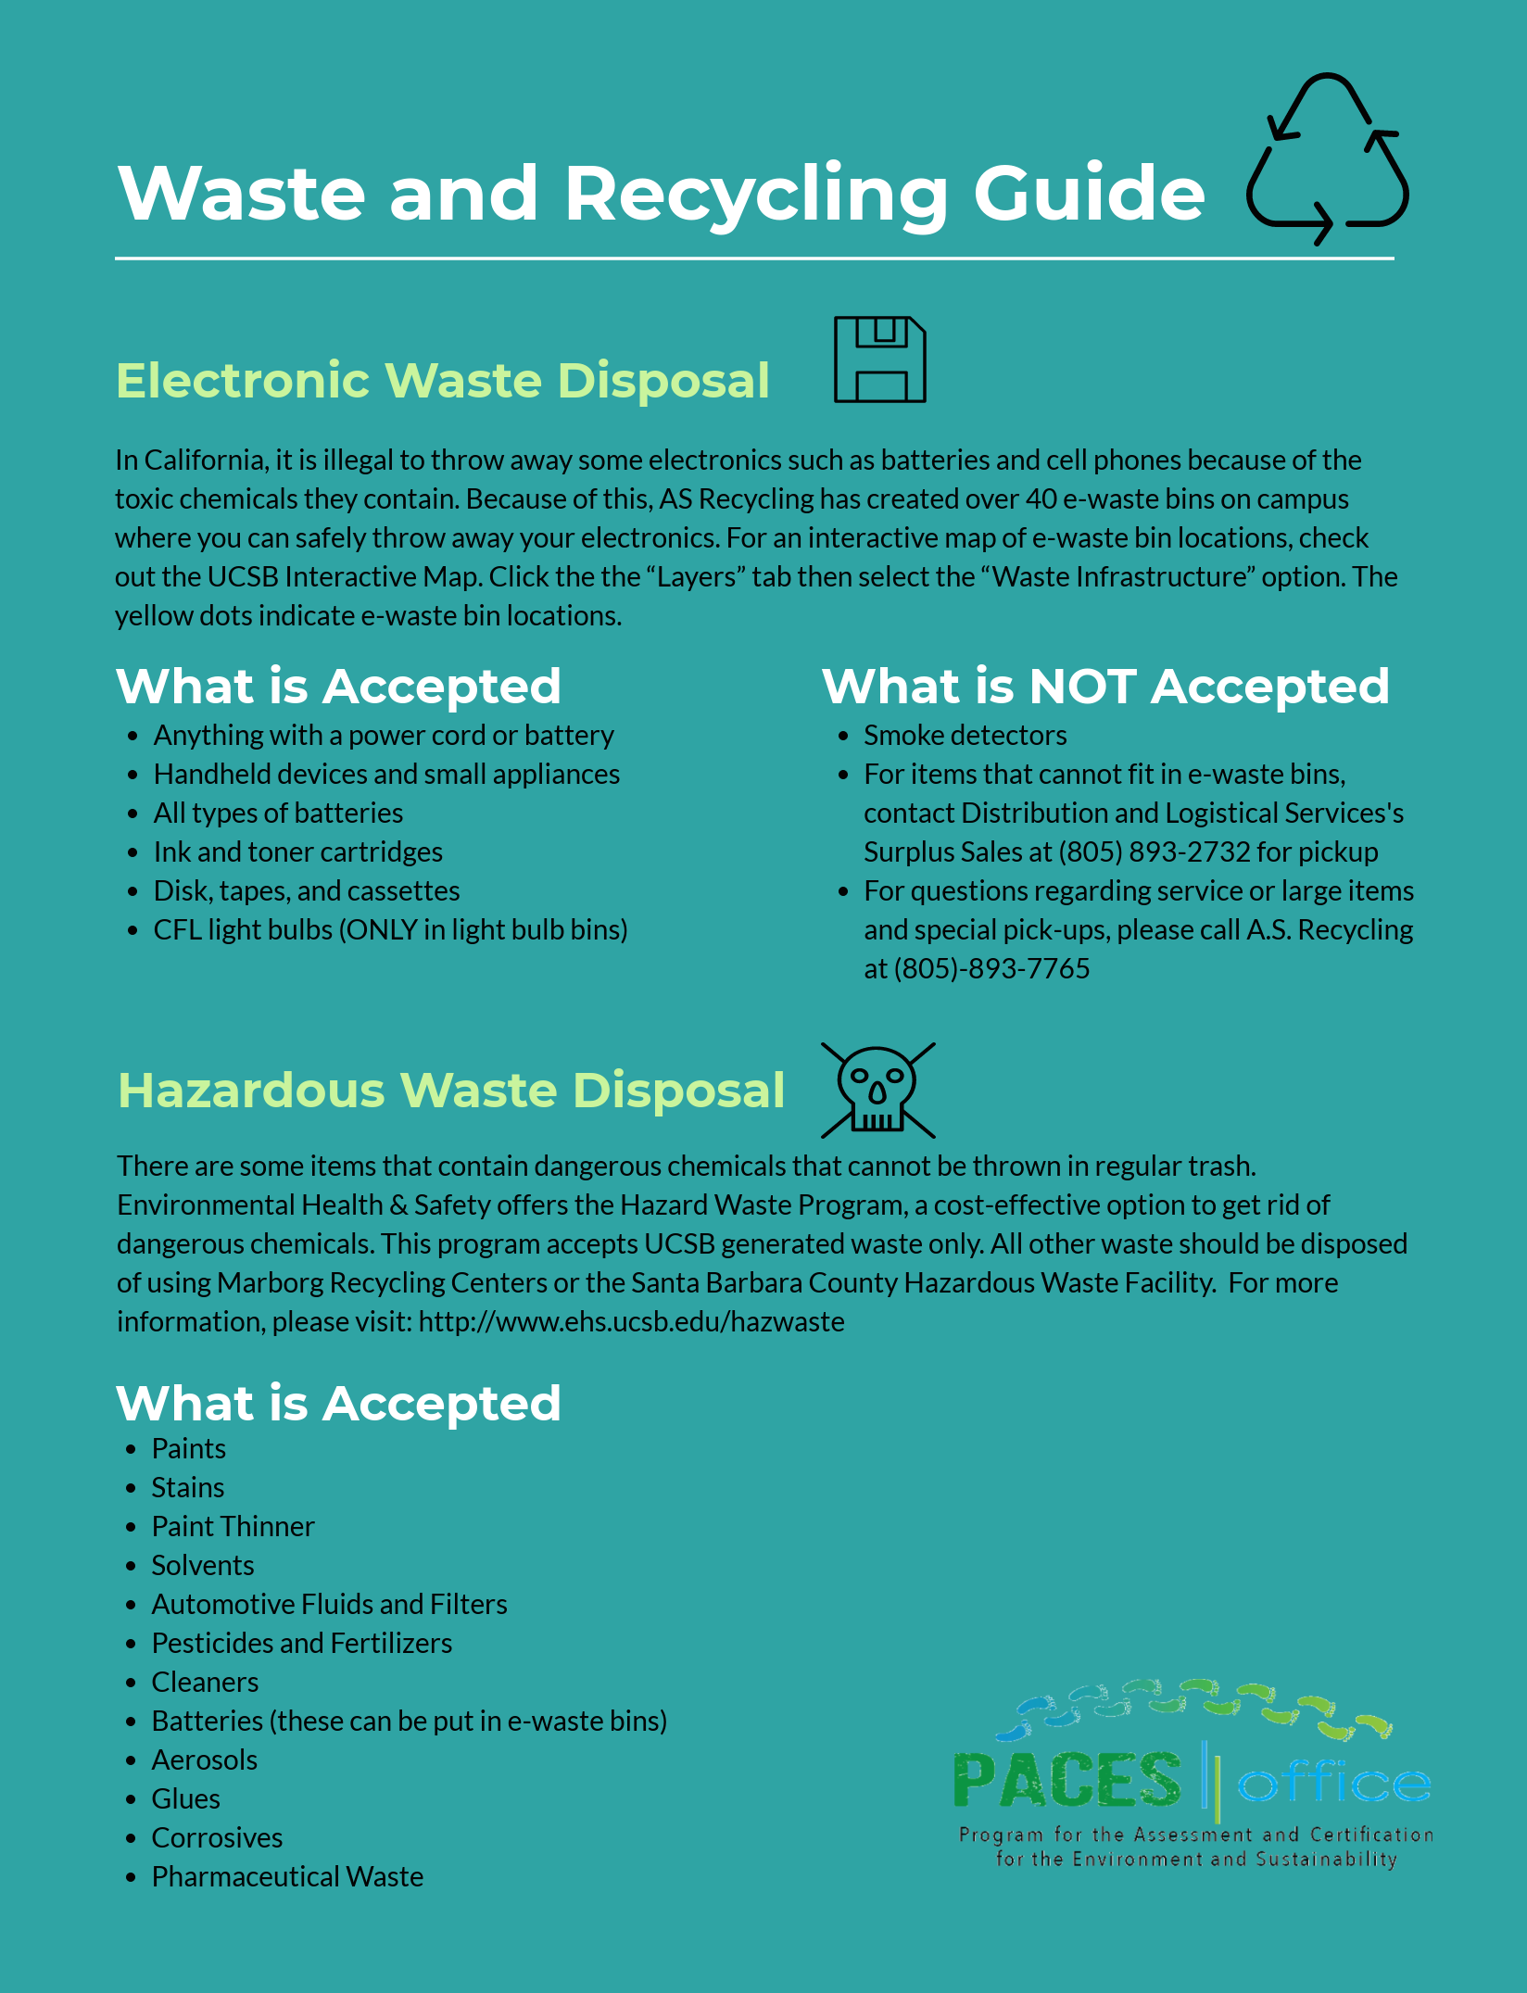

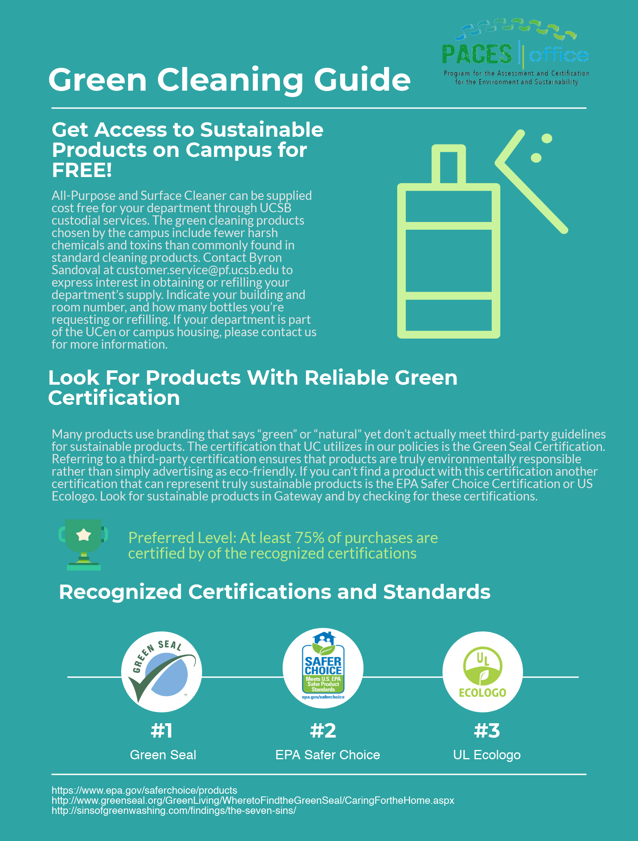

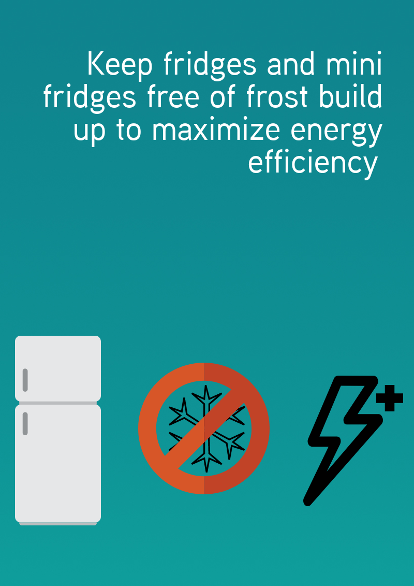

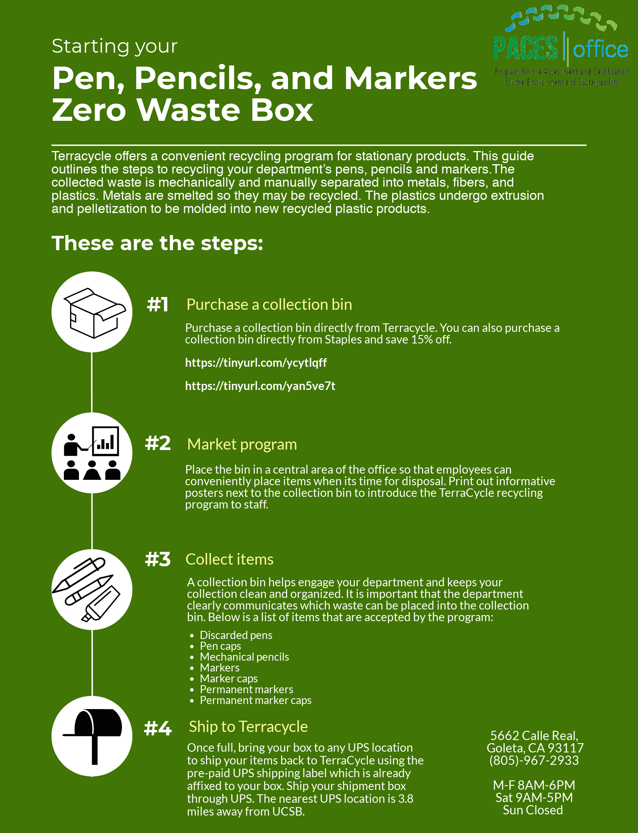

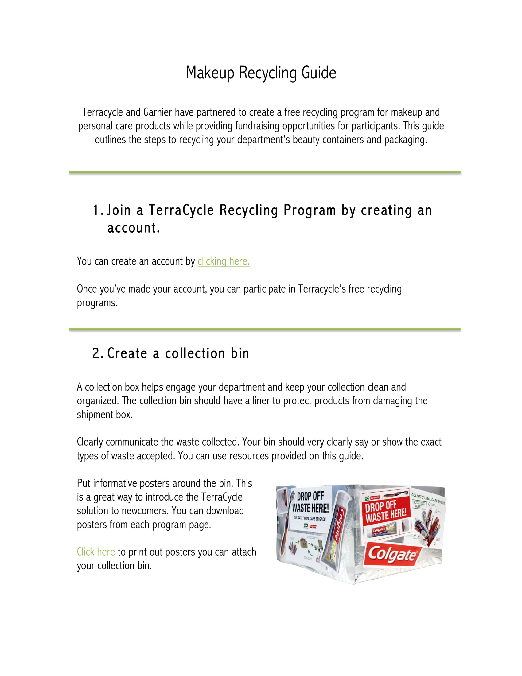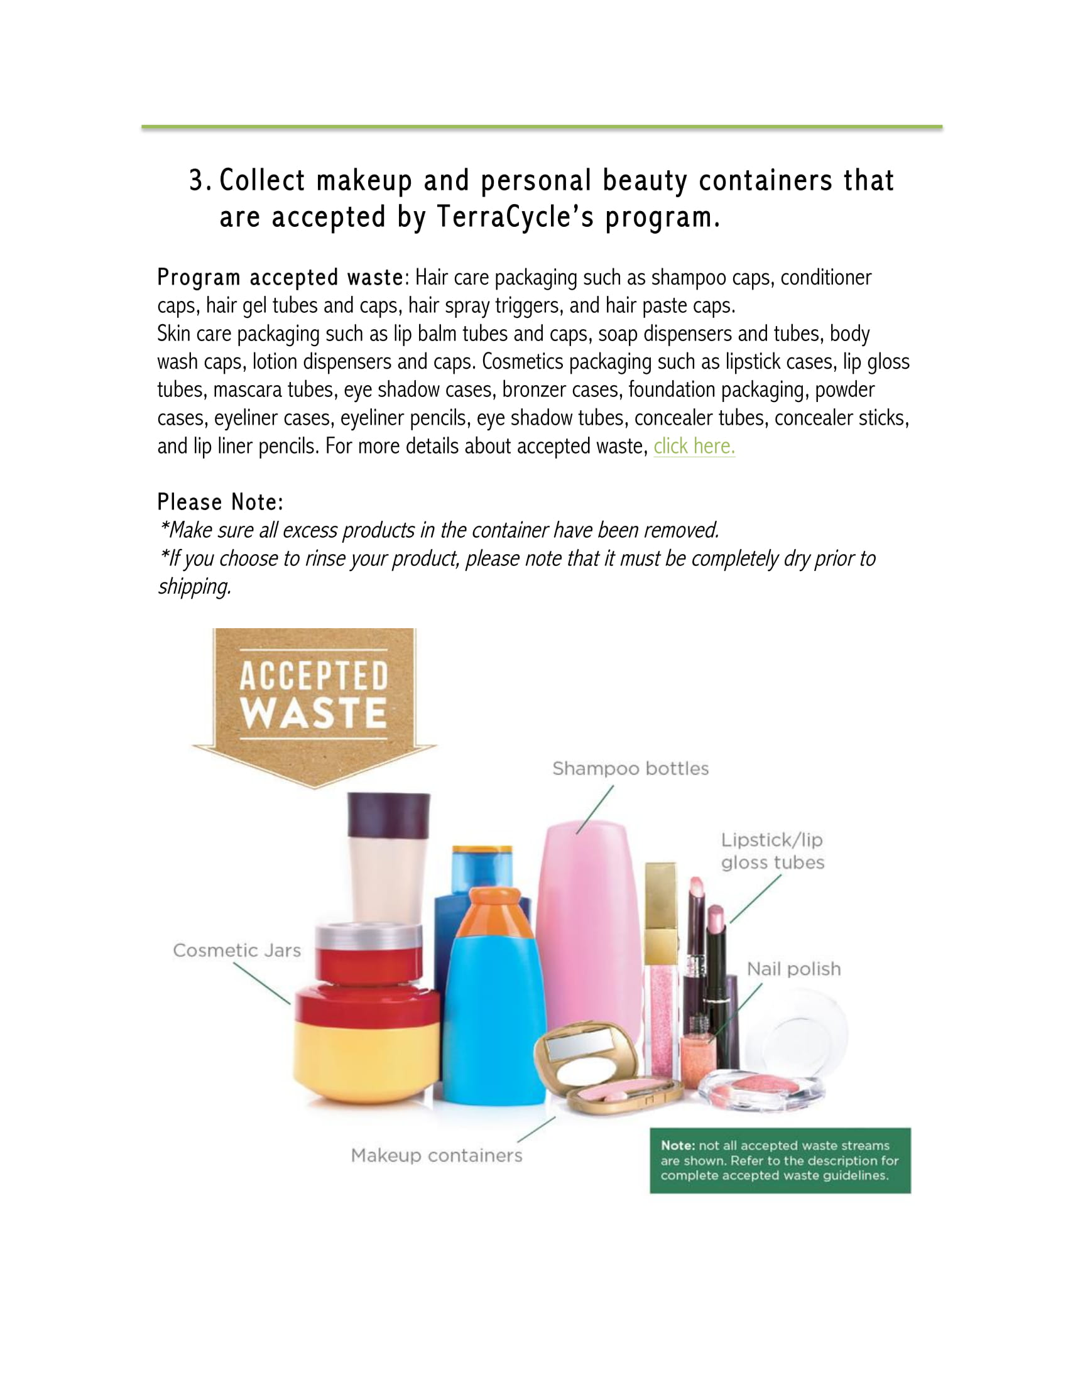

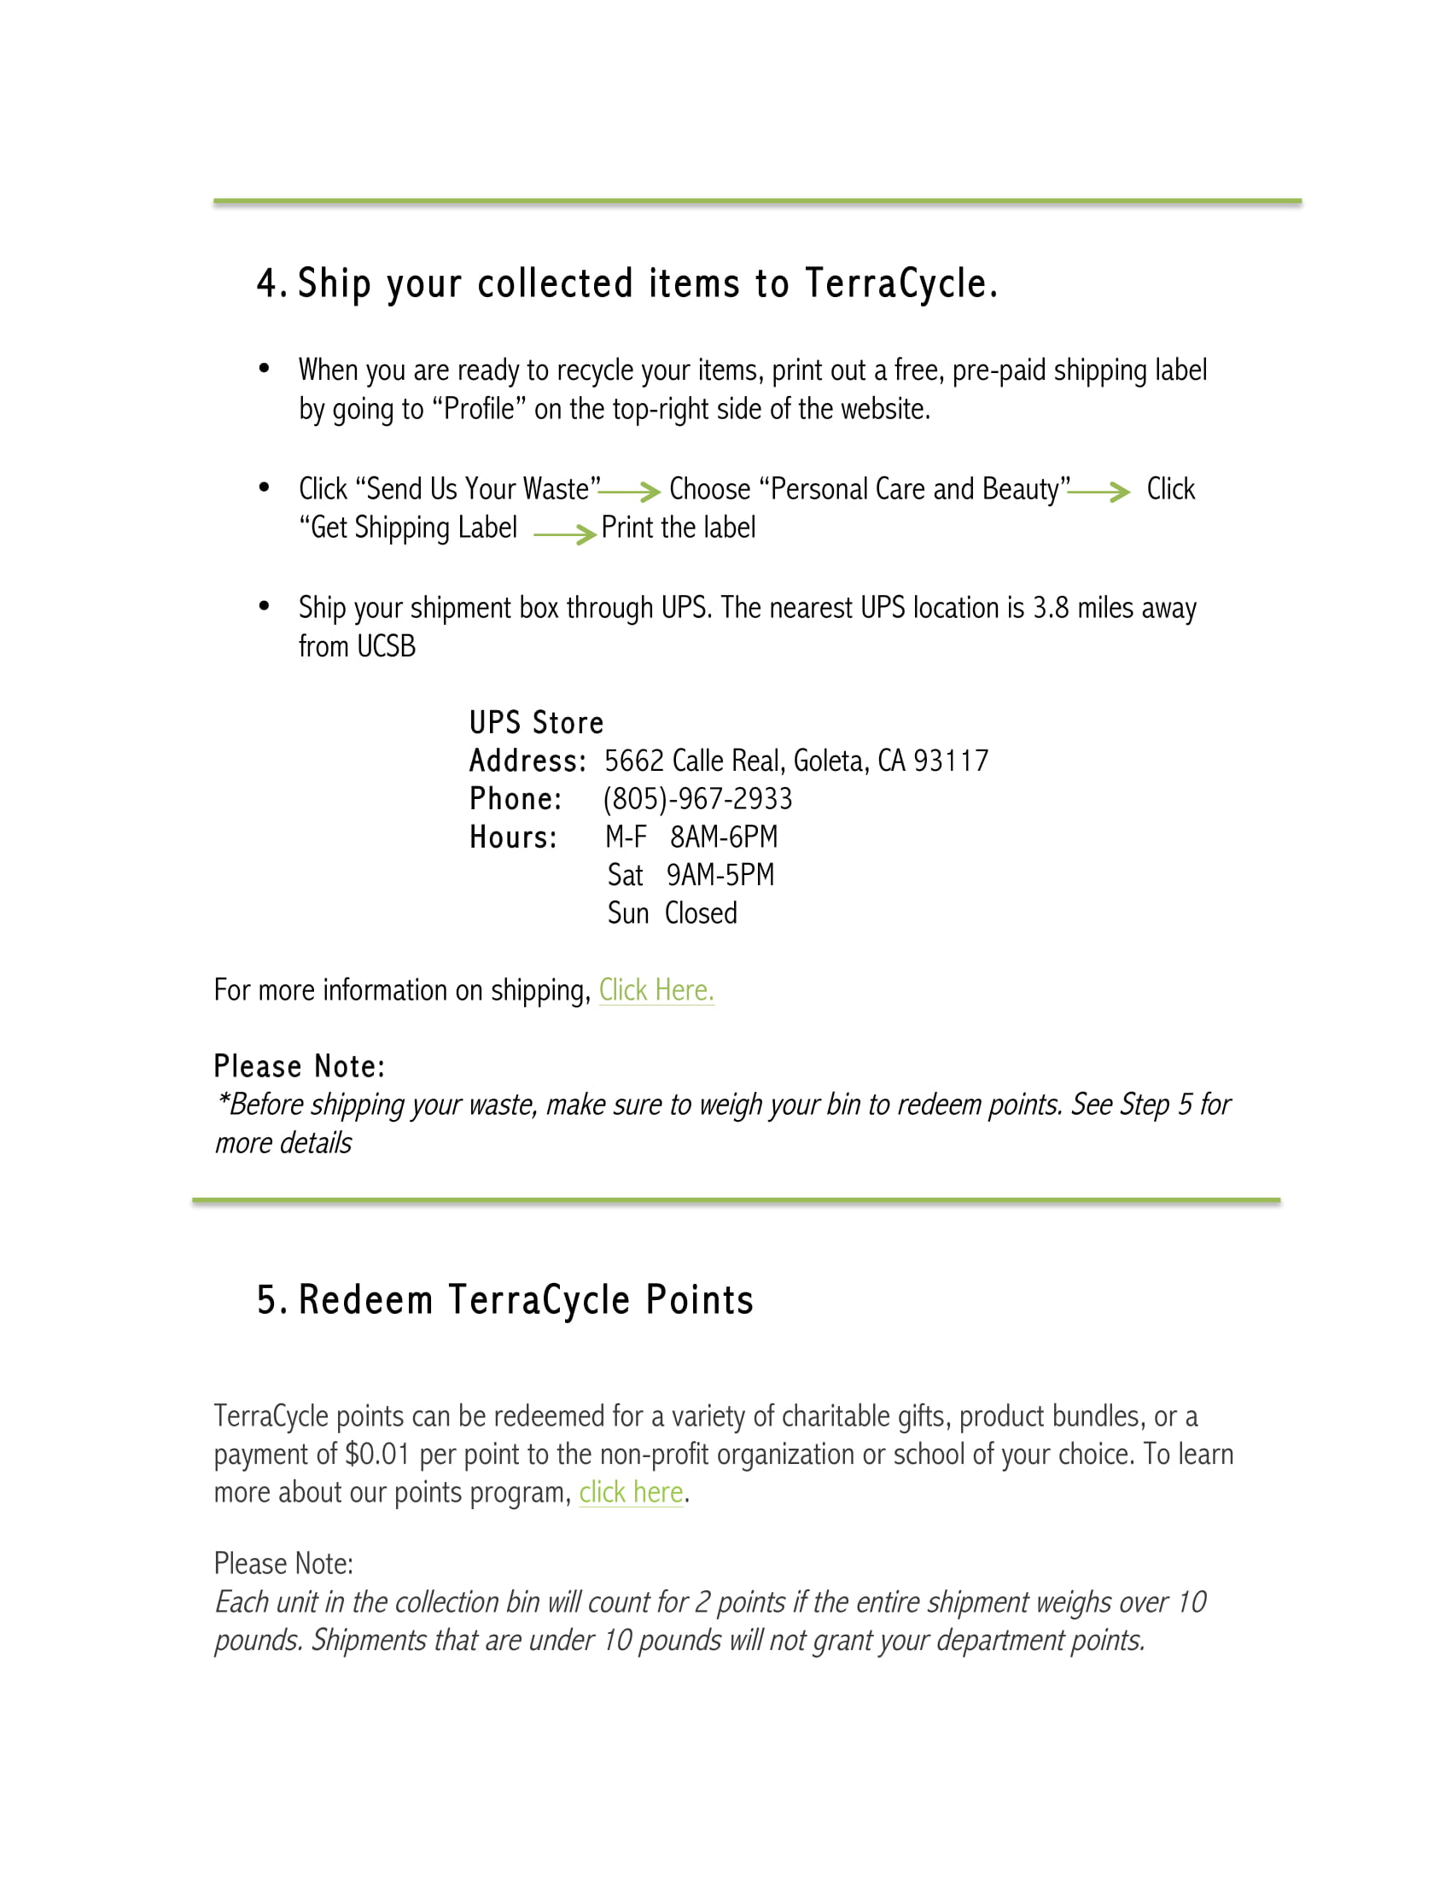

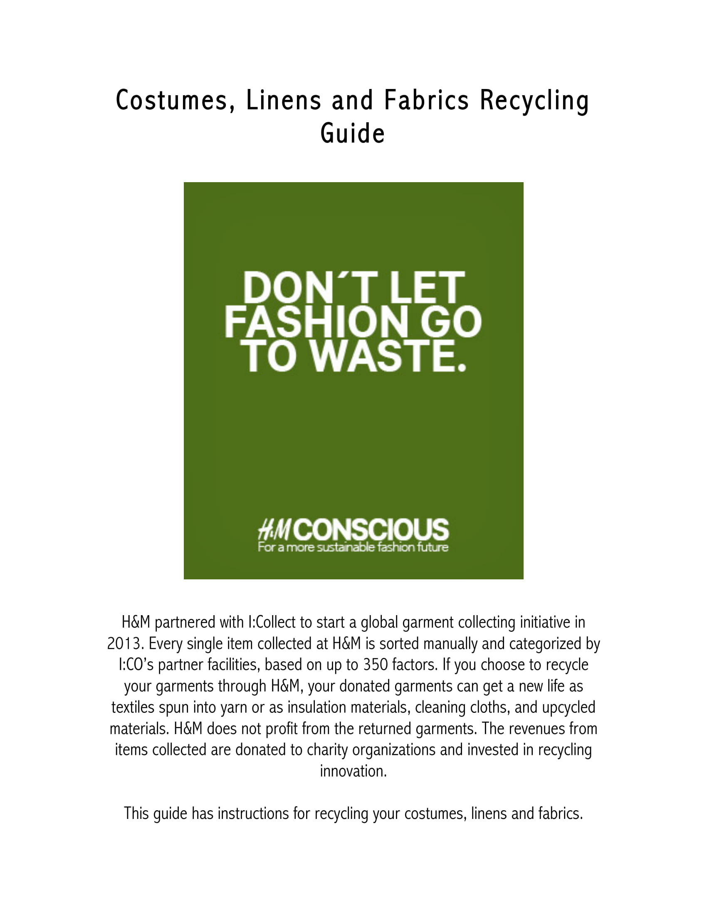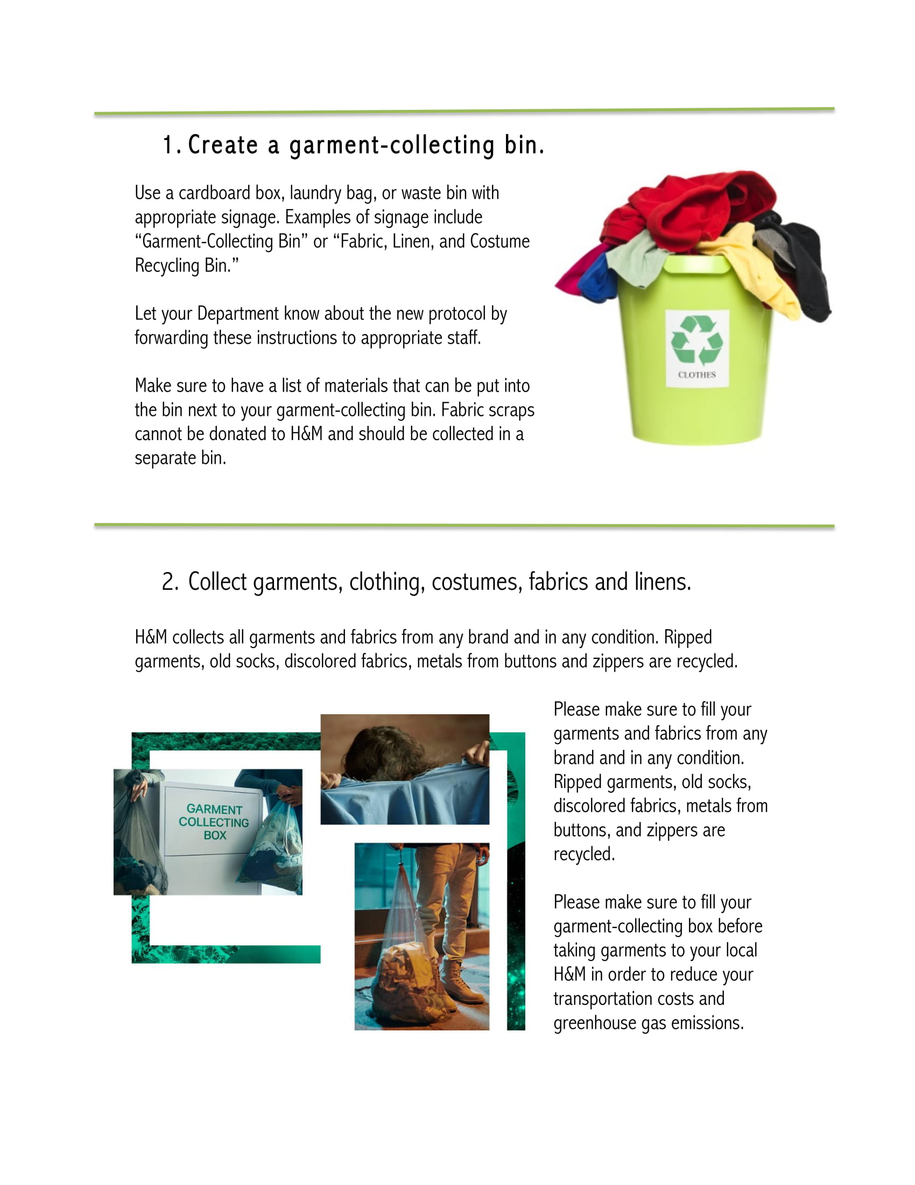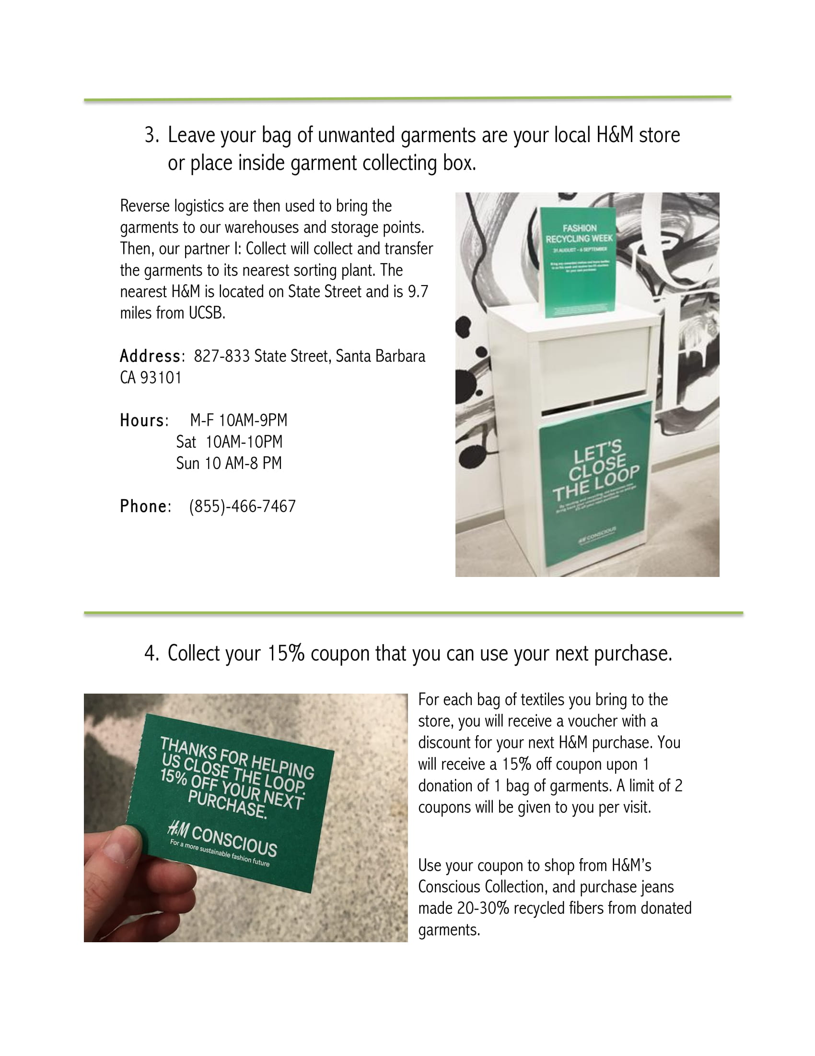

**Efficient Washer Guide**

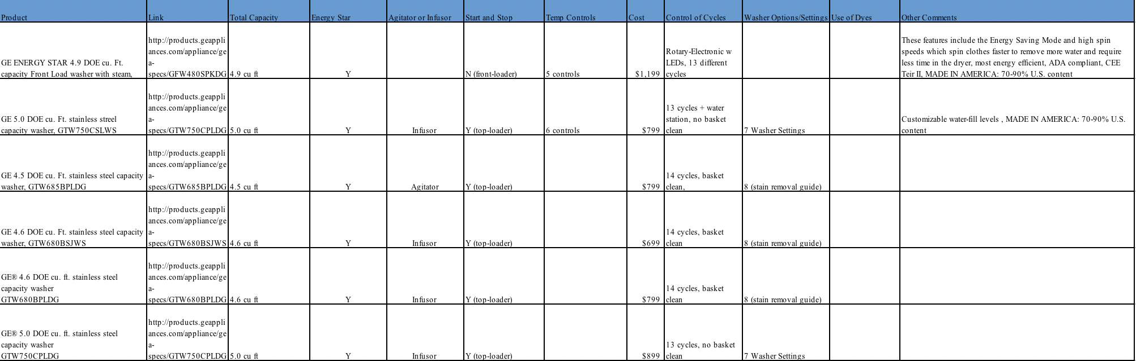

**Next Steps to Achieve PACES “Gold” Rating**

* Increase departmental awareness of TAP program to 80%
* Promote the use of Zipcar to faculty, staff and students
* Increase departmental knowledge of how to report a dripping faucet to 80%
* Give priority to products and services that use water as efficiently as possible
* Enable energy saving measures (sleep, power-save, turning off, etc.) on 75% of departmental computers
* Increase centralized printing by reducing the amount of personal printers present in occupant spaces to under 25%
* Increase the use of surface and kitchen cleaners that are Green Seal certified to 75%
* Increase departmental knowledge on who to contact to recycle furniture to 75%
* Increase office supplies made with recycled-content purchased by department members to 40%
* Reduce amount of alkaline batteries purchased by department occupants to less than 50%
* Promote teleconferencing and videoconferencing instead of long-distance travel when applicable
* Host departmental sustainability training events or informational sessions
* Incorporate sustainability information into staff/faculty/graduate student meetings
* Develop a sustainability plan/policy on at least three of the seven PACES subject areas
* Provide information on stretching to department occupants
* Develop a “First In, First Out” policy regarding cleaners and other chemicals
* Use water-based permanent and dry-erase markers and pens
* When buying food for functions, request food that meets at least 1 sustainability criteria (organic, local, fair trade, humane, etc.)
* Collect packing peanuts for reuse at Mail Services
* Set all centralized printers to double-sided printing as default
* Increase reminder signs near light switches to at least 90% of all department managed spaces
* Provide sustainability resources and information through a bulletin board or electronic listserv
* Purchase paper with 100% post-consumer recycled content